Chemical Investigations
Effect of Concentration on Reaction Speed
Teacher/Technician Guide
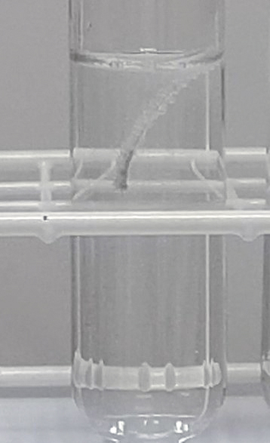

Effect of Concentration on Reaction Speed
UNIT 1 PPA 2
INTRODUCTION
The aim of this experiment is to find out how changing the concentration of sulphuric acid changes the speed that it reacts with magnesium.
When a piece of magnesium reacts with sulphuric acid bubbles of gas are formed. The piece of magnesium gets smaller and smaller until it 'disappears'. If we time how long it takes to 'disappear' we can get some idea of the reaction speed. The longer the time the slower the reaction speed.
We will do three experiments but only one factor - the concentration of the sulphuric acid - will change in each one. To change the concentration of the sulphuric acid we will add water to it - this dilutes the acid and makes it less concentrated. Other factors must be kept the same. This means that the pieces of magnesium ribbon we use must be the same size and the experiments must be carried out at the same temperature. Each experiment will be done at room temperature
Each group will need

2 x 100 cm³ glass beaker | 2 mol l⁻¹ sulphuric acid
1 x 50 cm³ glass beaker | 3 x 2 cm long pieces of clean magnesium ribbon
1 x 10 cm3 syringe | 1 x 20 cm³ syringe*
timer | 25 cm³ distilled water

* Measuring cylinders can be used instead.
Safety
2 mol l⁻¹ sulphuric acid is corrosive to skin and eyes. Wear goggles. (BS EN166 3)
Magnesium ribbon is flammable and the hydrogen gas produced is highly flammable – keep away from sources of ignition.
The reaction produces an acid mist which irritates the eyes and throat. Work in a well-ventilated lab and tell pupils not to sniff at it. One way to mitigate this is to plug the test tubes with cotton/mineral wool.

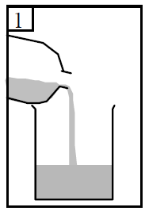
Procedure
- Add dilute sulphuric acid to one of the 100 cm³ glass beakers until it is half full. The acid has a concentration of 2 mol l⁻¹. Record this concentration by writing it down in the table

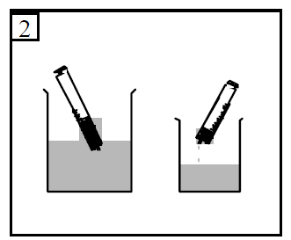
- Using the 20 cm3 syringe measure out 20 cm³ of the acid into the 50 cm3 glass beaker.

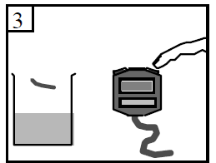

- Add a piece of magnesium ribbon to the acid and at the same time start the timer.

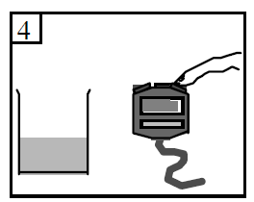

- When the magnesium has just 'disappeared' stop the timer and record the time to the nearest second.

- Wash out the small beaker and dry it.
- Fill the other 100 cm³ beaker half full with water.
- Using the 10 cm³ syringe measure out 10 cm3 of water into the small dry beaker. Then using the 20 cm³ syringe measure out 10 cm³ of the acid into the same beaker. This makes the concentration of the acid 1 mol l⁻¹. Record this new concentration in the table on your 'assessment' sheet.
- Add a piece of magnesium ribbon to the diluted acid and measure and record the time it takes for the magnesium to just 'disappear'.
- Repeat the experiment using 15 cm³ of water and 5 cm³ of acid.
- Measure and record the time it takes for the magnesium to just 'disappear'.
- The acid concentration this time is 0.5 mol l⁻¹. Record this concentration in the table

