Chemical Investigations
Effect of Concentration on Reaction Speed
Teacher/Technician Guide
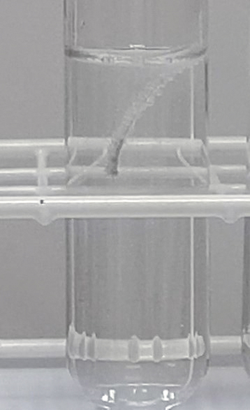

Effect of Concentration on Reaction Speed
UNIT 1 PPA 2
INTRODUCTION
The aim of this experiment is to find out how changing the concentration of sulphuric acid changes the speed that it reacts with magnesium.
When a piece of magnesium reacts with sulphuric acid bubbles of gas are formed. The piece of magnesium gets smaller and smaller until it 'disappears'. If we time how long it takes to 'disappear' we can get some idea of the reaction speed. The longer the time the slower the reaction speed.
We will do three experiments but only one factor - the concentration of the sulphuric acid - will change in each one. To change the concentration of the sulphuric acid we will add water to it - this dilutes the acid and makes it less concentrated. Other factors must be kept the same. This means that the pieces of magnesium ribbon we use must be the same size and the experiments must be carried out at the same temperature. Each experiment will be done at room temperature
You will need

100 cm³ glass beaker | 2 mol l⁻¹ sulphuric acid
50 cm3 glass beaker | 2 cm long pieces of clean magnesium ribbon
10 cm3 syringe | 20 cm³ syringe
timer

Safety
Wear goggles.
Do not sniff at the reaction mixture – an irritating acid mist is formed.
Keep away from flames.

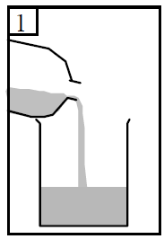
Procedure (what you do)
- Add dilute sulphuric acid to one of the 100 cm³ glass beakers until it is half full. The acid has a concentration of 2 mol l⁻¹. Record this concentration by writing it down in the table

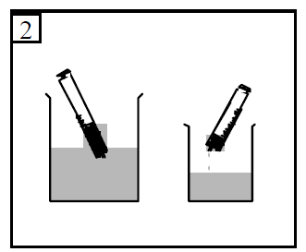
- Using the 20 cm3 syringe measure out 20 cm³ of the acid into the 50 cm3 glass beaker.

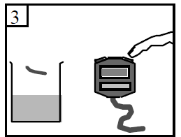

- Add a piece of magnesium ribbon to the acid and at the same time start the timer.

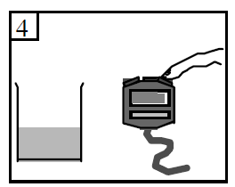

- When the magnesium has just 'disappeared' stop the timer and record the time to the nearest second.

- Wash out the small beaker and dry it.
- Fill the other 100 cm³ beaker half full with water.
- Using the 10 cm³ syringe measure out 10 cm3 of water into the small dry beaker. Then using the 20 cm³ syringe measure out 10 cm³ of the acid into the same beaker. This makes the concentration of the acid 1 mol l⁻¹. Record this new concentration in the table on your 'assessment' sheet.
- Add a piece of magnesium ribbon to the diluted acid and measure and record the time it takes for the magnesium to just 'disappear'.
- Repeat the experiment using 15 cm³ of water and 5 cm³ of acid.
- Measure and record the time it takes for the magnesium to just 'disappear'.
- The acid concentration this time is 0.5 mol l⁻¹. Record this concentration in the table

Results sheet
What was the aim of the experiment?

Procedure

How did you change the concentration of the sulphuric acid?

How did you get some idea of how quickly the magnesium reacted with the dilute sulphuric
acid?

Complete the following table:
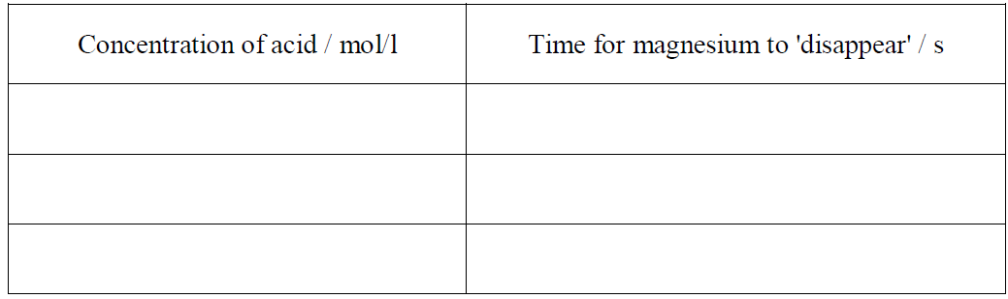

Conclusion

What did you find out from this experiment?

