Chemical Investigations
Effect of Temperature on Dissolving Speed
Pupil Guide
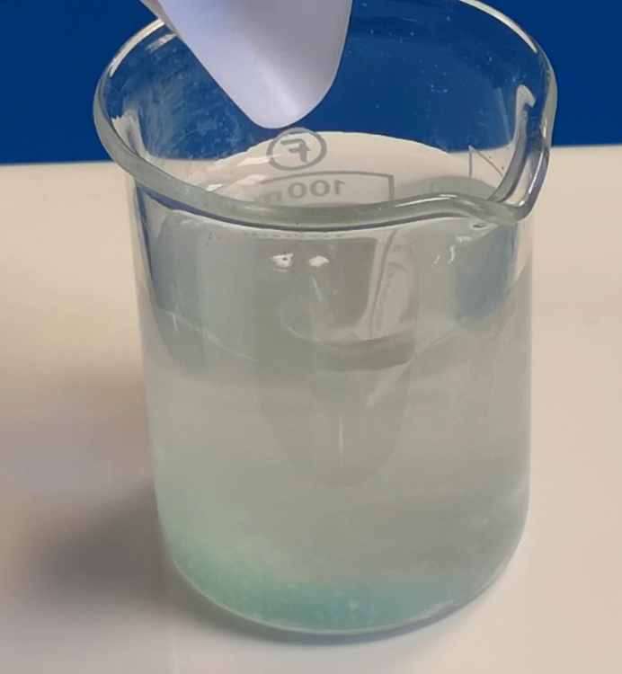

Effect of Temperature on Dissolving Speed
UNIT 1 PPA 1
INTRODUCTION
When a substance dissolves in a liquid it forms a solution. In this experiment the substance used will be sugar crystals and the liquid will be water.
The aim of the experiment is to find out how changing the temperature of the water changes the speed at which the sugar dissolves.
To make the experiment fair, only one factor - the temperature of the water - will change.
Other factors like the volume of water, the mass and size of the sugar crystals and how much we stir the mixture must be kept the same.
You will need

large glass beaker | large sugar crystals
test tubes and rack | stopper
thermometer | syringe
tripod | Bunsen burner and heating mat

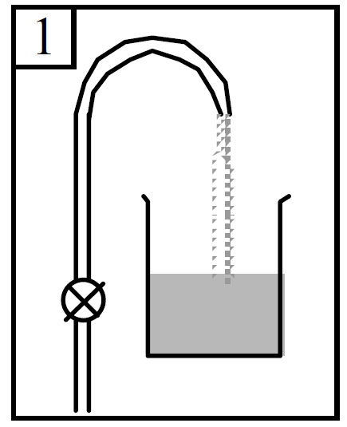
Procedure (what you do)
- Fill the glass beaker half full with water.

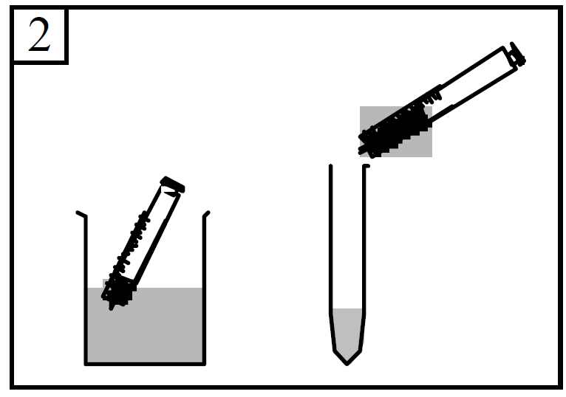
- Use a syringe to put water into a test tube. Add the water until it is about 3 cm from the top of the test tube.

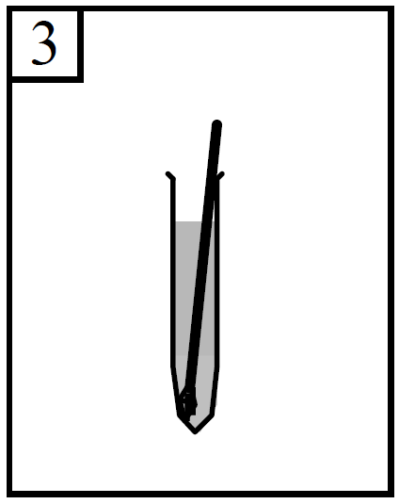
- Use a thermometer to measure the temperature of the water in the test tube. Record this temperature by writing it down in the table.

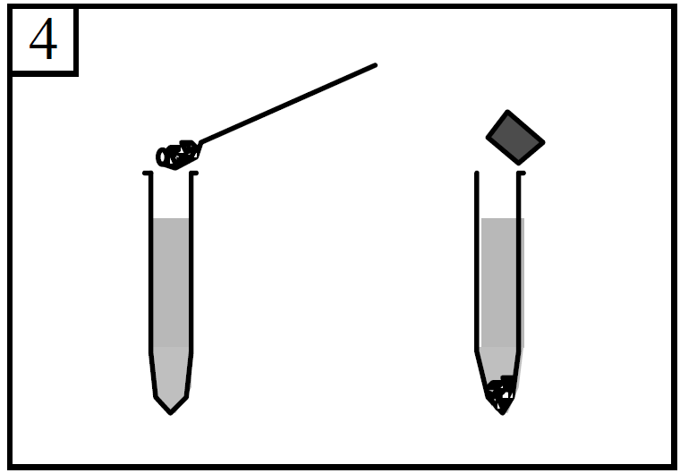

- Fill a spatula with sugar crystals and put them in the water in the test tube. Put a stopper on the test tube.

- Turn the test tube upside down. Hold it upside down until the crystals fall to the bottom. This counts as one 'upturn'. Then turn the test tube the right way up again until the crystals fall to the bottom. This counts as the second 'upturn'.
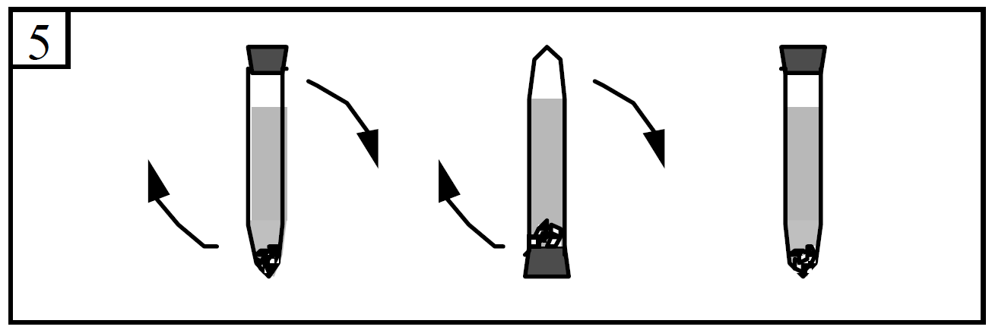
- Keep on doing this. Count how many 'upturns' you have to do before the crystals just 'disappear' (dissolve). Record this number by writing it down in the table. This number of 'upturns' gives an idea of how quickly the sugar crystals dissolve.

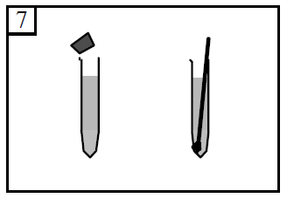
- Take the stopper out of the test tube. Measure the temperature of the solution in the test tube. Record this temperature in the table.

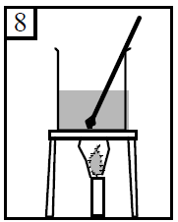
- Put the beaker of water on top of the tripod. Light the Bunsen burner, put it under the tripod and heat the beaker of water until your thermometer shows that the temperature of the water is between 35 °C and 40 °C. Remove the Bunsen burner from below the beaker.

- Use a syringe to put this warm water into a test tube. Add the warm water until it is about 3 cm from the top of the test tube. Use a thermometer to measure the temperature of this warm water and record it in the table.
- Fill a spatula with sugar crystals. Make sure it is about the same amount as you used before. Put them in the warm water in the test tube and put a stopper on this test tube.
- Turn the test tube upside down as you did before. Hold it upside down until the crystals fall to the bottom. You will remember that this counts as one 'upturn'. Then turn it the right way up again.
- Carry on doing the 'upturns' at the same speed as you did before. Count how many 'upturns' you have to do before the crystals just dissolve ('disappear'). Record this number.
- Take the stopper out of the test tube. Measure the temperature of the solution in the test tube and record it.
- Repeat the experiment once more after heating the water to between 55 °C and 60 °C.
- Remember to measure and record the temperature of the water before the sugar crystals are added and after the sugar crystals have just dissolved.
- Also count and record the number of 'upturns' it takes until the crystals just dissolve.

Results sheet
What was the aim of the experiment?

Procedure

What factor did you change in your experiment?

What did you count that told you how quickly the sugar crystals dissolved in the water?

Complete the following table:
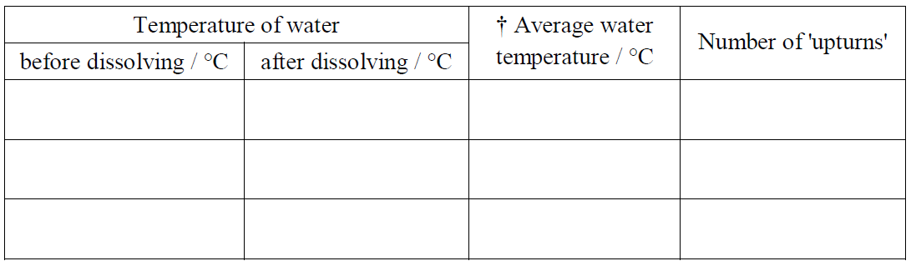
† To work out the average water temperature add the two temperatures together and divide this number by 2.

Conclusion

What did you find out from this experiment?

The experiment could be improved by doing it at more than three temperatures.

Give a reason for this.

