Microscale Chemistry
The Haber Process

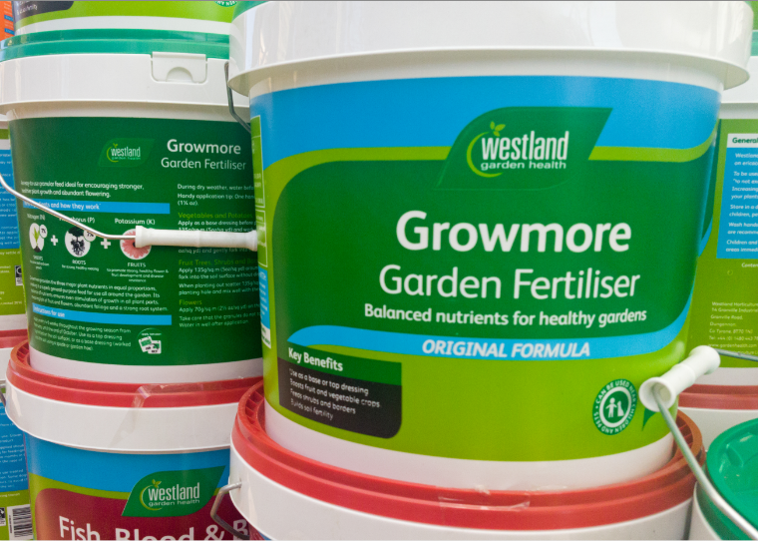

Curriculum links

National 4 – Chemistry in Society.
Fertilisers
National 5 - Chemistry in Society.
Fertilisers
Introduction
Industrial chemistry is very important to a nation’s economy. The Haber process is used still used extensively as the main source of ammonia. The industrial conditions of a temperature of around 400 – 450° and a pressure of 200 are impossible in the school lab.
Yet using this simple equipment is possible to demonstrate the process.

Health & Safety
Wear eye protection. Make sure that any long hair is tied back.

You will need
1 x 60 cm³ syringe | Nitrogen gas*
Hydrogen gas* | Gas mixture (15 cm³ Nitrogen, 45cm³ Hydrogen).
10 cm length of 6mm wall borosilicate tubing | Iron wool
1 x Small test tube (or bijou) | Burner
Silicone tubing to connect | Water with universal indicator.

* You can prepare both of these in separate syringes and combine them in a third syringe.
Preparation
Fill your 60 cm³ syringe with 15 cm³ of nitrogen and 45 cm³ of Hydrogen.
Set up the apparatus as in the diagram.
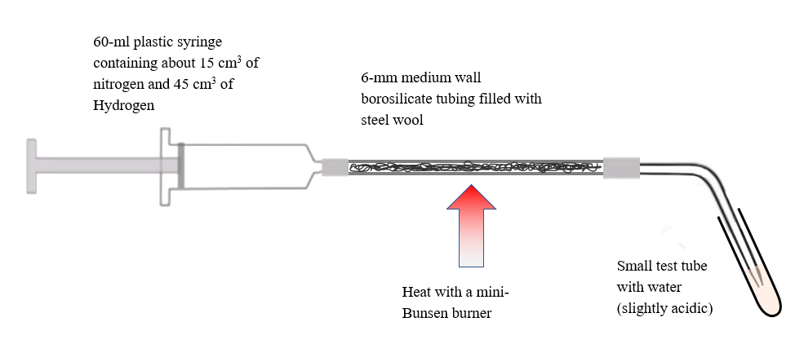

To Do
- Wear eye protection
- Fill the borosilicate glass tube with iron wool by twisting the wool into a fine length and threading it through the tube.
- Set up the equipment by clamping the 60-ml syringe. The small test tubes can be stabilised by placing it in a 100-ml beaker.
- The test tubes are filled one-quarter filled with distilled or deionised water which is often slightly acidic due to dissolved carbon dioxide. The a few drops of Universal Indicator is added to each which should go yellow. One test tube will act as a control.
- Light the mini-Bunsen Burner and when the iron gets very hot, start pushing the barrel to force the gas mixture slowly over the catalyst. This is best done by holding the stem of the barrel rather than pushing the end with the palm of the hand.
- The aim is to make ammonia and cause the water in the test tube to become slightly alkaline

Extensions
The fact that the gas is alkaline is a very good indicator of it being ammonia – there are very few alkaline gases. Other tests are:
- Hold the end of the delivery tune next to a small, open container of concentrated hydrochloric acid – ammonia should cause the appearance of fumes of white ammonium chloride.
- You can also test for ammonia using Nessler’s reagent. However, this is toxic and contains mercury so if done at all, it should be done with great care and on a very small scale.

