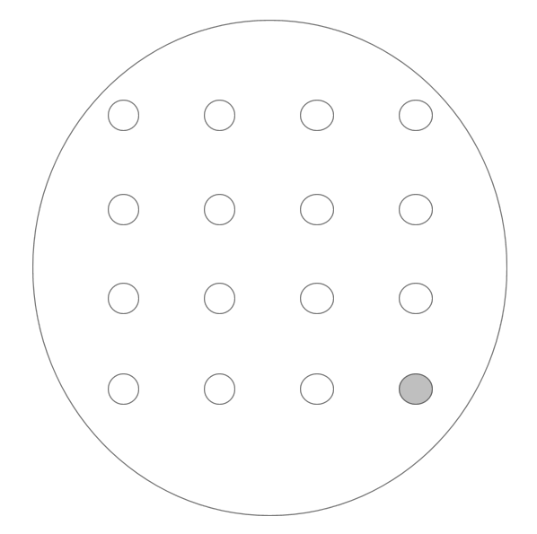 | Diffusion of Gases - 1  Work in a well-ventilated lab.  - Put this sheet in a poly pocket.  - Place the petri dish on top of the sheet, covering the circle.  - To each of the white circles add 1 drop of diluted universal indicator – with tap water so it remains green.  Then  - Place a blister pack on the grey circle and then add:  either  - 10 drops of 2 mol l⁻¹ ammonia and then  - 1 or 2 grains of anhydrous calcium chloride..  Or  - A small spatula (0.25g) of sodium sulphite (Na₂SO₃) then  - 5-10 drops of 2 mol l⁻¹ HCl.  - Replace the lid immediately and watch what happens.

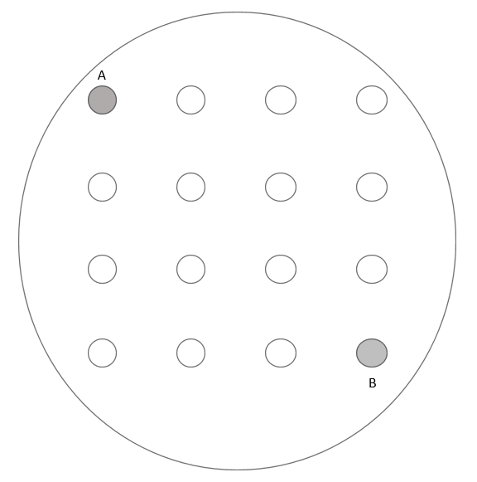 | Diffusion of Gases - 2  Work in a well-ventilated lab.  - Put this sheet in a poly pocket.  - Place the petri dish on top of the sheet, covering the circle.  - To each of the white circles add 1 drop of diluted universal indicator – with tap water so it remains green.  Then  - In the grey circle A add:  - 10 drops of 2 mol l⁻¹ ammonia and then  - 1 or 2 grains of anhydrous calcium chloride.  - To the grey circle, B, place a blister pack and add  - A small spatula (0.25g) of sodium sulphite (Na₂SO₃) then  - 5-10 drops of 2 mol l⁻¹ HCl.  - Replace the lid immediately and watch what happens.

Diffusion of Gases - 3
Work in a well-ventilated lab.

- Put this sheet in a poly pocket.
- Place the petri dish on top of the sheet, covering the circle.
- To each of the white circles add
- 1 drop of 0.1 mol l⁻¹ potassium iodide and
- 1 drop of 1% starch
Then
- In the grey circle A add:
  - 2 drops of 50% domestic thin bleach and then
  - 2 drops of 1 mol l⁻¹ hydrochloric acid.

- Replace the lid immediately and watch what happens.

