

|  |
| --- |
| Simple Chemical Reactions |
| Changing the position of an equilibrium 1 - concentration |

**Introduction**

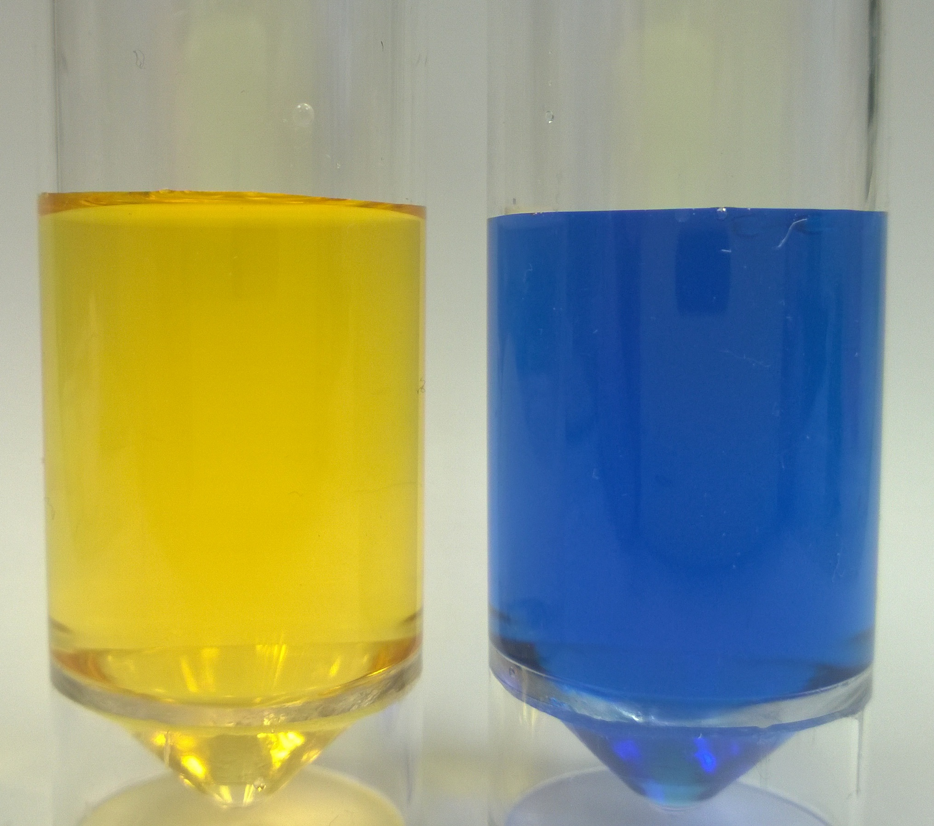

CfE Advanced Higher

Inorganic & Physical Chemistry

Here are three simple experiments that show the effect on an equilibrium of changing one or other of the components of that equilibrium.

There is no need to do all of them. Any one will demonstrate the principle.

**You will need**

|  |  |
| --- | --- |
| 0.1 mol l-1 potassium chromate | 1 mol l-1 sulphuric acid |
| 2 mol l-1 sodium hydroxide | Methyl orange indicator* |
| Bromothymol blue indicator* | Ammonium chloride (solid) |
| 0.5 mol l-1 Iron III chloride solution (acidified – make up in 1 mol l-1 HCl) | 0.5 mol l-1 potassium thiocyanate solution |
| 2 x pasteur pipettes | Test tubes and rack |
| Distilled water | spatula |

**To do**

**Experiment 1**

1. Put about 2 cm3 of distilled water in a test tube
2. Add 2 – 3 drops of **one** of the indicators.*
3. Explore the effect of adding drops of dilute sulphuric acid until there is no further change.
4. Now add drops of sodium hydroxide until there is no further change.
5. Repeat steps three and 4 and note your observations

* You can use any indicator for this – including natural ones such as tea or turmeric.

**Experiment 2**

1. put about 2 cm3 of potassium chromate solution in a test tube.
2. Explore the effect of adding drops of dilute sulphuric acid until there is no further change.
3. Now add drops of sodium hydroxide until there is no further change.
4. Repeat steps three and 4 and note your observations

**Experiment 3**

1. Put **one drop** of Iron III chloride solution in a test tube and add **one drop** of potassium thiocyanate solution.
2. Add about 5 cm3 of distilled water and mix
3. Divide this solution equally between 4 test tubes. Label them 1 – 4.
4. Carry out the following procedures – in each case agitate the tube to mix

Tube 1: add 1 drop of Iron III chloride

Tube 2: Add 1 drop of potassium thiocyanate

Tube 3: Add a single level spatula of ammonium chloride

Tube 4: This is the control

1. Observe any colour changes

**What is happening**

**Experiment 1**, an indicator is a weak acid in which the HIn form is a different colour from the In- form. In solution it is in equilibrium as shown below

HIn(aq) ⇋ H+ (aq) + In - (aq)

Adding acid increases the amount of H+ on the right of the equilibrium. To compensate, the equilibrium shifts to the left, increasing HIn and decreasing In-.

Addition of alkali has the opposite effect as

H+ (aq) + OH - (aq) 🡪 H2O

Thus the concentration of H+ decreases and the equilibrium shifts to the right, this time decreasing HIn and increasing In-.

In **experiment 2**, a very similar process is happening with an equilibrium between the chromare and dichromate ions.

2CrO42-(aq) + 2H+ (aq ⇋ Cr2O72-(aq) + H2O

**Yellow Orange**

**Experiment 3**

The following are present in equilibrium

Fe3+(aq) + SCN- (aq) ⇋ [Fe(SCN)]2+(aq)

In Tube 1, the addition of Fe3+ increases the Fe3+ concentration this shifts the equilibrium position to the right and so the solution becomes darker red.

In Tube 2, similarly, the addition of SCN- increases the SCN- concentration this shifts the equilibrium position to the right and so the solution becomes darker red.

In Tube 3, chloride ions will react with iron III as shown below

Fe3+(aq) + Cl- (aq) ⇋ [FeCl4]2-(aq)

So addition of ammonium chloride causes a reduction in the amount of Fe3+  which causes the equilibrium to shift to the left and so the colour becomes lighter

**Safety**



chromate / dichromates are toxic, carcinogenic, mutagenic and more.

The experiment, however, uses very small quantities of diluted solutions and if the method is followed as described, there should be no contact with it. It may, however, be sensible to wear disposible nitrile gloves

Sodium hydroxide solution and sulphuric acid are corrosive. Wear goggles (BS EN166 3)

**It is the responsibility of teachers doing this demonstration to carry out an appropriate risk assessment.**