

|  |
| --- |
| Simple Chemical Reactions |
| Changing the position of an equilibrium 1 - concentration |

**Experiment 1**

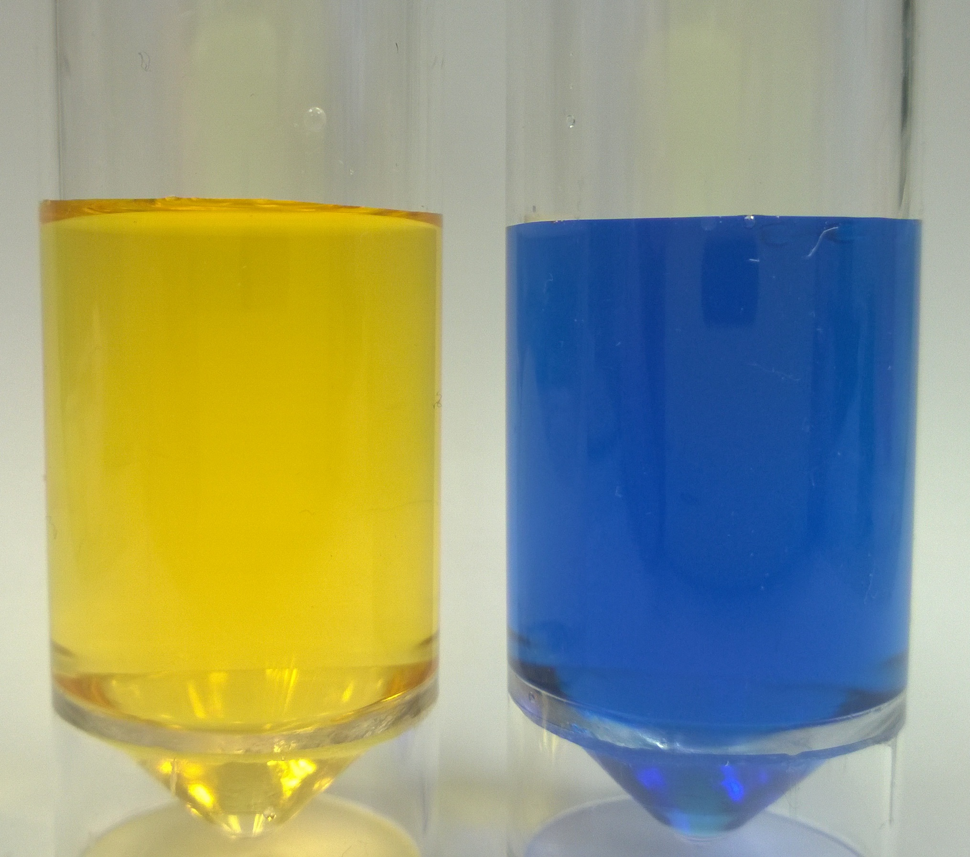

**Indicator equilibrium**

**You will need**

|  |  |
| --- | --- |
| 0.1 mol l-1 sodium hydroxide | 1 mol l-1 hydrochloric acid |
| Bromothymol blue indicator* | Methyl orange indicator* |
| 2 x pasteur pipettes | Test tubes and rack |
| Distilled water | spatula |

* You can use any indicator for this – including natural ones such as tea or turmeric.

**Safety**

There are no significant risks with this experiment.

**To do**

1. Put about 2 cm3 of distilled water in a test tube
2. Add 2 – 3 drops of **one** of the indicators.*
3. Explore the effect of adding drops of dilute sulphuric acid until there is no further change.
4. Now add drops of sodium hydroxide until there is no further change.
5. Repeat steps three and 4 and note your observations

**Experiment 2**

**Chromate / dichromate equilibrium**

**You will need**

|  |  |
| --- | --- |
| 0.1 mol l-1 potassium chromate | 1 mol l-1 sulphuric acid |
| 2 mol l-1 sodium hydroxide | Test tubes and rack |
| 2 x pasteur pipettes | spatula |

**Safety**

Chromium VI compounds like chromate / dichromate are toxic, carcinogenic, mutagenic corrosive and more.

The experiment, however, uses very small quantities of diluted solutions and if the method is followed as described, there should be no contact with it.



However, you should still wear goggles and it may be sensible to wear disposible nitrile gloves.

**To do**

1. put about 2 cm3 of potassium chromate solution in a test tube.
2. Explore the effect of adding drops of dilute sulphuric acid until there is no further change.
3. Now add drops of sodium hydroxide until there is no further change.
4. Repeat steps three and 4 and note your observations

**Experiment 3**

**Equilibrium of Iron thiocyanate complex**

**You will need**

|  |  |
| --- | --- |
| 0.5 mol l-1 Iron III chloride solution (acidified – make up in 1 mol l-1 HCl) | 0.5 mol l-1 potassium thiocyanate solution |
| 2 x pasteur pipettes | Test tubes and rack |
| Distilled water | spatula |

**Safety**

Iron chloride solution is corrosive.

The experiment, however, uses very small quantities of diluted solutions and if the method is followed as described, there should be no contact with it.



However, you should still wear goggles.

**To Do**

1. Put **one drop** of Iron III chloride solution in a test tube and add **one drop** of potassium thiocyanate solution.
2. Add about 5 cm3 of distilled water and mix
3. Divide this solution equally between 4 test tubes. Label them 1 – 4.
4. Carry out the following procedures – in each case agitate the tube to mix

Tube 1: add 1 drop of Iron III chloride

Tube 2: Add 1 drop of potassium thiocyanate

Tube 3: Add a single level spatula of ammonium chloride

Tube 4: This is the control

1. Observe any colour changes