Chemical Investigations
Anodising Titanium
Teacher / Technician Guide
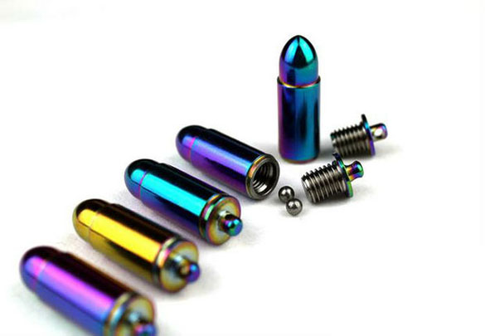
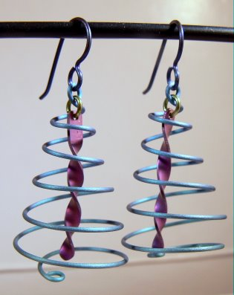

Background
Many metals, such as aluminium and titanium have a protective oxide coating on them. That is why, for instance, aluminium seems much less reactive than it really is.
Anodising is an electrochemical process that is used to thicken this protective oxide layer. As well as increasing the protection provided, anodising can also be used as a way of colouring these metals with a layer of hard, permanent colour.
The titanium is used as the anode of an electrochemical circuit. Oxygen from the acidic electrolyte is produced at the anode and this can react with the metal to thicken the metal oxide layer. The higher the voltage, the thicker the oxide layer can become.
The colour produced by anodising titanium is an example of ‘structural’ colour: rather than the simple production of pigment. The colour comes from light scattering through the oxide layer.
Some light is bounced off the surface of the titanium dioxide layer. Other light travels through the oxide layer and bounces off the metal surface under it.
If the light reflected by the oxide layer is in phase with that reflected by the metal there will be constructive interference and therefore the anodised titanium strip will appear coloured.
Destructive interference will result in no colouration. eg
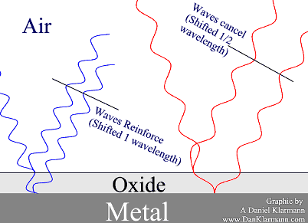
The shorter blue wavelength reflects of the surface, and off the metal.
The interior wave travels a full wavelength farther than the first reflection, so they reinforce.
The longer red wave travels the same distance, but that's only ½ of its wavelength, so it cancels out.
When all the colours which are in white bounce off this double layer, what you see is blue.
So particular voltages (and therefore TiO₂ thicknesses) are associated with particular colours.
A whole range of colours is possible with very high voltages, however for safety reasons this experiment is limited to a range of up to 30 V.
This version uses simple, cheap reagents (though titanium itself is relatively expensive) and can be finished in around 30 minutes.

Colours.
If you have access to a high voltage supply, you can get a wider range of colours. In the interests of safety, however, this should not be done by the pupils. The diagram below (from the Mr Titanium website) shows the colours produced at different voltages.

Curriculum links

CfE level 3 19a –
Through experimentation, I can identify indicators of chemical reactions having occurred. I can describe ways of controlling the rate of reactions and can relate my findings to the world around me.

National 5 – Chemistry in Society
Metals

Advanced Higher Physics - Quanta and Waves
Interference

Interdisciplinary Learning
Setting up and running of a jewellery business. Pupils will have to design the jewellery (Art); create a manufacturing process (Chemistry and CDT); advertise the goods; create a business plan with costs and expected expenditure; consider the environmental impact of the manufacturing process and health and safety risks posed by their product.

Method

Each group will need
Sheet of titanium | Shears to cut the titanium
Fine file for smoothing cut edges. | 250 cm³ beaker
Diet coke | DC power supply able to go up to 30V (or 3 x 9V batteries).
Wires and crocodile clips. | Aluminium foil
Brasso or other metal polish | Paper towel
tweezers

To Do

Preparing the titanium
- Cut your shape from the piece of titanium – leaving a small ‘tag’ where the crocodile clip can be attached.
- Smooth the edges with the file
- Clean both sides of your piece of titanium with brasso (or other metal polish) using paper towel.

Anodising the titanium
- Pour diet coke into the beaker to the required level.
- Attach a piece of aluminium foil to the negative electrode and dip into the liquid – secure it against the wall of the beaker with a paper clip or bulldog clip.
- Connect the piece of titanium to be anodised to the positive terminal on the power supply and suspend it in the diet coke.
- For a single colour, select 9V, 18V or 27V on your power pack (or use 1, 2 or 3 x 9V batteries - connected in series).*
- Switch on, or make the connection, and leave the titanium object in the liquid for 5 - 15 minutes. You will see the colour developing so can make your own judgement about when to stop.
- When you are satisfied with the colour, switch off the power supply or disconnect the batteries. Disconnect the anodised titanium and rinse with distilled water (Take care! The crocodile clips and liquid can get hot).
* for more interesting effects with more than one colour, insert the titanium object to a certain level and leave for xxx minutes at 9V. Then move it up (or down and change the voltage to 18 V and then repeat at 27 V. This way you can get different areas of the metal anodised different colours.

Tips
It is best if the area of the aluminium cathode is greater than that of the titanium anode.
It is possible to use dilute (1 mol l⁻¹) phosphoric acid rather than diet coke if preferred
Try using different electrolytes and comparing which produce the best effects – e.g. compare fizzy drinks (cola, lemonade etc), or try vinegar. The electrolyte must contain oxygen.

Safety
Other than the possibility of cutting yourself on the edges of the metal, this experiment is of low hazard.
Hydrogen is given off at the cathode. If a whole class is carrying out the experiment, there is a very slight explosion risk. Work in a well-ventilated room.

Technician’s Guide

Each group will need:
- 1 x piece of titanium
- Access to a pair of tin shears for cutting the titanium
- Access to a fine file to smooth the edges
- Access to Brasso and paper towel
- 1 x piece of aluminium foil
- 1 x 250 cm³ beaker
- 1 x DV power supply (up to 30V) or 3 x 9V batteries.
- Cables and crocodile clips to complete the circuit
- 100 cm³ of diet coke (or other electrolyte as specified)

Titanium sheet
This used to be available from Mindsets but seems to have been discontinued; though it is still possible to get titanium rods
There are various sources onAmazon, Ebay and elsewhere on the internet, though we realise this might cause problems for purchasing.

