Chemical Investigations
Anodising Titanium
Pupil Guide
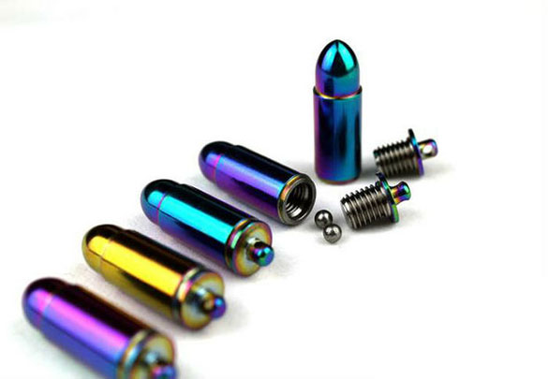
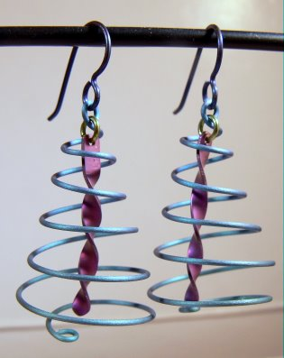

Anodising titanium
Anodising titanium is an interesting process in that the colours obtained are not due to dyes. Rather they are the result of interference caused by different thicknesses of oxide layer. Different voltages will give different thicknesses and hence different colours.
This version uses simple, cheap reagents (apart from the titanium itself) and can be finished in around 30 minutes.

You will need
Sheet of titanium | Shears to cut the titanium
Fine file for smoothing cut edges. | 250 cm³ beaker
Diet coke | DC power supply able to go up to 30V (or 3 9V batteries).
Wires and crocodile clips. | Aluminium foil
Brasso or other metal polish | Paper towel
tweezers

To Do

Preparing the titanium
- Cut your shape from the piece of titanium – leaving a small ‘tag’ where the crocodile clip can be attached.
- Smooth the edges with the file
- Clean both sides of your piece of titanium with brasso (or other metal polish) using paper towel.

Anodising the titanium
- Pour diet coke into the beaker to the required level.
- Attach a piece of aluminium foil to the negative electrode and dip into the liquid – secure it against the wall of the beaker with a paper clip or bulldog clip.
- Connect the piece of titanium to be anodised to the positive terminal on the power supply and suspend it in the diet coke.
- For a single colour, select 9V, 18V or 27V on your power pack (or use 1, 2 or 3 9V batteries - connected in series).*
- Switch on, or make the connection and leave the titanium object in the liquid for 10 - 15 minutes – take the titanium out and examine it. If the colour is not clear enough put it in for longer.
- Once finished, switch off the power supply or disconnect the batteries. Disconnect the anodised titanium and rinse with distilled water (Take care! The crocodile clips and liquid can get hot).

* For more interesting effects with more than one colour, Put the titanium into the acid all the way in when using the lowest voltage set-up (i.e. one battery). Raise the titanium out of the liquid about half a centimetre and adjust the set-up to give a higher voltage. Repeat and you should get stripes of increasing thickness of titanium oxide as you go down the titanium, giving different coloured stripes.

Safety
Other than the possibility of cutting yourself on the edges of the metal, this experiment is of low hazard.

