Chemical Investigations
Anodising Aluminium
Pupil Guide
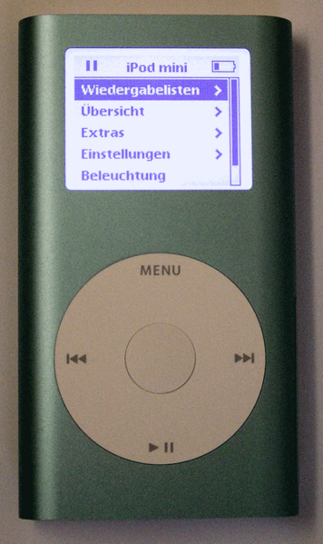
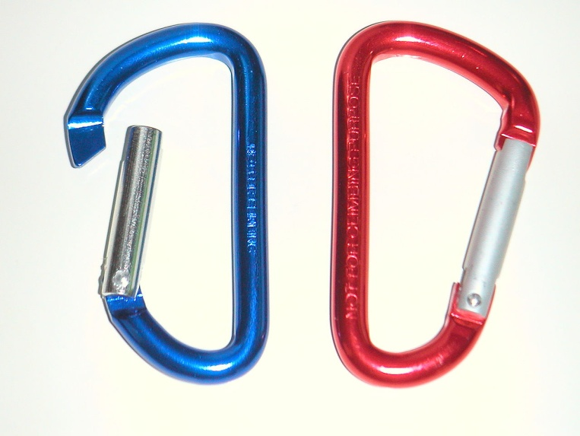

Background
Anodizing is an electrochemical process that converts a metal surface into a decorative, durable, corrosion-resistant, anodic oxide finish.
Anodizing is carried out by immersing the aluminium into an acid electrolyte bath and passing an electric current through it. The aluminium acts as the anode, and oxygen ions are released from the electrolyte which combine with the aluminium atoms at the surface of the part being anodized.
The aluminium oxide is not applied to the surface like paint or plating, but is fully integrated with the underlying metal, so it cannot chip or peel. It has a highly ordered, porous structure that allows dyes to be absorbed into the structure rather than just sitting on the surface.

You will need
Aluminium metal sheet or food ‘takeaway’ container | DC power supply, variable 0 to 16 V
2 x leads to connect to power supply with crocodile clips at the other end. | 10 cm square (max. 7 mm thick) piece of wood with two 4 mm holes drilled 5 cm apart
500 cm³ beaker | 1 mol l⁻¹ sulphuric acid
Industrial Methylated Spirits (IDA) 9The purple form is fine) | Various coloured dyes (clothes dyes, waterproof drawing ink)
Distilled water | Forceps or tweezers

To Do

Preparing the Aluminium Strip
- Cut out 2 strips, 2 cm x 6 cm, from an aluminium sheet or food container. Attach a crocodile clip to each of these.
- Clean and de-grease the aluminium strips by immersing in a beaker of Industrial Methylated Spirits (IMS) for about 1 minute.
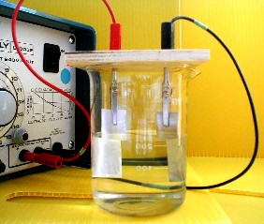
- Remove the aluminium strip from the IMS, handling the crocodile clips only. Once the aluminium has been so cleaned do not touch it. Rinse it with distilled water and use immediately.

Anodising the Aluminium Strip
- Add about 300 cm³ of 1mol l⁻¹ sulphuric acid to a 500 cm³ beaker. Aim to leave about 1 cm of the aluminium strip above the level of the acid and ensure the crocodile clips are kept out of the acid (Fig. 1 - opposite).
- Fit two, 4 mm test lead plugs through the holes in the square of wood and fit the crocodile clips holding the aluminium strips to these. Taking care not to touch the strip to be anodised, place the assembly in the beaker of acid.
- Connect the aluminium strip to be anodised to the positive terminal on the power supply.
- Turn on the power supply and adjust to 15 V. An aerosol of acid may be produced but, if this does occur, the ‘wooden lid’ will contain it. Leave running for 30 minutes.
- Prepare the dyes for use. The dyes work best if they are hot but not boiling! So start warming them up before you stop the anodising process.
- After 30 minutes switch off the power supply. Disconnect the anodised aluminium strip and rinse with distilled water (Take care! The crocodile clips and acid can get very hot).
- Place the anodised aluminium in the hot dye solution for about 10 minutes, moving it every minute or so. Then, using tweezers, remove the aluminium from the dye solution and wash it under a running tap to remove any excess dye. Drop the aluminium into a beaker of boiling water and leave for 10 minutes to seal the dye.
To obtain the best results use fresh sulphuric acid for each strip of aluminium to be anodised.

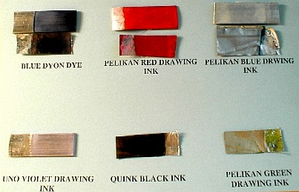
Results
We found that Dylon clothes dyes (one tin in 250 cm³ of water) and Pelikan and Uno waterproof drawing inks (slightly diluted) worked well. The best colours were blue, purple and red. We also managed to produce a navy-blue effect using black Quink ink.

Safety
Wear eye protection and work in a well-ventilated laboratory. Ensure any acid aerosol produced during the anodising process is contained or work in a fume cupboard.

