Microscale Chemistry
Ion migration
Pupil

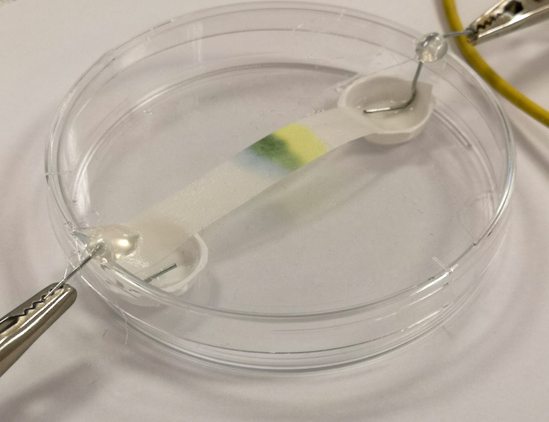

Introduction
A demonstration to show the movement of coloured ions when an electric current is applied has been around since at least the 1960s.
The experiment used copper chromate as this contains both brightly coloured cations (copper – blue) and anions (chromate – yellow). This version is smaller scale still and safer – as the whole process takes place inside a Petri dish.
Health & Safety
The ammonia electrolyte and the chromate solution should be added in the fume cupboard to avoid exposure to ammonia. The covered Petri dish can then be taken back to the bench where the rest of the experiment can safely be carried out.
You will need
1 prepared petri dish | copper chromate solution
Electrolyte (2% ammonium chloride in 2 mol l⁻¹ ammonia | Power supply or 9v battery plus connecting leads
Pasteur pipettes | Filter paper
Scissors

The experiment
Preparation
- Cut a piece of filter paper narrower than the blisters and long enough to stretch across the Petri dish.
- Prepare your ammonium chloride/ammonia electrolyte if you have not already.
Method
- Place your filter paper so it spans the Petri dish with the two ends in each of the blisters – adding 1 drop of water at each end will make the paper easier to push into the blisters.
- Add 1 drop of your copper chromate mixture to the middle of the filter paper
- Add 10 drops or so of the electrolyte to each of the blisters and one or 2 along the length of the strip of filter paper. Just enough that it is all damp but not soaking.
- Place the prepared lid with its electrodes on top of the petri dish – making sure the 2 paper-clip electrodes are in fact touching the electrolyte.
- Connect the 2 electrodes to your power pack or battery and wait.

The setup should look something like this
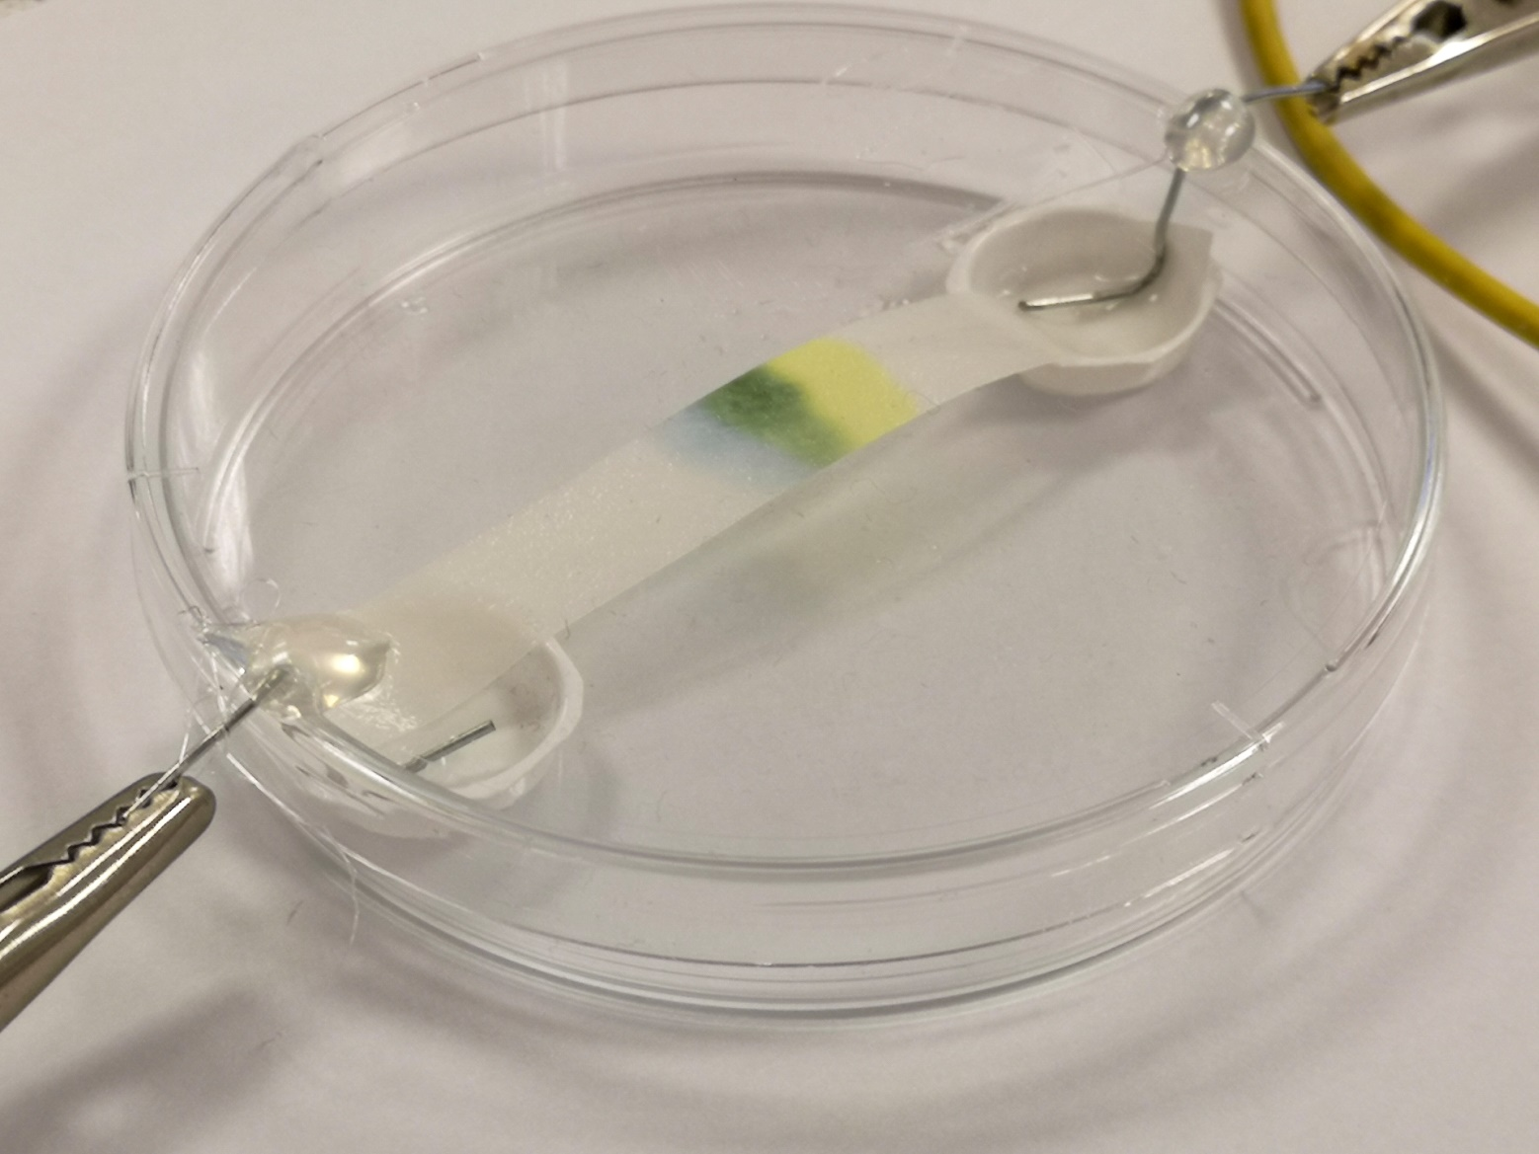
Results
After a few minutes you should see the colours starting to separate.
It will take about 15 minutes, however, to get a good separation – as in the image above.
You will see that the blue copper ions, which are positive, have moved towards the negative electrode, while the yellow chromate ions, which are negative, have moved towards the positive electrode.
What is happening?
Mixing copper sulphate and potassium chromate in solution creates copper chromate. This is a brown solid that is practically insoluble in water. The precise chemical nature of this precipitate does not appear to be straightforward.
Mixing the solids in concentrated ammonia, however, releases the ions, forming
tetraammino copper ions. [Cu(NH₃)₄]²⁺ As well as being more soluble, they are a darker blue colour that is easier to see. ions and chromate ions and
Chromate CrO₄.²⁻ ions. (in alkaline conditions, dichromate (Cr₂O₇) becomes chromate CrO₄)
The solution is in fact a very dark green which you can see if you hold it up to the light. This is merely an optical effect from the mixture of the blue copper and the yellow chromate.
Being soluble, these can move in solution – towards the opposite charge.

