Microscale Chemistry
The chemistry of sulphur dioxide

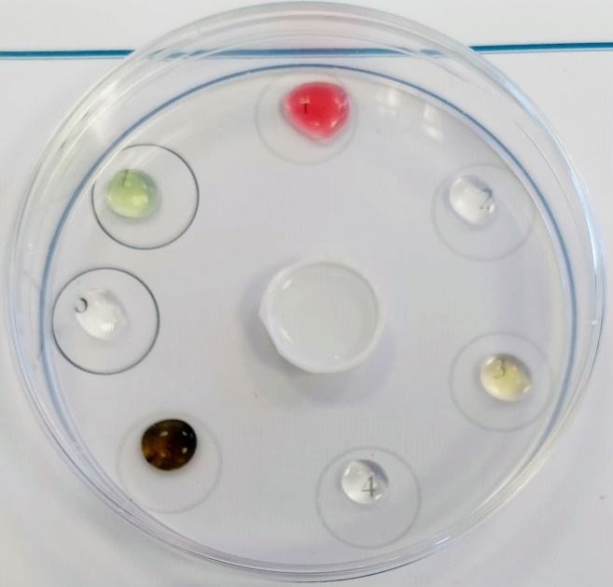

A simple method for investigating the reactions of ammonia. Using a technique which can be applied to many other reactions.
CfE Level 3
Through experimentation, I can identify indicators of chemical reactions having occurred. I can describe ways of controlling the rate of reactions and can relate my findings to the world around me.
SCN 3-19a
National 5 – Chemistry in Society
Fertilisers
Introduction
Sulphur dioxide dissolves in water readily to produce an acidic solution (of sulphurous acid, HSO₃). It is unusual as an acidic gas in that it can act as either a reducing agent or an oxidising agent.
Health & Safety
- Wear eye protection.
- Sulphur dioxide gas is toxic and corrosive – work in a well-ventilated area
If all the sulphur dioxide were to be released, which it isn’t due to high solubility in solutions and the containment, each dish would release 15 cm³ of gas.
While harmful if sniffed directly, when dispersed in the room, it would take 6 or more to breach the Workplace Exposure Limit.
So as long no one, or very few, open their Petri dishes at the end of the experiment – except in a fume cupboard, there is no significant hazard.

Each pupil will need
2 x petri dishes | Laminated reaction sheet – or non-laminated inside a plastic wallet.
Sodium sulphite solution (1.6g in 10 cm³) | 1mol l⁻¹ hydrochloric acid
Universal indicator solution (or paper, damp) | Potassium manganate(VII) (0.001 mol l⁻¹)
Blue food dye (diluted) | Iodine solution
Potassium iodide 0.1 mol l⁻¹ | Potassium iodide/iodate(V) 0.1 mol l⁻¹
Ammonium vanadate solution 0.1 mol l⁻¹ | Hydrogen peroxide (20 vol)
Small watch glass or ‘blister’ from tablet pack | 1 cm³ Pasteur pipettes

Instructions
- If not already laminated, place the reaction sheet in a plastic wallet/folder.
- Place two 9 cm diameter Petri dishes on the thick (blue) circles on the sheet. Remove the lid.
- Place 2-3 drops of the test solutions/papers in the Petri dishes in the numbered positions, 1 – 7, as described below.
(one of the dishes is the control to allow you to see the colour changes more clearly)
  - Universal indicator solution – or a damp piece of indicator paper - 1-2 cm
  - Potassium manganate(VII) (0.001 mol l⁻¹)
  - Blue food dye, dilute
  - Iodine solution
  - Potassium iodide, 0.1 mol l⁻¹
  - Potassium iodide / potassium iodate(V), 0.1 mol l⁻¹ of each (mixed)
  - Ammonium vanadate solution 0.2 mol l⁻¹
- Place an empty ‘reaction vessel’ (eg, small watch glass) in the ‘RV’ circle in the upper petri dish.
- To generate the sulphur dioxide gas
Put 5 drops of sulphite solution in the reaction vessel (gas generator). Add approximately 5 drops of 1 mol l⁻¹ hydrochloric acid solution to the reaction vessel. Immediately place the lid on the Petri dish.
- Watch carefully and record your observations over the next 5-10 minutes (eg, take photographs).
- Explain as much of the chemistry going on in the Petri dish as you can.

Disposal: put petri dish in a bowl of water, without opening it. All the gas will dissolve in the water. Wash solution to waste with cold running water.
TIP
If you place the control petri dish upside-down: put the drops in the lid and then put the ‘base’ on top, you get less ingress of SO₂ leaking from the experimental dish next to it and changing the colour of the indicator.
Results and explanation
Adding acid to the sodium sulphite released sulphur dioxide.
2 HCl + Na₂SO₃ → SO₂ + 2 NaCl + H₂O
- Universal indicator – goes red
SO₂ + H₂O → H₂SO₃ (H₂SO₃ H⁺ + HSO₃⁻)
- Potassium manganate(VII) (0.001 mol l⁻¹) goes from purple to colourless
The sulphur dioxide is reduced by KMnO₄
5 SO₂ + 2 MnO₄⁻ + 2 H₂O → 2 Mn²⁺ + 5 SO4²⁻ + 4 H⁺
- The blue food dye goes from blue to colourless
This is due to the dye molecule being reduced to its reduced form which is colourless.
- Iodine solution goes from yellow to colourless
I₂ + SO₂ + 2H₂O → 2HI + H₂SO₄
- Potassium iodide solution – no change
- Potassium iodide/iodate solution goes from clear (possibly pale yellow)to dark red as the acid facilitates the iodate reaction with iodide to produce elemental iodine.
IO₃⁻ + 5 I⁻ + 6 H⁺ → 3 I₂ + 3 H₂O
Although the iodine is theoretically reduced by the SO₂, in reality this process is too slow to remove the iodine quickly enough.
- Ammonium vanadate changes from yellow to green and then blue
SO₂ reduces the vanadium from V⁵⁺ (yellow) to V⁴⁺ (blue). The green colour is a physical effect due to the mixing of yellow and blue.

Sample results
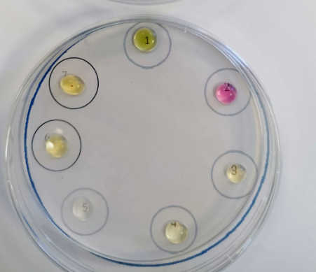
Before After

Extensions / alternatives
Bromine water – this can be used as well as or instead of iodine – it too is decolorised by the sulphur dioxide.
Potassium dichromate (instead or as well as the vanadate) – the yellow/orange dichromate(VI) is reduced by the SO₂ to green Cr(III)
Experiment  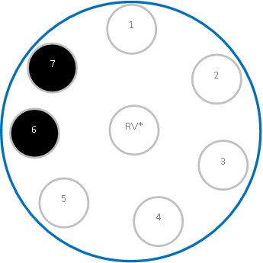  7  6  Control | Sulphur dioxide chemistry
Wear eye protection. Work in a well-ventilated lab.

- If not already laminated, place this sheet in a plastic wallet/folder.
- Place 2 x 9 cm diameter Petri dishes on the two blue circles (left). Remove lids.
- Place 2 – 3 drops of the test solutions/papers in both Petri dishes in the numbered positions, 1 to 7 as described below.
- Universal indicator solution
- Potassium permanganate.
- Blue dye.
- Iodine solution
- Potassium iodide, 0.1 M
- Potassium iodide / potassium iodate(V) 0.1 M
- Ammonium metavanadate solutions 0.2 M
- Place an empty ‘reaction vessel’ (eg,) in the ‘RV’ circle.
- To generate sulphur dioxide gas (TOXIC): place 5 drops of sodium (or potassium) sulphite IV to the gas generator). Add approximately 5 drops) of 1.0 M hydrochloric acid to the reaction vessel. Immediately place the lid on the Petri dish.
- Watch carefully and record your observations over the next 5-10 minutes (eg, take photographs).
- Explain as much of the chemistry going on in the Petri dish as you can.
- Disposal: put petri dish in a bowl of water. Wash solution to waste with cold running water.
3
4
5
7
RV*
2
1
6
6
7

