Experiment  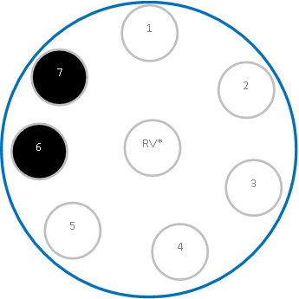  7  6  Control | Sulphur dioxide chemistry
Wear eye protection. Work in a well-ventilated lab.

- If not already laminated, place this sheet in a plastic wallet/folder.
- Place 2 x 9 cm diameter Petri dishes on the two blue circles (left). Remove lids.
- Place 2 – 3 drops of the test solutions in both Petri dishes in the numbered positions, 1 to 7 as described below.
- Universal indicator solution
- Potassium permanganate 0.001 mol l⁻¹
- Iodine 0.1 mol l⁻¹ .
- Ammonium metavanadate solutions 0.1 mol l⁻¹
- Potassium dichromate 0.1 mol l⁻¹
- Barium chloride 0.1 mol l⁻¹
- Barium chloride 0.1 mol l⁻¹ + 1 drop of 20 vol H₂O₂
- Place an empty ‘reaction vessel’ (eg,) in the ‘RV’ circle.
- To generate sulphur dioxide gas (TOXIC): place about ½ a small spatula tip of sodium (or potassium) sulphite IV (or any of the various bisulphites and similar) in the blister pack). Add 0.5 cm³ (approximately 10 drops) of 0.5M sulphuric acid to the reaction vessel. Immediately place the lid on the Petri dish.
- Watch carefully and record your observations over the next 5-10 minutes (eg, take photographs).
- Explain as much of the chemistry going on in the Petri dish as you can.
- Disposal: put petri dish in a bowl of water. Wash solution to waste with cold running water.
3
4
5
7
RV*
2
1
6

