Microscale Chemistry
Reduction of copper oxide with hydrogen

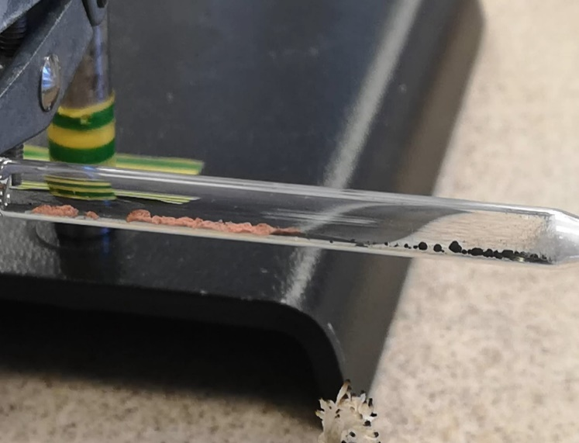

Curriculum links
National 5 - Chemistry in Society
Metals

CfE Higher - Chemistry in Society
Oxidising or reducing agents
Introduction
The reduction of copper oxide to metallic copper by hydrogen gas has been a popular chemistry experiment for generations.
It is not without its problems however. Hydrogen is extremely flammable and explosive over a wide range of concentrations. A common problem is that the air in the apparatus is not properly flushed out so that an explosive mixture remains which is detonated when a flame is applied to the end to burn off the excess hydrogen.
This microscale method uses a small amount of hydrogen only and in a very small space so there is no danger of explosion.
Health & Safety
Wear eye protection.
You will need
1 x glass pasteur pipette | Spirit burner
Copper II oxide | Mineral wool
Micro spatula | 50 cm³ Luer lock syringe and cap
Source of hydrogen | Short length of silicone tubing
Clamp and stand

Preparation
Fill the syringe with hydrogen gas and put the cap on. The gas will slowly diffuse through the walls of the syringe but it is definitely a slow process. The syringes of gas will certainly last several days, commonly a week or more.
To Do
Wear eye protection
- Put a small plug of mineral wool into the barrel of the pasteur pipett. and push it down to the narrow end.
- Holding the pasteur pipette horizontally, use a microspatula to add a small amount of copper oxide. By tapping and possibly pushing, you should aim to get the copper oxide piled up along the barrel of the pipette.
- Attach the length of silicone tubing to the end of the pasteur pipette and fix the assembly in a clamp, still horizontal.
(See diagram on the next page)
- Use your spirit burner to heat the copper oxide for 2 – 3 minutes.

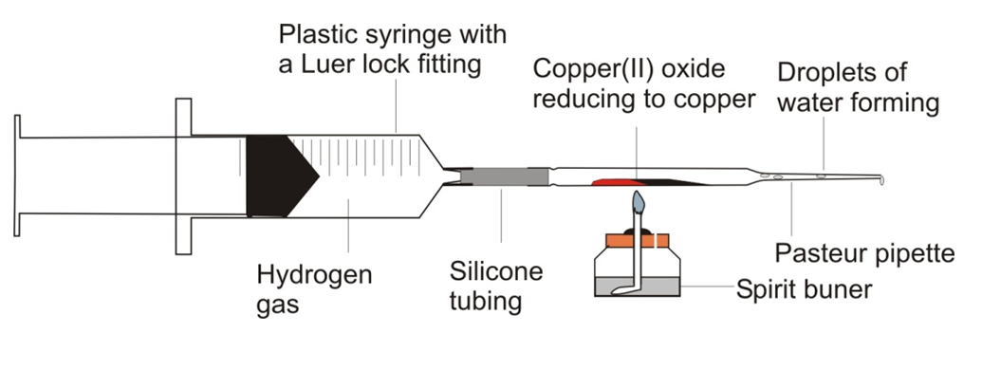
- Blow out the spirit burner, take the cap off the syringe of hydrogen and fix it to the other end of the silicone tubing – it should sort of screw in.
- Steadily depress the plunger. This will send a stream of hydrogen gas over the hot copper oxide. You should see a glow in the copper oxide and water vapour appearing at the other end. You should also see red, metallic copper appearing in the barrel of the pipette.

Hints
Copper oxide is often “damp”. Heat the oxide in a borosilicate test-tube first and then allow it to cool before using it in the reduction experiment.
The same approach can also be used for the reduction with hydrogen of:
lead(II) oxide,
iron(III) oxide,
cobalt(II) oxide
nickel(II) oxide (Nickel compounds are carcinogenic – this one should only be done by the teacher in a fume cupboard)
These reactions are not noticeably exothermic and the flame needs be kept on. The products of the iron, nickel and cobalt oxide reductions are magnetic!

