Chemical Demonstrations
A spectacular reversible reaction
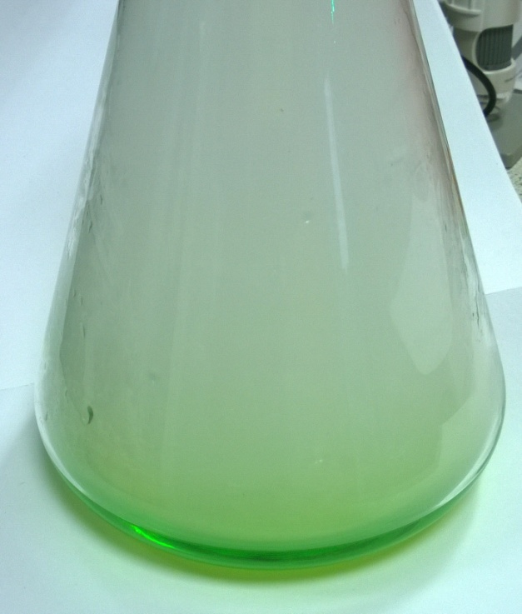
This reaction can be applied to curriculum for excellence.
Through experimentation, I can identify indicators of chemical reactions having occurred ...
SCN 3-19a
New (CfE) Higher – Chemistry in Society
Oxidising or reducing agents

Introduction
When concentrated hydrochloric acid is added to a very dilute solution of copper sulphate, the pale blue solution slowly turns yellow-green on the formation of a copper chloride complex. When concentrated ammonia solution is added, copious quantities of white smoke are produced, heat is generated and the yellow-green complex turns into a very dark blue copper ammonia complex. The reaction can then be reversed by adding more acid.
You will need
Two-litre conical flask | 100cm³ 0.2 M copper sulphate
100cm³ concentrated ammonia solution | 100cm³ concentrated hydrochloric acid

Preparation
You must be very careful when you add the acid to the ammonia because very large quantities of ammonium chloride smoke are produced which quickly fill the room. Carry out the experiment near fume cupboard or an open window (with air going out rather than in!)
To Do
- Pour the copper sulphate solution into the conical flask.
- Slowly add the acid down the side of the flask and swirl vigorously. (It will take around 30 cm³ to form the green complex).
- Carefully add the ammonia in the same way but initially without swirling.
- Wait and show the students the colour change.
- Continue to add the ammonia with gentle swirling as the colour eventually changes to dark blue. (This will take around 25 – 30 cm³ to form the deep blue complex)
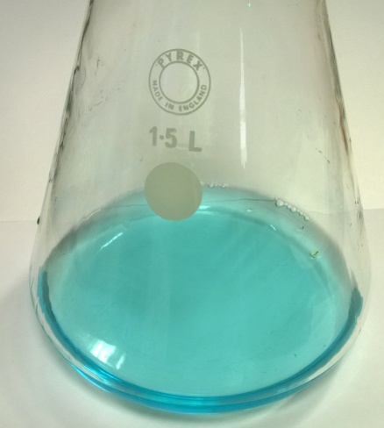
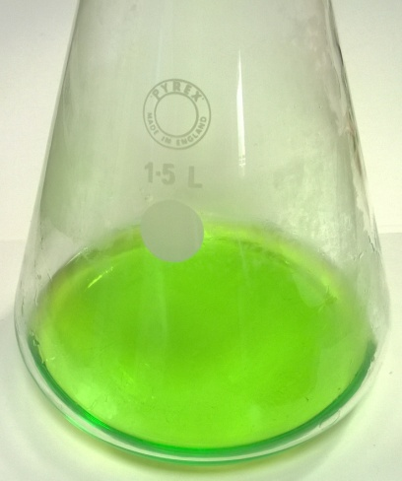
- Reverse the reaction by adding acid in a similar fashion to the ammonia. (For this step and subsequent reversals only around 5cm³ of acid or ammonia will be needed).
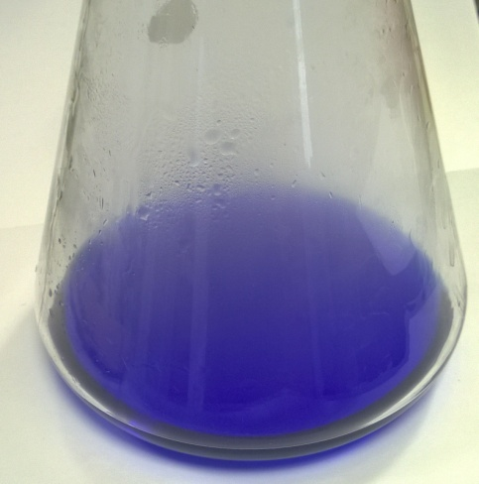

Safety
Small amounts of dilute copper sulphate solution can be flushed down a sink with a large quantity of water, unless local rules prohibit this.
Concentrated ammonia is corrosive and on contact with skin may cause burns.
Concentrated solutions can give off dangerous amounts of ammonia vapour. This presents a significant hazard if inhaled.
Concentrated hydrochloric acid contact with the eyes or skin can cause serious, permanent damage. It is also a respiratory irritant - the concentrated solution releases dangerous quantities of hydrogen chloride vapour.
Both ammonia and hydrochloric acid should be diluted before disposal down a sink.
Special tips
A significant amount of heat is generated but this has not been a problem. The demonstrator should point the mouth of the flask away from him/herself and the students in the unlikely event that the solution spits out.
The trick with this demonstration is doing it on a large enough scale for the whole class to see clearly. The white smoke should be allowed to escape and not distract from the colour change.
Swirl the flask when necessary to produce a homogenous mixture. It is possible to produce a mixed solution with the yellow-green complex on the bottom, the dark blue complex on the top, and with the pale blue copper hydroxide precipitate at the interface of the two layers.
Teaching points
This demonstration can be used as an introduction to reversible reactions in N4/5 and for equilibrium at higher and also as an example of entropy changes in solution.
However, it is best used as an opening for complex chemistry in Andvanced Higher.
A complex ion has a metal ion at its centre with several other molecules or ions surrounding it. These can be considered to be attached to the central ion by coordinate (dative covalent) bonds. These molecules or ions are called ligands and all have the same common feature: a pair of non-bonding (lone pair) electrons. By donating a pair of electrons, ligands act as Lewis bases.
Copper has the electronic structure: 1s²2s²2p⁶3s²3p⁶3d¹⁰4s¹. To form a Cu²+ ion a copper atom loses the 4s electron and one of the 3d electrons, leaving it with the electronic structure: 1s²2s²2p⁶3s²3p⁶3d⁹. When copper sulphate dissolves in water, the water molecules act as ligands, producing the complex ion [Cu(H₂O)₆]²+. When concentrated hydrochloric acid is added, ligand exchange occurs:
[Cu(H₂O)₆]²⁺ + 4Cl⁻ [CuCl₄]²⁻ + 6H₂O
The empty 4s and 4p orbitals are used to accept a lone pair of electrons from each chloride ion. In this case, the coordination number of the copper changes from six to four. When concentrated ammonia is added, further ligand exchange occurs:
[CuCl₄]²⁻ + 4NH₃ [Cu(NH₃)₄]²⁺ + 4Cl⁻
Copper can have coordination numbers of four, five and six, though the shape is often described as square-planar. However, the distinction between square-planar and tetragonally-distorted octahedral coordination is not easily made. (You will have to refer to advanced texts on the Jahn-Teller effect to explain.) The usual result is an elongation of the octahedron (four + two) coordination with complete loss of the axial ligands resulting in square-planar complexes. This is the normally accepted structure for tetrammines. These are relatively easily to prepare and isolate. Hexammines can be made from liquid ammonia and stored in an atmosphere of ammonia. Six coordination is normally more easily achieved using chelates such as edta.
Depending on the cation, [CuCl₄]₂⁻ displays structures ranging from square-planar (NH₄⁺) to almost tetrahedral (Cs⁺), the former being usually green and the latter orange in colour.

In this series, Colin Baker of Bedford School provides spectacular demonstrations, designed to capture the student's imagination. The demonstrations are easy to prepare, safe to dispose of and they work. In this issue: a spectacular reversible reaction

