

**Making your Wave Turbine**

The following diagrams show the construction of the turbine. It uses 5 litre bottles.

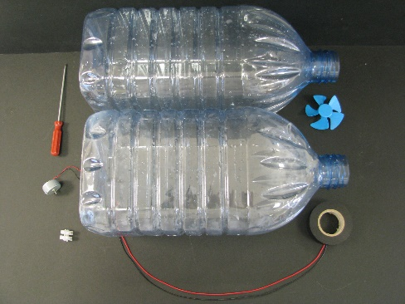

1. What you need
2. Cut the base off one of the bottles with the scissors.

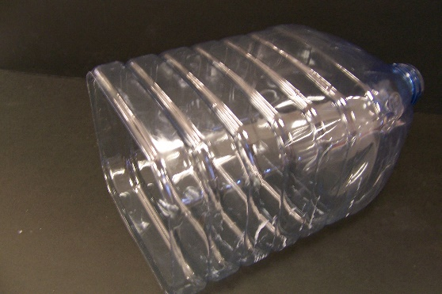

1. Now use the hot cork borer to burn two (2) holes in each side of the s**econd** bottle at the approximate distances shown from the base to the centre of the holes, giving eight (8) holes in total. This is to allow air to re-enter the bottle on raising it in the water.

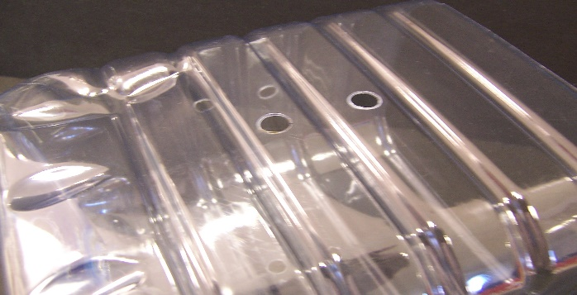





1. Now take this second bottle and cut the neck off at the approximate distance shown from the neck to the cut.

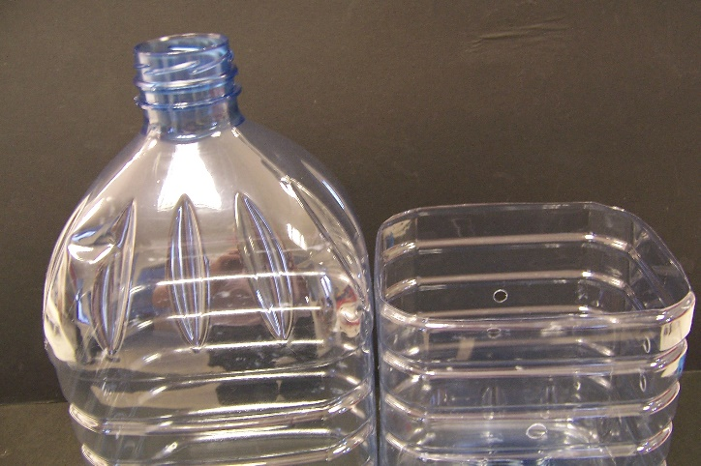



1. Using the motor as a template, mark its outline on the base of this second bottle. Then use a hot wire or similar to burn out a hole in the centre of the base which the motor will fit into. (ensure there is a snug fit).

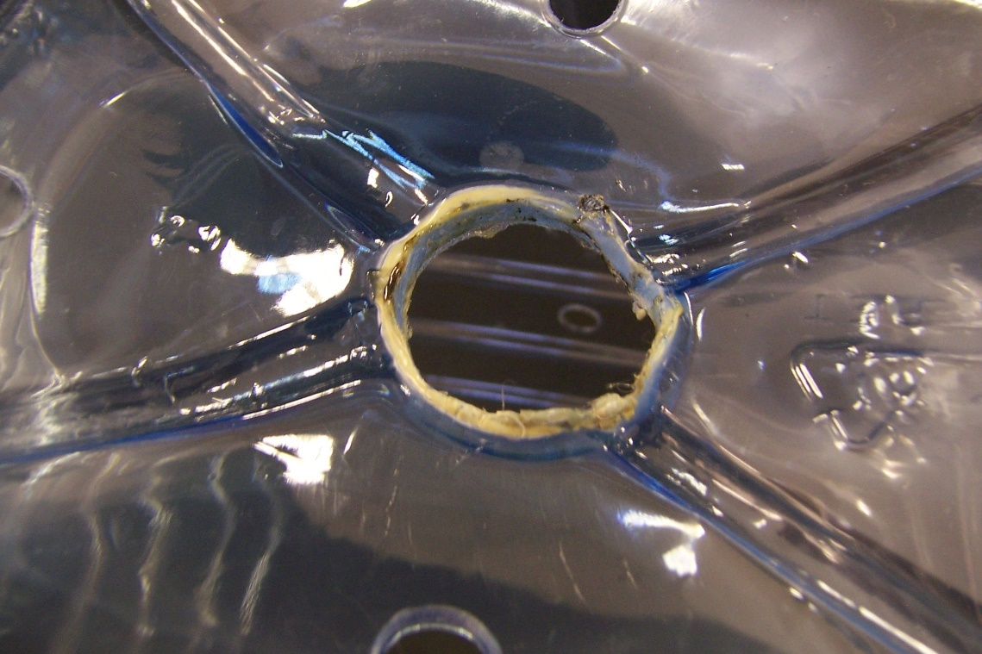

1. Also burn four (4) holes in the base as shown using the hot cork borer.

These are approximately 2 cm in from the edge

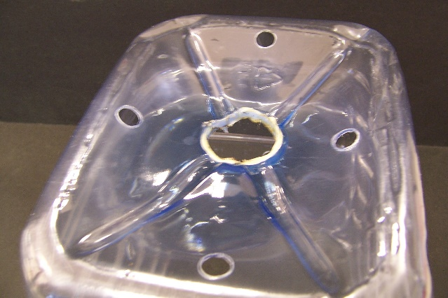

These holes in 3&6 allow air

to escape on the down-thrust

and help air to enter on the

up-thrust.

1. Wrap one layer of insulating tape round the solar motor and insert it into the hole with the spindle inside the bottle. This can also be taped or siliconed into position to make it more secure.

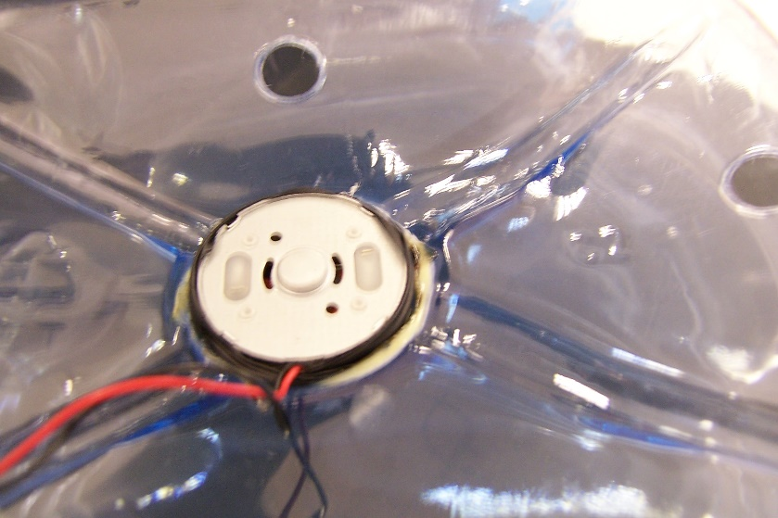

1. Insert a blue fan on the spindle of the motor

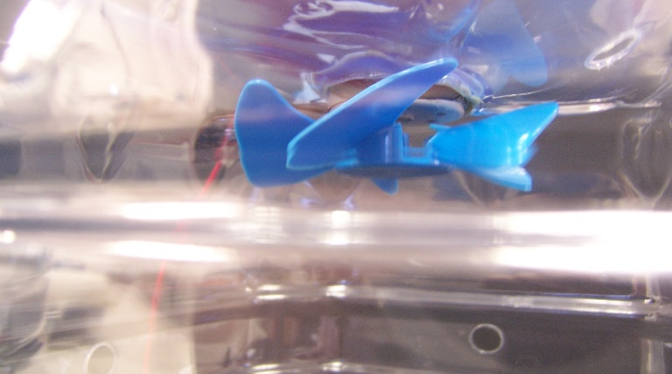

1. Use the connector block to connect the wires from the motor to the 40 cm lengths of wire. Also tape the wires from the motor and the other wires to

the side of the bottle. This helps stop the connections breaking during use.

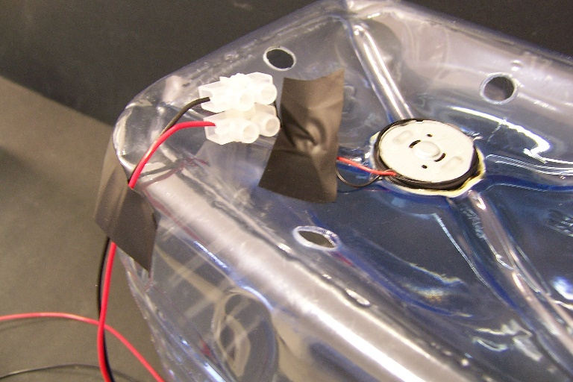

1. Lower the bottle with the motor over the other bottle and tape the two together.

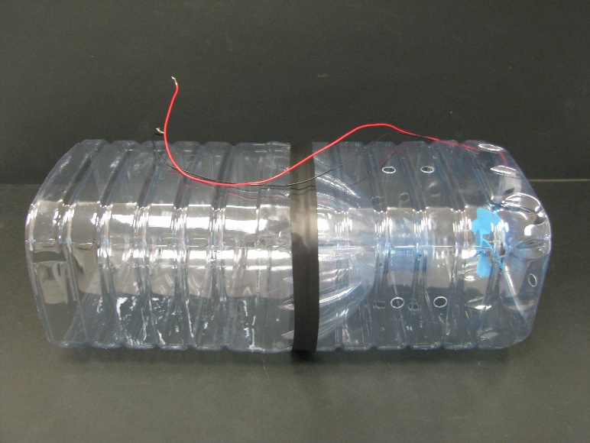

1. Connect the other ends of the wire to a multimeter set at the 2V or 20V scale.
2. Fill a bucket or sink with water to a maximum depth of 14-15 cm. Check this level does not cause water to splash onto the motor and adjust as needs be.

You can place some tape on the inside of the sink or bucket at the maximum depth to help students. The experiment is ready!

Place the generator in the water and raise and lower it. Check the fan turns and produces electricity.

Turbines with different numbers of blades can be made for pupils to see if they have any effect on the voltage produced. E.g. it is possible to buy small 2-bladed and 4 bladed propellers.