Making your Turbine
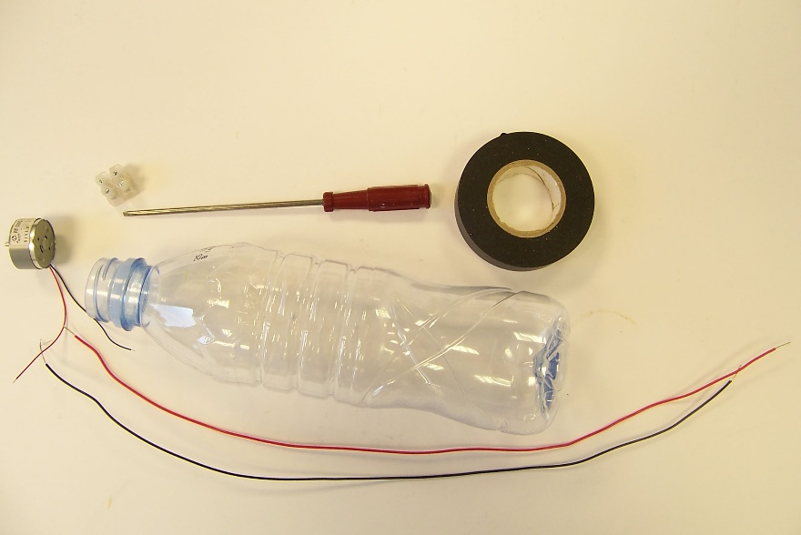
Insulating tape
screwdriver
Connecting block
Solar
motor
Thin wires 40 cm long

Plastic Evian water bottle

- Take the two long wires and push one through each of the holes in the base so they stick out the neck of the bottle.

- Wrap one layer of insulating tape round the solar motor.
(This gives it a good snug fit in the neck of the bottle)

- Attach the wires from the motor to one side of the connecting block.

- Attach the long wires from the neck of the bottle to the other side
of the connecting block.
Wrap some insulating tape around the block.

- Push the motor into the neck of the bottle, ensuring a good fit.

- Carefully feed the two wires out from the centre of the base in the grooves in the base of the bottle.

- Tape the wires in place with insulating tape.

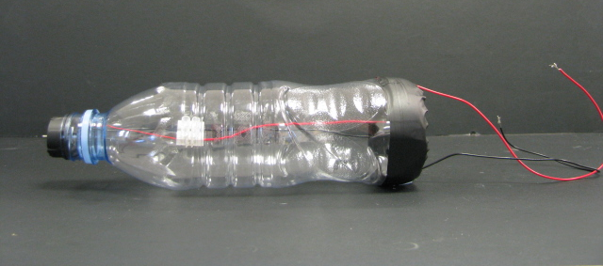

Your turbine is complete

