Fact Sheet – Hydro Power

The world’s leading form of renewable energy!

Small scale hydro power can be done with a water height of just
a few metres; but the best drop from top to bottom is around 120m. They only need small reservoirs compared with large projects, and often can be completed much more quickly.

Micro hydro plants just use the water flowing in a stream or river.

In both cases, some of the water is fed down a pipe or channel. This then turns the blades of a turbine which is connected to a generator. This produces electricity. The water then flows back to the river.
Hydro is usually the cheapest of all electrification options for isolated communities, where hydro resources exist. Unlike wind turbines and PV, hydro power can potentially generate electricity 24 hours a day. It is a proven and reliable technology.

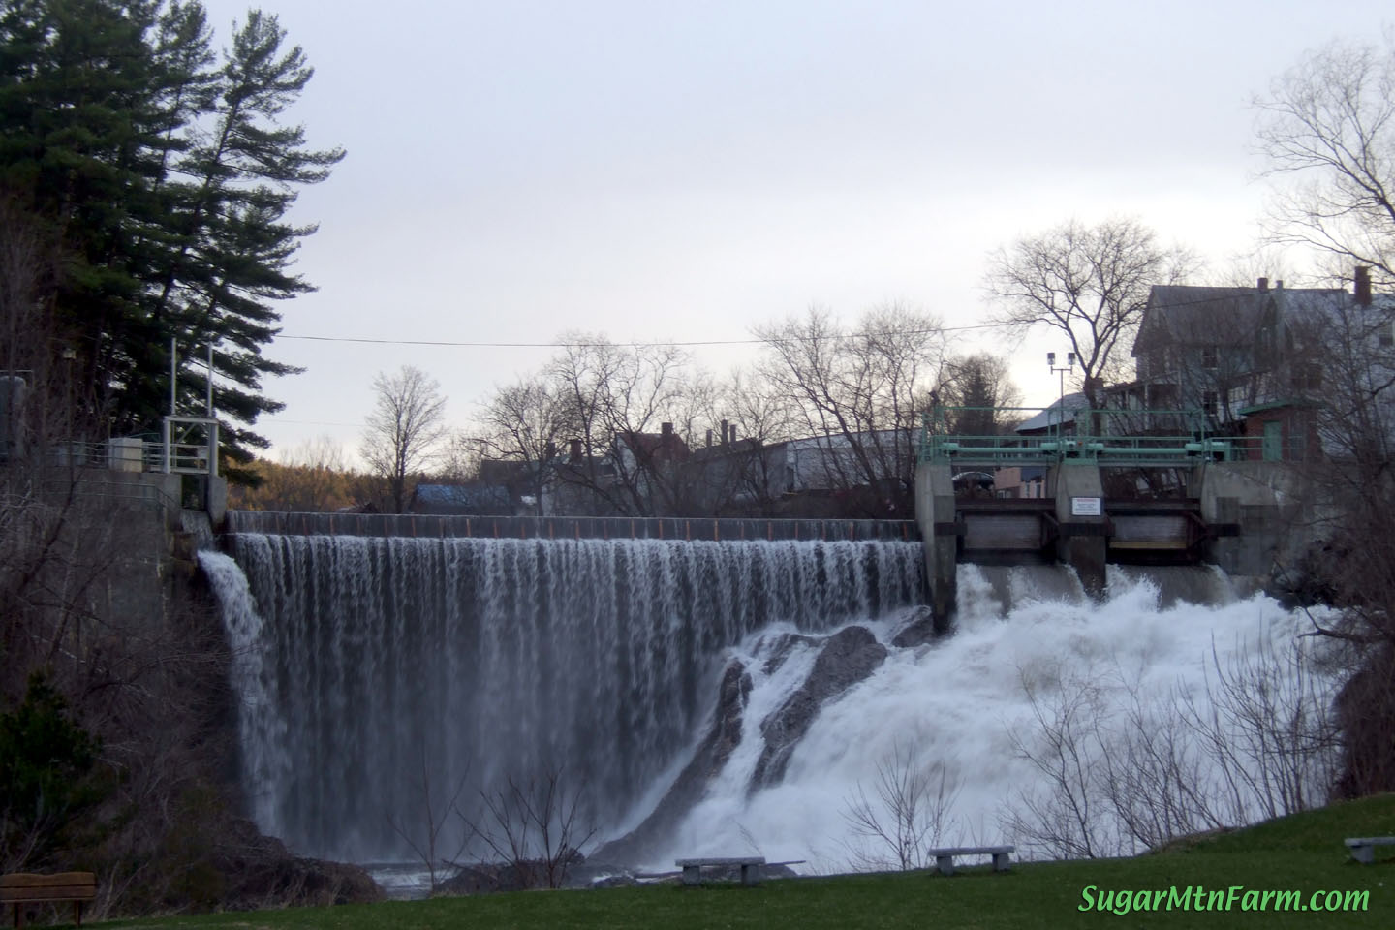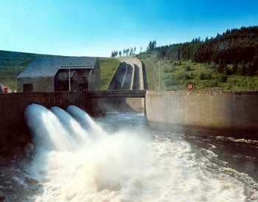

www.tynax.com

One small hydro plant A 7 Megawatts that can power 3000 homes
costs £7 million to install

-

One micro hydro plant From
A 0.025 Megawatt plant that can power 12 or so homes
Cost = £170,000 to install
a 0.5 Megawatt plant that can power around 250 homes
cost = £1.6 million to install

Does hydro power affect tourism?
There is no evidence to suggest this although walkers may find some areas flooded and therefore no longer accessible.

How big are they?

The size will depend on the width of the river or stream used and how much electricity must be generated.

How safe is hydro energy?
Hydro energy is very safe and non-polluting.

What are hydro power stations made of?
Steel and concrete.

Are hydro stations noisy?
Unfortunately there are visual and noise issues with hydro, but these can be very easily reduced.

Does hydro power affect animal life?
They are generally designed to use part of the river flow, which goes back to its original course only few hundreds meters down river, therefore causing minimal or no damage to living species.
Small fish ladders may have to be constructed.

Does hydro power affect the environment?
Small hydro schemes are environmentally friendly; because they are usually built using simple structures with only small changes to the watershed conditions. Care has to be made not to divert the flow of the river more than necessary for the system, and certainly no more than that with which the river's ecology can cope. Small hydro is a clean energy option and generates neither heat nor greenhouse emissions.

Fact Sheet – Solar Power

Photo-Voltaic (PV) panels work even when it’s cloudy!

Solar energy is a renewable, sustainable resource. Sunlight is free. The light energy from the Sun falls on these special panels and is converted directly into electricity.

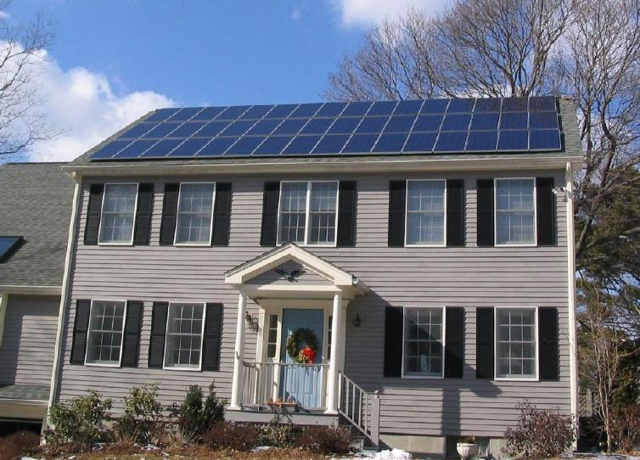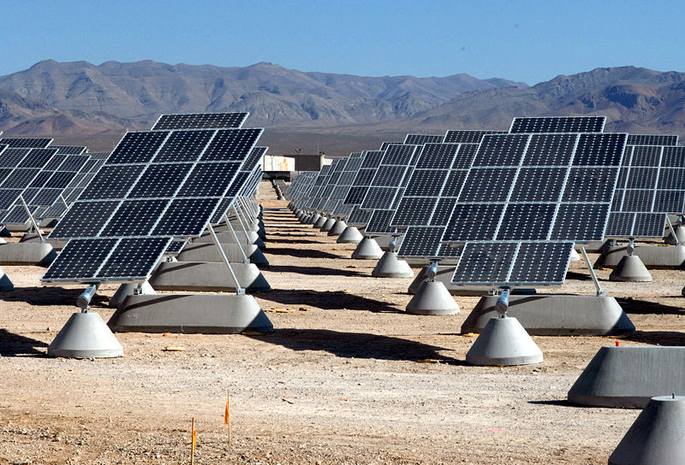
In rural areas ground-mounted PV systems are more common.

PV technology is ideally suited to use on buildings where it gives pollution and noise-free electricity without using extra space.

The DC power produced by the panels is converted into alternating current to power lights etc.
Except for the processes involved in manufacturing the materials, solar energy does not give off any harmful substances.

PV panels one panel set up for just one home using 4 kW (quite high usage)
Cost = around £6,000
A 200kW solar panel system of 800 solar panels (enough for about 40 homes)
Cost = around £180,000 but will depend on the mains supply capacity.

solar panel prices are 70% cheaper than in 2010 and will probably continue to fall

Other considerations
- Strength of roof if to be placed on a building.
- Area required if to be placed in a big bank of panels.

While far from perfect, the technology required to use solar radiation as energy to produce electricity already exists and small solar power systems are easily installed.
The systems are very low maintenance: they have no moving parts (except for fans and pumps, for example) and can last for over 40 years. However, the initial costs for components can be high.

Do Solar Panels affect tourism?

There is no evidence for this.

What are PV panels made of?
A PV array is made from a number of solar cells. A cell consists of layers of silicon, a semi conducting material.

How big are they?
The size of the array is determined by the number of solar cells joined together. This can be adjusted to suit the electricity needs of the building or area.

What happens when the sun stops shining?
It does not have to be very hot and sunny for solar panels to produce electricity, just light. However, solar power’s natural enemy is shade (from trees and other buildings). This reduces the power obtained. The system also requires batteries to store power for use at night when there is no light from the Sun.

Electricity from the National Grid could also be used.

Are PV arrays noisy?
Solar modules are silent and generate no greenhouse gases.

How popular is solar energy?

People generally accept the idea of PV's as nonpolluting,
"free" electric power from the sun. An average house in the UK would save about 1.2 tonnes of carbon dioxide emissions per year if using a solar array to produce electricity.

Fact Sheet – Wave power

Wave and tidal power could supply a fifth of UK energy needs!

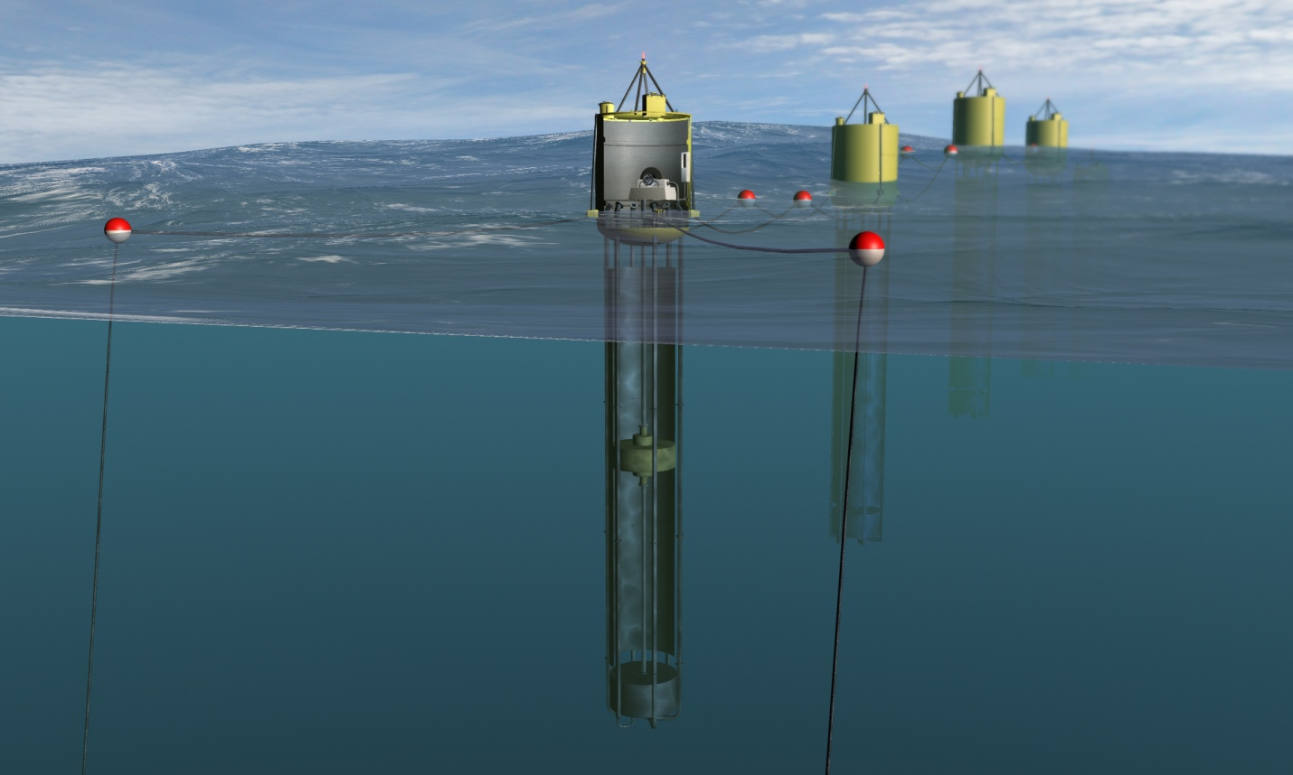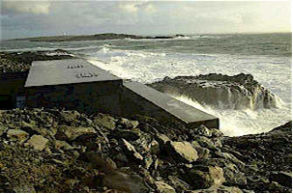At a wave power station, the waves make the water in a chamber rise and fall. This forces air in and out of a hole in the top of the chamber. A turbine is placed in the hole and this is turned by the air rushing in and out. The turbine turns a generator which produces electricity.

Picture Courtesy of Finavera
Picture Courtesy of Wavegen

Wave power can be onshore or offshore.
Both types require an average wave height of at least 2 metres.

With permission from http://www.finavera.com/

One onshore station: - costs £10 million
- generates 0.6 Megawatts
- can power 250 homes
- requires an (onshore) area of
0.1 square kilometres

One offshore station: - costs £40 million
- generates 2.4 Megawatts
- can power 1000 homes
- requires an (offshore) area of 0.5 square kilometres
- can cause reduced wave height in the surrounding seas

What are wave stations made of?

Steel and concrete.

Does wave power affect tourism?
A floating buoy system or an offshore platform placed many kilometres from land is not likely to have much visual impact
(nor will a submerged system). Onshore facilities and offshore platforms in shallow water could, however, change the visual landscape from one of natural scenery to industrial and have an adverse affect on tourism.

What happens when the sea is calm?
The wave power stations will be sited at places where there are always waves. This limits where they can be placed but since there will always be waves reaching them; this is a sustainable method of generating electricity.

How safe is wave energy?
Wave energy is very safe and non-polluting.

Are wave turbines noisy?
Unfortunately the rushing air can be very noisy, unless a
silencer is fitted to the turbine. The waves themselves also
make quite a bit of noise.

How big are they?
The chamber is about 10 m x 10 m. Probably a single device
long-term is not going to be cost-competitive with fossil power. But placing a number of them along a breakwater will significantly reduce the cost of the electricity.

Do wave turbines affect marine life?
Off shore power stations could damage the sea-bed and may affect the local environment and marine life. On-shore or near-shore plants can be designed as part of harbour walls or water-breaks so minimising damage to the environment.

How established is the technology?
At present, this generation is still in the development stage. Tidal power is looking more promising that wave power but in neither case are they really ready commercially.

Fact Sheet - Wind power

The UK is the windiest country in Europe (we have 40% of Europe's total wind energy resources – and it is free!)

Wind turbines, like aircraft propellers, turn in the moving air and power an electric generator that supplies an electric current.

Wind turbines may be built onshore or offshore.

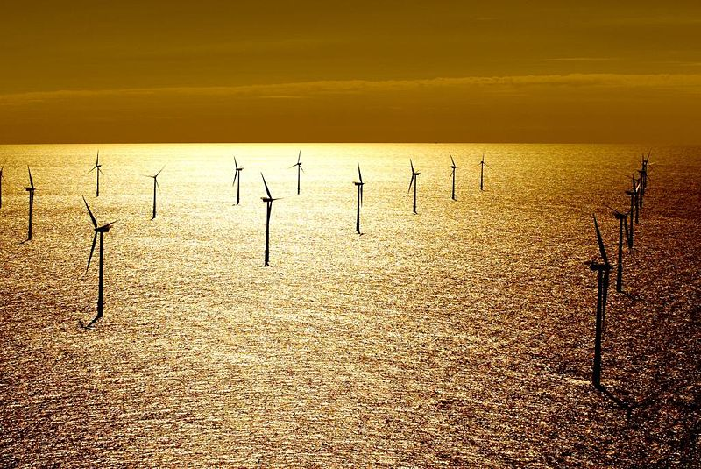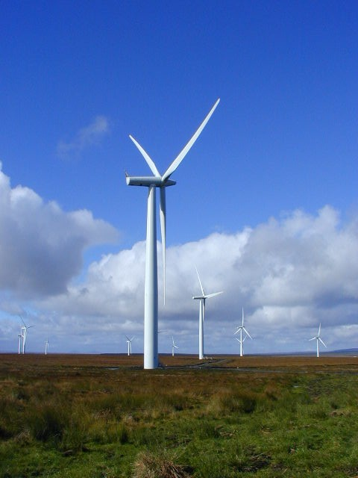

Both types: require an average wind speed of at least 8 metres per second and need an area of 0.2 square kilometres per turbine

One onshore turbine: a 3 Megawatts turbine can power around 1000 homes

Cost = £2.3 million

One offshore turbine: a 5 Megawatt turbine can power around 1500 homes

Cost = £4 million

In both cases costs vary and can be reduced per turbine if multiple units are installed in a wind farm.

Does wind power affect tourism?

There is no evidence to suggest this. Wind farm developers are often asked to provide a visitor centre, viewing platforms and rights of way to their sites.

How big are they?

Large modern wind turbines have rotor diameters ranging up to

65 metres. Towers range from 25 to 80 metres in height.

How safe is wind energy?

Wind energy is very safe and non-polluting.

What happens when there is no wind?
Turbines do not produce power when the wind isn't blowing so a back-up electrical supply or connection to the National Grid is also needed. If batteries provide the backup they are expensive and needing to be replaced every few years.

Are wind turbines noisy?
It is possible to hold a conversation directly underneath a modern wind turbine without any difficulty whatever and without raising one's voice. The modern turbine is quieter than its predecessors owing to improvements in the blade design. As wind speed rises, the noise of the wind masks the noise made by wind turbines.

Do wind turbines affect animal life?

Studies show that the number of birds and bats killed by wind turbines is negligible when compared with other human activities such as traffic, hunting, power lines and high-rise buildings. Wind farming is popular with farmers, because their land can continue to be used for growing crops or grazing livestock. Sheep, cows and horses are not disturbed by wind turbines.

What are wind turbines made of?
The towers are mostly tubular and made of steel. The blades are made of fibreglass-reinforced polyester or wood-epoxy.

