

|  |
| --- |
| Chemical Demonstrations |
| Screaming Jelly Baby |

### Apparatus you will need

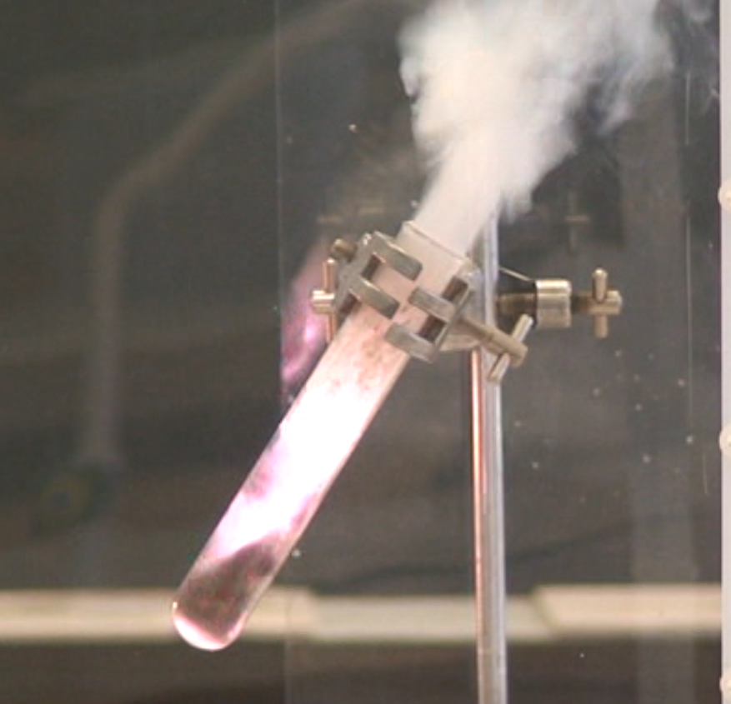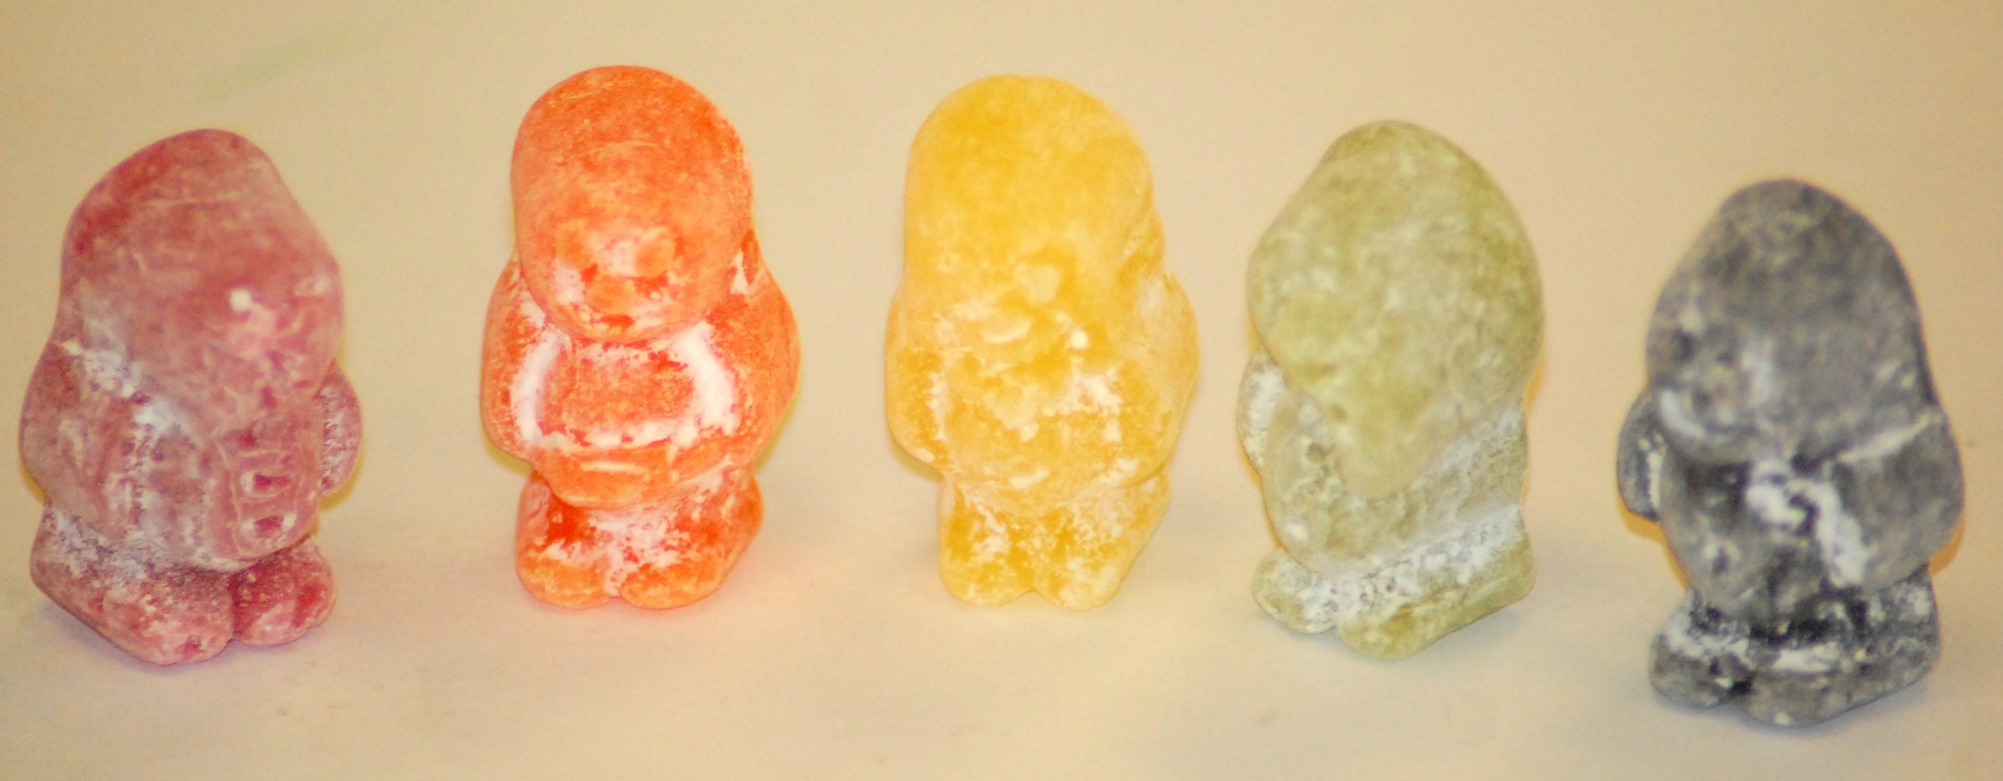

This reaction can be applied to curriculum for excellence.

*Through experimentation, I can identify indicators of chemical reactions having occurred … and can relate my findings to the world around me.*

SCN 3-19a

CfE Higher Chemistry- Chemistry in Society

- *Oxidising or reducing agents.*

Pyrex or borosilicate boiling tube (must be **CLEAN**)

Heat proof mats (to cover whole area occupied by the apparatus)

Retort Stand

Clamp (free of **RUBBER** grips to avoid any combustion)

Safety screens (to completely **SURROUND** the apparatus)

Bunsen burner

Tongs (must be **CLEAN**)

# Chemicals you will use

15g Potassium chlorate(V) (Oxidising, Dangerous for the environment, Harmful)

Jelly Baby Bassets/ Tesco-own brand (**NOT** Gummy bears)

**Deviation from the details given here is not recommended. Any variations you must contact SSERC.**

# Safety

Conduct experiment in a well ventilated lab to avoid any fume cupboard pre filters from catching fire.

Ensure there are no smoke alarms in the near vicinity.

The apparatus must be surrounded by safety screens.



Demonstrator must wear face shield & heat resistant gloves.



Audience must wear safety goggles and be at a distance of several metres from the safety screens.

**It is the responsibility of teachers doing this demonstration to carry out an appropriate risk assessment.**

Turn over …

# What you will do

1. Ensure there is adequate ventilation by opening the windows.
2. Take a boiling tube of the same diameter to that being used in the demonstration and ensure the jelly baby can easily slide down inside the tube to the bottom.
3. Place the heat proof mats on the bench to completely cover the area the apparatus will be placed in.
4. Set up the retort stand, angle the clamp so that the boiling tube is 50-60 degrees to the vertical (steep enough that the jelly baby falls to the bottom on its own) and that the Bunsen burner can be easily placed underneath the bottom of the tube.
5. Take the safety screens and place them so the all of the apparatus is completely surrounded. The demonstrator should still be able to insert and remove the Bunsen burner easily.
6. Ensure the demonstrator and audience are wearing the appropriate safety gear and standing at the correct distance.
7. Take the boiling tube and check to ensure it is clean and not damaged.
8. Carefully add the potassium chlorate to the tube.
9. Clamp the tube on the stand.
10. Using the blue flame on the Bunsen burner, strongly heat the potassium chlorate until it is fully molten.
11. Remove the Bunsen burner.
12. Using clean tongs drop the jelly baby into the boiling tube and retire to a safe location a few metres away.