

|  |
| --- |
| Chemical Demonstrations  This reaction can be applied to curriculum for excellence.  *Through experimentation, I can identify indicators of chemical reactions having occurred ...*  SCN 3-19a  N4 Chemistry in Society  *- Chemical Analysis.*  N5 Chemistry in Society  *- Chemical Analysis.* |
| Flame Colours - splints |

Flame Colours

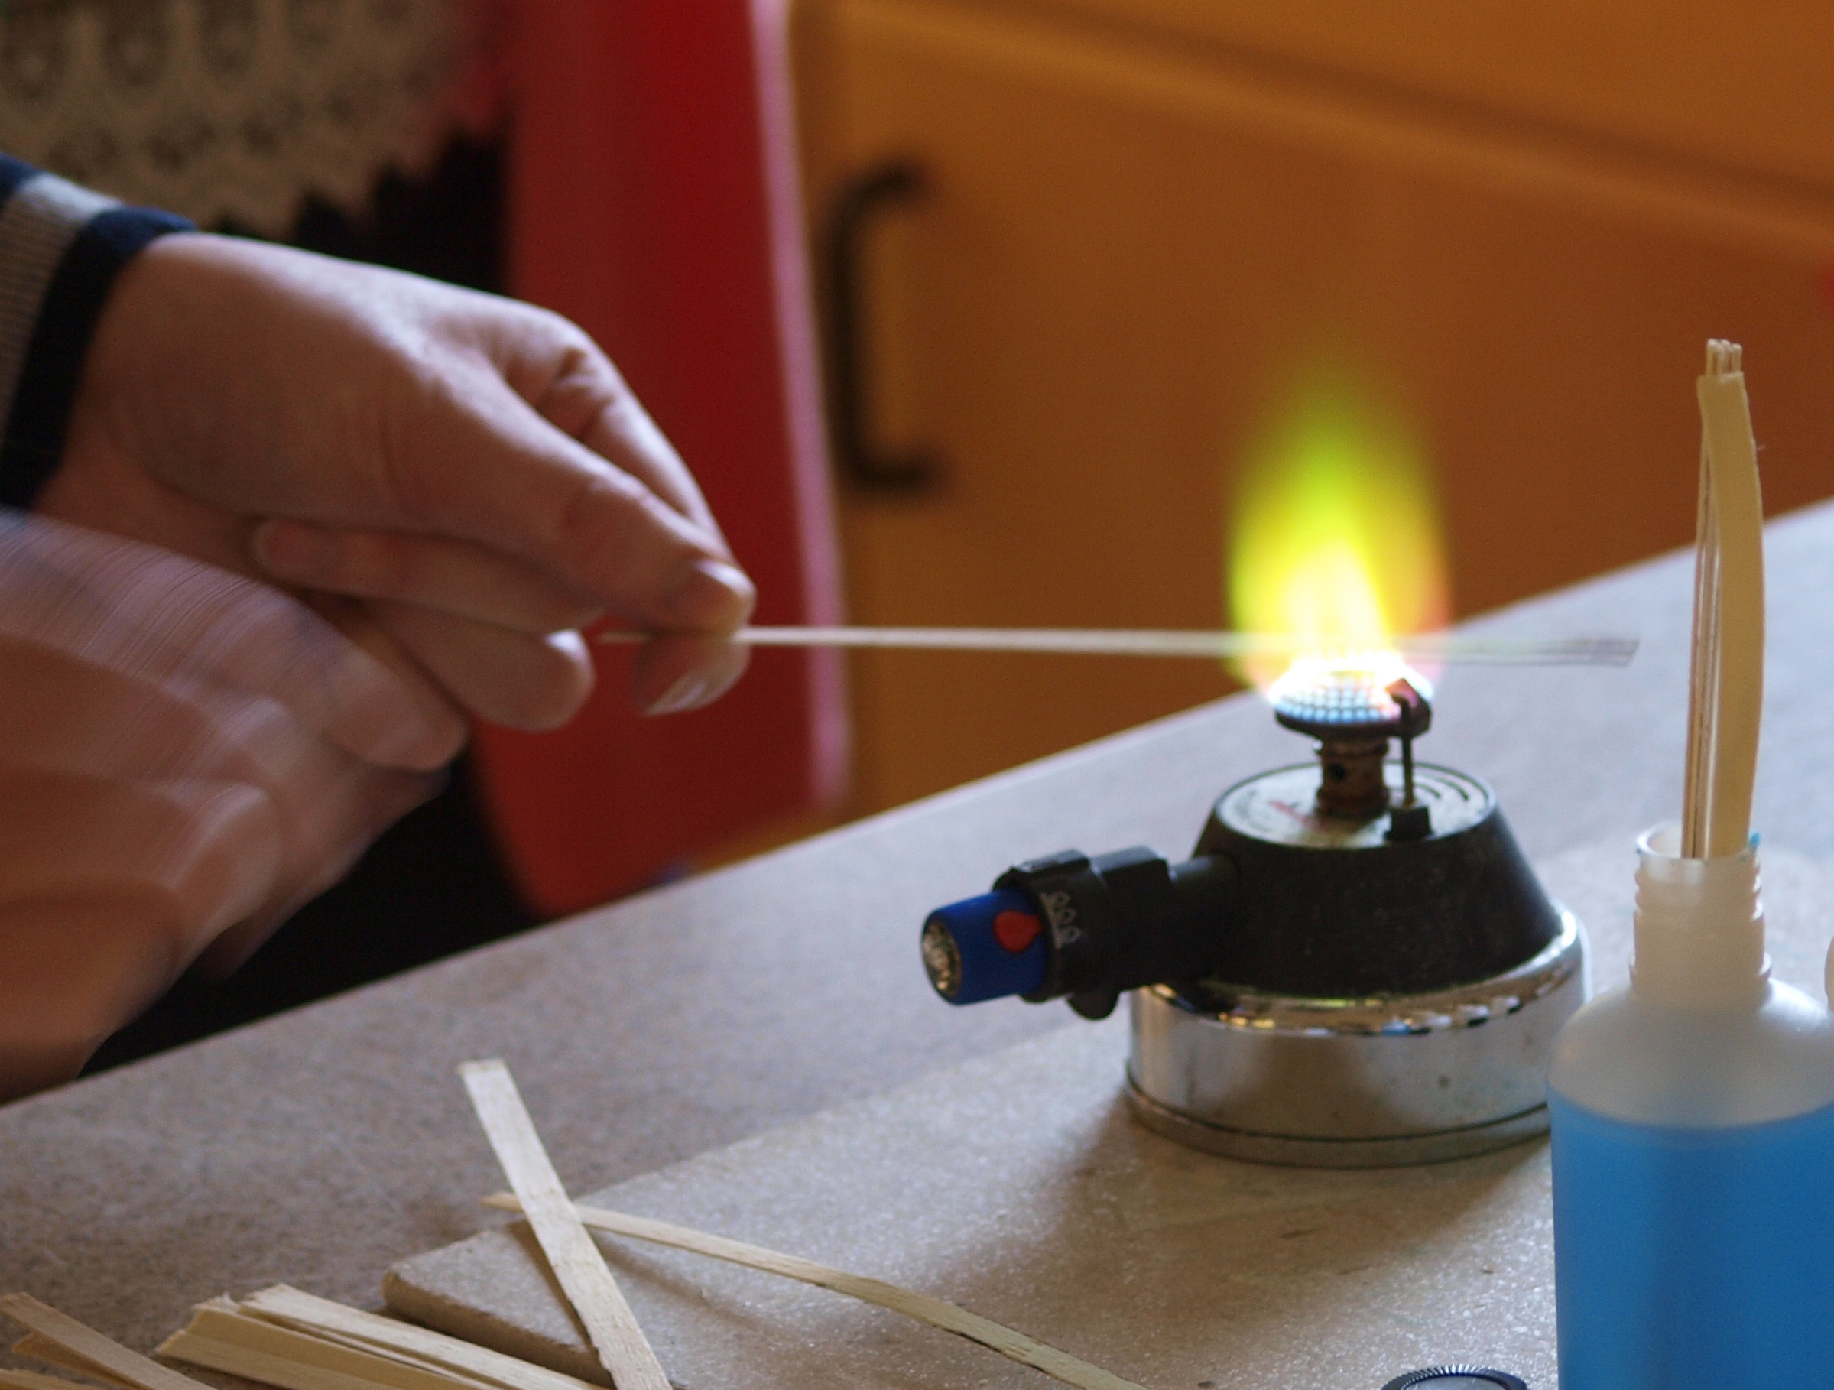

# Apparatus you will need

* Bottles of solutions of different metal salts
* Wooden splints
* Bunsen burner
* Heat proof mat

# Chemicals you will use

Suitable salts for flame tests might be:

sodium chloride, lithium iodide, potassium chloride, barium chloride, strontium nitrate, calcium chloride, copper sulphate

1 molar solutions of thee are used.

## Safety



Wear eye protection



Care with solutions – toxic and irritants



Care if using ethanol solutions - highly flammable

**It is the responsibility of teachers doing this demonstration to carry out an appropriate risk assessment.**

# What you will do



## Before the demonstration:

1. Prepare 1 molar aqueous solutions of the different salts.
2. Place some splints in the top of each bottle and leave them for a few hours to soak.

## The demonstration/experiment:

1. Put the Bunsen burner on a half blue flame.
2. Take a splint from the bottle and hold the wet end in the flame

The colour of the flame will soon become apparent but the water absorbed into the wood prevents it from catching fire . . . at least for a while though if you hold it in the flame for a long while it will eventually catch fire and burn.

1. Now try the other solutions.

## Some salts to try:

|  |  |
| --- | --- |
| Compound | Flame colour |
| sodium chloride | Yellow/orange |
| lithium iodide | Crimson |
| potassium chloride | Lilac |
| barium chloride | Green |
| strontium nitrate | Red |
| calcium chloride | Brick Red |
| copper sulphate | Green |