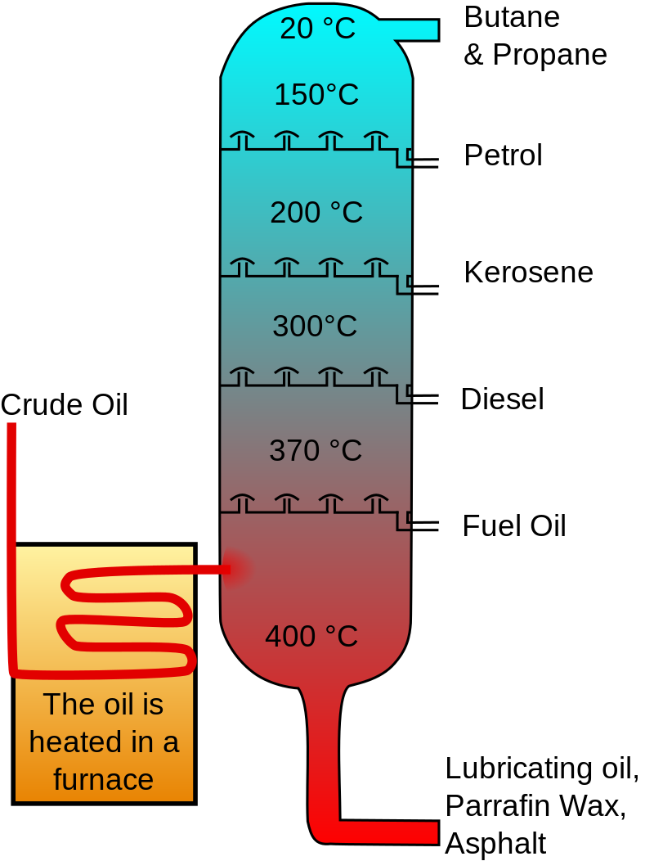

Chemical Reactions
Distillation of ‘Crude Oil’
Teacher/technician Guide
Introduction
National 4 – Nature’s Chemistry
Hydrocarbons
Can possible be demonstrated elsewhere as well.
Image from Wikimedia Commons Under a Creative Commons license

Crude oil is still a key industry in the UK, providing fuel for heating and transport, and raw materials for many other industries, including the manufacturing of plastics, dyes, pharmaceuticals and many more.
Crude oil itself is a mixture of dozens or hundreds of different hydrocarbons and the first step in purification of this mixture is to distil the mixture to separate it into bands with a common boiling point range.
The particular form of distillation used in this process is called fractional distillation and it can be successfully modelled in the classroom.

You will need
crude oil alternative, 10 cm³ | measuring cylinder, 10 cm³
plastic dropping pipette | Mineral/ceramic wool
retort stand, boss and clamp | side-arm boiling tube, with bung holding a thermometer
a wide-range spirit or digital thermometer (0 - 300°C – or thereabouts)* | short L-shaped delivery tube
silicone or rubber tubing to connect to delivery tube | Bunsen burner
5 x small test tubes (75 x 10 mm) | test tube rack
heat resistant mat
graduated 1 cm³ pipettes (optional) | tap water (optional)

* Spirit and digital thermometers are available which read above 250°C. Do not use mercury thermometers.

Method
- Prepare synthetic crude oil as per the recipe (see Technicians Guide)
- Place a piece of mineral wool (about the width of the boiling tube and ) at the bottom of a side-arm boiling tube*.
- Add 5-10 cm³ of crude oil alternative.
- Label four small test tubes - 1, 2, 3, 4.

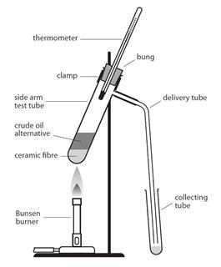
- Set up the apparatus as shown in the diagram to the right
- Place the delivery tube into test tube 1.
For the first fraction only it is advisable to have the collecting tube sitting in a beaker of cold water.
- Light the Bunsen and adjust the gas tap, so the flame is reduced in size. Adjust the collar so that the flame is just non-luminous.
- Holding the base of the Bunsen burner, gently warm the boiling tube, collecting distillate up to about 80°C

Image from the Royal Society of Chemistry
- Move the delivery tube to tubes 2, 3 and 4 and continue heating, collecting distillate in ranges up to 300°C.
The exact temperature ranges are not critical, a suggestion could be:
- 10 - 80°C
- 80-150°C
- 150-200°C and
- 200-300°C
- And the final fraction remains in the tube
Stronger heating is required for the higher temperature fractions.
- Once you have finished, inspect each fraction, and look at their colour, clarity and viscosity
Testing the burning of your fractions
- Place four small pieces of mineral wool on a heat resistant mat.
- Pour a little of each fraction on a separate piece of mineral wool.
- Light each fraction with a burning splint and observe the colour of the flame and the amount of smoke given off
Alternatively, a small amount could be placed on a watch glass and lit

Safety
- This procedure is usually carried out as a demonstration, since it requires a certain amount of experience to choose the moment to change collecting tubes.
- That said, the experiment can be carried out by senior pupils as long as there is a good level of supervision and they have had some training in the procedure prior to carrying it out for real..
- Eye protection should be worn – safety spectacles are sufficient.
- This can be carried out in a well-ventilated lab or a fume cupboard but students should be warned not to inhale gases or vapours.
- Care should be taken to avoid skin contact – gloves would be a sensible idea.
- DO NOT use real crude oil as this contains benzene. While no now actually illegal, it is a known human carcinogen.
- Make sure the side-arm boiling tube is made of borosilicate glass, not soda glass. And ensure the tubing connection between the side-arm boiling tubes and the delivery tube is as short as possible to minimise distillate collecting in the tubing
- Make sure pupils (or demonstrators) do not use the Bunsen burner carelessly and set light to the delivery tube – the low boiling point fractions are highly flammable.

Notes
The distillation of this synthetic, crude oil alternative does not directly reproduce the results of genuine crude oil distillation. When real crude oil is distilled, there is a pronounced change in the colour between different fractions. There is also a pronounced change in viscosity, from the free-running lighter fractions, to the thicker heavier fractions. With crude oil alternative, the colour and viscosity changes are less pronounced.
The side-arm boiling tube is heated gently at the start of the procedure, working up to stronger heating as higher distillation temperatures are required. Each fraction is a mixture of different hydrocarbons with similar boiling points. The longer the carbon chain of a substance, the stronger the intermolecular forces between the molecules, hence the more energy and hence higher temperature required to overcome these forces, and to allow the substance to evaporate.
It is important to try the experiment beforehand. It may be necessary to add an additional low boiling point fraction to the ‘crude oil’ mixture (such as cyclohexane) to obtain something below 70 °C.
There is no need for a water bath to cool the distillates.
The mineral wool is used to absorb the liquid, and to provide a surface for smooth distillation. An additional advantage of the mineral wool is that the residue sticks to the wool, and can be easily hooked out of the tube, after the apparatus has cooled, and disposed of in a polythene bag. Anti-bumping granules may be used as an alternative.
Once the procedure has been completed, allow the apparatus to cool to a reasonable temperature, and disconnect the rubber fittings. This will help prevent the rubber sticking to the glass.
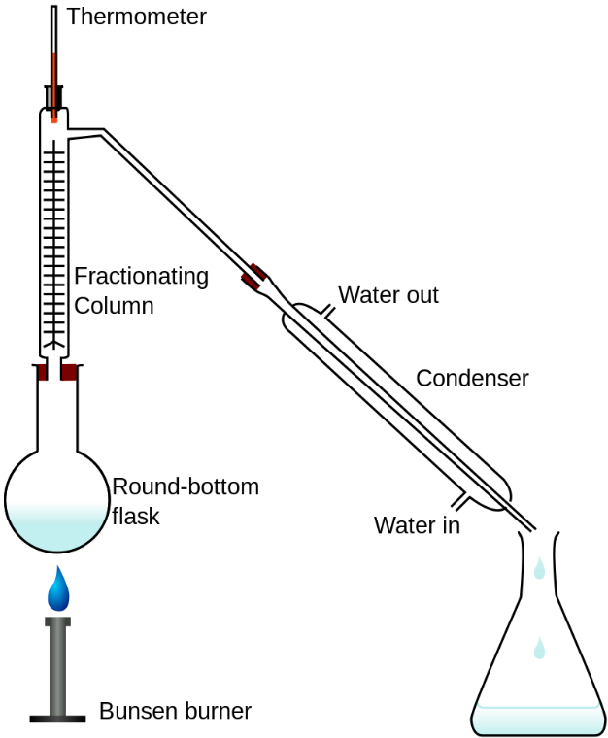
Some sources, e.g. websites and textbooks, show fractional distillation of crude oil using large scale apparatus, including a fractionating column – as shown in the diagram (right).
This setup is inappropriate and will not work. The top of the column cannot reach in excess of 150°C without itself being heated, a procedure not possible in schools.

(Image from Wikimedia Commons by Theresa Knott under a Creative Commons License (CC BY-SA 3.0)

Disposal
The boiling tube is difficult to clean afterwards, but can be reused for the same procedure. The mineral wool can be placed in a polythene bag which can be put in the waste. Dilute any remaining liquid in soapy water and dispose of down the foul water drain

Extension
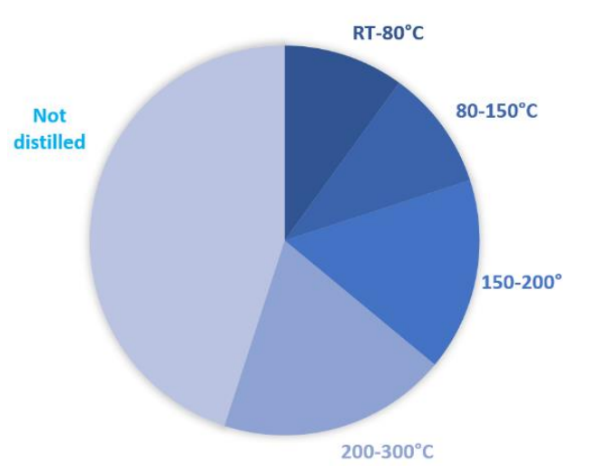
Label an additional test tube 5.
Use a 1 cm³ graduated pipette to place 1 cm³ of water in the tube.
Measure the height of the water in the tube.
Measure the height of the fractions in test tubes 1-4.
Estimate the volume of each fraction and determine what percentage of the original mixture was not distilled.
A pie-chart can be constructed such as in Figure 2 (right)

Technician’s Guide
Each group will need
crude oil alternative, 10 cm³ | measuring cylinder, 10 cm³
plastic dropping pipette | Mineral/ceramic wool
retort stand, boss and clamp | side-arm boiling tube, with bung holding a thermometer
a wide-range spirit or digital thermometer (0 - 300°C – or thereabouts)* | short L-shaped delivery tube
silicone or rubber tubing to connect to delivery tube | Bunsen burner
4 x small test tubes (75 x 10 mm) (5 if extension is being done. | test tube rack
heat resistant mat
graduated 1 cm³ pipettes (optional) | tap water (optional)

* Spirit and digital thermometers are available which read above 250°C. Do not use mercury thermometers.

Method
- Prepare synthetic crude oil as per the recipe
Prepare in a fume cupboard wearing eye protection. The recipe from CLEAPSS consists of mixing together in a glass bottle :-
- liquid paraffin (medicinal) (55 cm³),
- paraffin oil (kerosene), (20 cm³),
- white spirit (11 cm³),
- petroleum spirit 100 to 120°C (4 cm³),
- petroleum spirit 80 to 100°C (4 cm³),
- petroleum spirit 60 to 80°C (6 cm³) and
- a little black oil based paint to make the mixture black. A squeeze from a tube of Newton and Windsor’s Black Ivory oil paint is convenient.
- Label the bottle Highly Flammable and Harmful, stopper and shake well. Shake well before use.

- Place a piece of mineral wool (about the width of the boiling tube) at the bottom of a side-arm boiling tube*.
- Add 5-10 cm³ of crude oil alternative.
- Label four small test tubes - 1, 2, 3, 4.
- Set up the apparatus as shown in the diagram to the right
- Place the delivery tube into test tube 1.
For the first fraction only it is advisable to have the collecting tube sitting in a beaker of cold water.
- Light the Bunsen and adjust the gas tap, so the flame is reduced in size. Adjust the collar so that the flame is just non-luminous.
- Holding the base of the Bunsen burner, gently warm the boiling tube, collecting distillate up to about 80°C

Image from the Royal Society of Chemistry
- Move the delivery tube to tubes 2, 3 and 4 and continue heating, collecting distillate in ranges up to 300°C.
The exact temperature ranges are not critical, a suggestion could be:
- 10 - 80°C
- 80-150°C
- 150-200°C and
- 200-300°C
- And the final fraction remains in the tube
Stronger heating is required for the higher temperature fractions.
- Once you have finished, inspect each fraction, and look at their colour, clarity and viscosity
Testing the burning of your fractions
- Place four small pieces of mineral wool on a heat resistant mat.
- Pour a little of each fraction on a separate piece of mineral wool.
- Light each fraction with a burning splint and observe the colour of the flame and the amount of smoke given off
Alternatively, a small amount could be placed on a watch glass and lit

Safety
- This procedure is usually carried out as a demonstration, since it requires a certain amount of experience to choose the moment to change collecting tubes.
- That said, the experiment can be carried out by senior pupils as long as there is a good level of supervision and they have had some training in the procedure prior to carrying it out for real..
- Eye protection should be worn – safety spectacles are sufficient.
- This can be carried out in a well-ventilated lab or a fume cupboard but students should be warned not to inhale gases or vapours.
- Care should be taken to avoid skin contact – gloves would be a sensible idea.
- DO NOT use real crude oil as this contains benzene. While not now actually illegal, it is a known human carcinogen.
- Make sure the side-arm boiling tube is made of borosilicate glass, not soda glass. And ensure the tubing connection between the side-arm boiling tubes and the delivery tube is as short as possible to minimise distillate collecting in the tubing
- Make sure pupils (or demonstrators) do not use the Bunsen burner carelessly and set light to the delivery tube – the low boiling point fractions are highly flammable.

Notes
The distillation of this synthetic, crude oil alternative does not directly reproduce the results of genuine crude oil distillation. When real crude oil is distilled, there is a pronounced change in the colour between different fractions. There is also a pronounced change in viscosity, from the free-running lighter fractions, to the thicker heavier fractions. With crude oil alternative, the colour and viscosity changes are less pronounced.
The side-arm boiling tube is heated gently at the start of the procedure, working up to stronger heating as higher distillation temperatures are required. Each fraction is a mixture of different hydrocarbons with similar boiling points. The longer the carbon chain of a substance, the stronger the intermolecular forces between the molecules, hence the more energy and hence higher temperature required to overcome these forces, and to allow the substance to evaporate.
It is important to try the experiment beforehand. It may be necessary to add an additional low boiling point fraction to the ‘crude oil’ mixture (such as cyclohexane) to obtain something below 70 °C.
There is no need for a water bath to cool the distillates other than the lowest bp one..
The mineral wool is used to absorb the liquid, and to provide a surface for smooth distillation. An additional advantage of the mineral wool is that the residue sticks to the wool, and can be easily hooked out of the tube, after the apparatus has cooled, and disposed of in a polythene bag. Anti-bumping granules may be used as an alternative.
Once the procedure has been completed, allow the apparatus to cool to a reasonable temperature, and disconnect the rubber fittings. This will help prevent the rubber sticking to the glass.
Some sources, e.g. websites and textbooks, show fractional distillation of crude oil using large scale apparatus, including a fractionating column – as shown in the diagram (right).
This setup is inappropriate and will not work. The top of the column cannot reach in excess of 150°C without itself being heated, a procedure not possible in schools.

(Image from Wikimedia Commons by Theresa Knott under a Creative Commons License (CC BY-SA 3.0)

Disposal
The boiling tube is difficult to clean afterwards, but can be kept and reused for the same procedure. The mineral wool can be placed in a polythene bag which can be put in the waste. Dilute any remaining liquid in soapy water and wash to waste with plenty of running water.

