Chemical Investigations
Redox titration
Teacher Guide
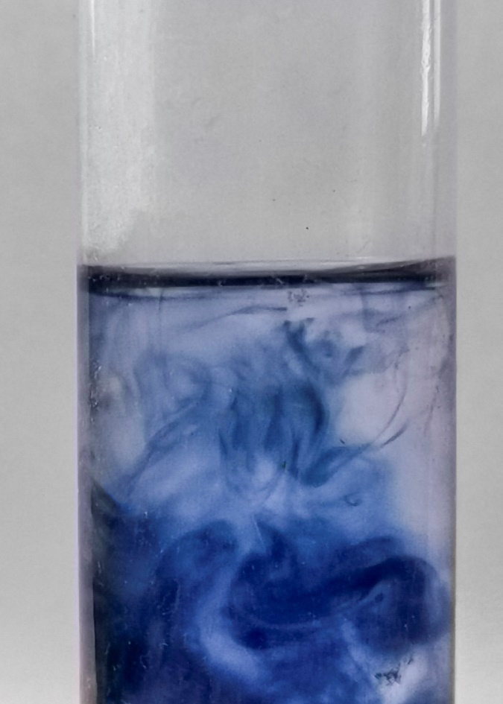

Redox Titration
UNIT 3 PPA 3
Introduction
Vitamin C (ascorbic acid) is an important component of our diet. In its absence the protein collagen cannot form fibres properly and this results in a disease called Scurvey, causing skin lesions and blood vessel fragility.
Although vitamin C occurs naturally in many fruits and vegetables, many people take vitamin C tablets to supplement their intake
Vitamin C can undergo a redox reaction with iodine in which the vitamin C is oxidised.
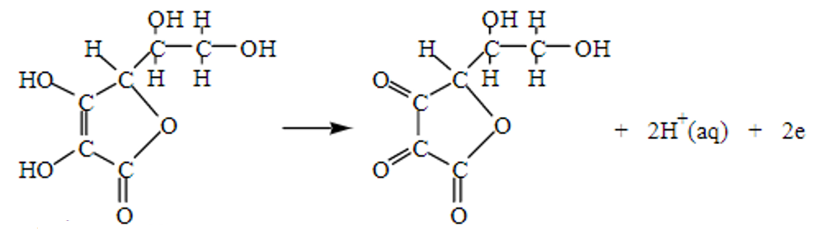
The iodine molecules are reduced ( I_{2(aq)} + 2e⁻ 2I⁻_{(aq)} ) but this is not shown in the diagram).

The aim of this experiment is to determine the mass of vitamin C in a tablet by carrying out a redox titration using a solution of iodine of accurately known concentration and starch solution as an indicator.
You will need
small beaker | 50 cm³ burette
pipette filler | 250 cm³ standard flask
25 cm³ pipette | filter funnel
50 cm³ burette | wash bottle
conical flask | pipette filler
standard solution of iodine | starch solution
vitamin C tablet | deionised water

Health & Safety
The iodine solution irritates the eyes.
Wear eye protection and wash your hands if any iodine solution spills on them.

Method
- Add a vitamin C tablet to the beaker.
- Add some deionised water (approximately 50 cm³) to the beaker and stir the mixture until the tablet has dissolved.
- Carefully add the resulting solution to the 250 cm³ standard flask. Rinse out the beaker several times with water and add the washings to the flask.
- Add water to the standard flask to bring the volume of the solution up to the graduation mark on the neck.
- Stopper the flask and invert it several times to make sure the solution is thoroughly mixed.
- After rinsing the pipette with a little of the vitamin C solution: pipette 25 cm3 of it into the conical flask.
- Add a few drops of starch solution to the vitamin C solution in the conical flask.
- After rinsing the burette with a little iodine solution: fill the burette with the iodine solution.
- Note the initial burette reading. Since the solution has a dark colour: it is difficult to see the bottom of the meniscus. Take the burette reading from the top of the meniscus.
- Add the iodine solution slowly from the burette whilst gently swirling the solution in the conical flask. Initially you will see a blue/black colour as the iodine reacts with the starch but this will rapidly disappear as the iodine reacts with the vitamin C.
- Near the end-point of the titration the colour disappears more slowly. At this point add the iodine solution drop by drop until the solution just turns a blue 'black colour and remains so.
- This is the end-point of the titration i.e. all the vitamin C has reacted. Note the final burette reading.
- Wash out the conical flask
- Repeat the titrations until concordant results are obtained.

Calculation
- Knowing the average volume and concentration of the iodine solution used in the redox titration, the number of moles of iodine can be calculated.
- With the result from step (a) and the balanced equation for the redox reaction, we can work out the number of moles of vitamin C in 25 cm³ of the vitamin C solution. This can be scaled up to find the number of moles of vitamin C in 250 cm³ of the vitamin C solution.
- Your final answer in step (b) will, of course: be equal to the number of moles of vitamin C in the tablet. Using this result and the mass of one mole of vitamin C (176 g) we can finally work out the mass of vitamin C in the tablet.

Example calculation
Suppose the average titre volume was 22.1 cm³ and the iodine solution had a concentration of 0.0250 mol l⁻¹.
From the average titre volume in litres (V) and the concentration of the iodine solution (C), we can calculate the number of moles of iodine (n) used in the titration:
N_{(iodine)} = C x V = 0.0250 x 0.0221
= 5.525 x 10⁻⁴ mol
We can now use the balanced redox equation to calculate the number of moles of vitamin C in a 25 cm³ sample of the vitamin C solution:
C₆H₈O₆ + I₂ C₆H₆O₆ + 2H⁺ + 2I⁻
1 mol 1 mol
5.525 x 10⁻⁴ mol 5.525 x 10⁻⁴ mol

But there were 250 cm³ of vitamin C in total and so to determine the number of moles of vitamin C in the tablet we have to scale up our last answer:
N_{(vitamin C)} per tablet = 10 x 5.525 x 10⁻⁴
= 5.525 x 10⁻³ mol
Vitamin C: C₆H₈O₆
Mass of 1 mole = 6(12) + 8(1) + 6(16) = 176g
We can now calculate the mass of vitamin C per tablet:
Mass of vitamin C per tablet = 176 x 5.525 x 10⁻³
= 0.972g

Technician Guide
You will need
1 small beaker | 1 50 cm³ burette
1 pipette filler | 1 250 cm³ standard flask
1 25 cm³ pipette | 1 filter funnel
1 50 cm³ burette | 1 wash bottle
1 conical flask | 1 pipette filler
1 white tile
~ 75 cm³ standard solution of iodine 0.025 mol l⁻¹ * | 1% starch solution (a few cm³ as an indicator)
vitamin C tablet 1g ** | ~ 250 cm³ deionised water

* 6.35g Iodine and 20g Potassium Iodide per litre
The iodine solution will need to be standardised. This can be done against a standard solution of sodium thiosulphate.
Alternatively, the iodine solution could be prepared from a commercial volumetric standard solution of iodine.
** Both lemon and orange-flavoured effvescent vitamin C tablets are suitable. Despite the bright orange colour Of the latter the end-point of the titration is distinct.

Health & Safety
Check the risk assessment for this activity.
Solid iodine is harmful is swallowed and in contact with the skin and eyes and gives off irritating fumes. Work in a well-ventilated area.
Wear eye protection and wash your hands if any iodine solution spills on them.

Method
- Add a vitamin C tablet to the beaker.
- Add some deionised water (approximately 50 cm³) to the beaker and stir the mixture until the tablet has dissolved.
- Carefully add the resulting solution to the 250 cm³ standard flask. Rinse out the beaker several times with water and add the washings to the flask.
- Add water to the standard flask to bring the volume of the solution up to the graduation mark on the neck.
- Stopper the flask and invert it several times to make sure the solution is thoroughly mixed.
- After rinsing the pipette with a little of the vitamin C solution: pipette 25 cm3 of it into the conical flask.
- Add a few drops of starch solution to the vitamin C solution in the conical flask.
- After rinsing the burette with a little iodine solution: fill the burette with the iodine solution.
- Note the initial burette reading. Since the solution has a dark colour: it is difficult to see the bottom of the meniscus. Take the burette reading from the top of the meniscus.
- Add the iodine solution slowly from the burette whilst gently swirling the solution in the conical flask. Initially you will see a blue/black colour as the iodine reacts with the starch but this will rapidly disappear as the iodine reacts with the vitamin C.
- Near the end-point of the titration the colour disappears more slowly. At this point add the iodine solution drop by drop until the solution just turns a blue 'black colour and remains so.
- This is the end-point of the titration i.e. all the vitamin C has reacted. Note the final burette reading.
- Wash out the conical flask
- Repeat the titrations until concordant results are obtained.

