Chemical Investigations
Quantitative Electrolysis
Teacher/Technician Guide
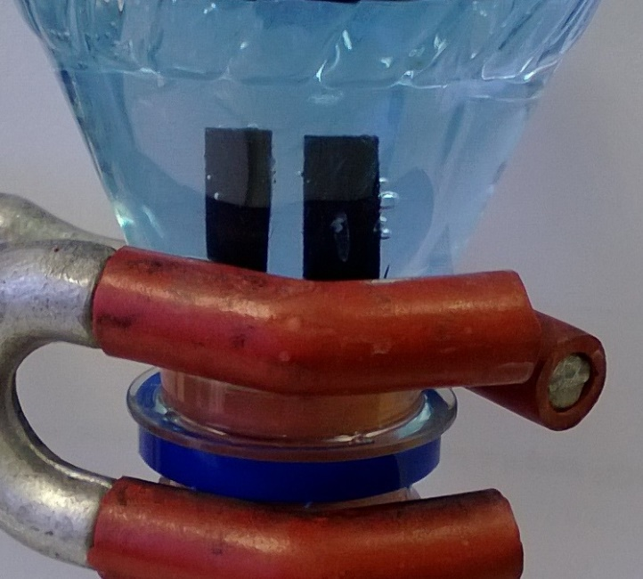

Quantitative Electrolysis
UNIT 3 PPA 2
Introduction
On electrolysing dilute sulphuric acid the hydrogen ions are reduced to hydrogen gas at negatively charged electrode
2H⁺_{(aq}) + 2e⁻ H_{2(g})
The ion-electron equation shows that two moles of electrons are needed to liberate one mole of the element Since 96,500 C is the charge associated with one mole of electrons, then 2 x 96,500 C will, in theory, be required to produce one mole of hydrogen.
The aim of the experiment is to confirm this i.e. to determine the quantity of electricity required to produce one mole of hydrogen by electrolysing dilute sulphuric acid.
You will need
electrolytic cell fitted with carbon electrodes | low voltage source of electricity
ammeter | variable resistor
connecting wires 9with crocodile clips if needed | 50cm³ graduated tube or measuring cylinder
clamp stand and clamp | timer
0.1 mol l^{-l} sulphuric acid

Health & safety
0.1 mol l^{-l} sulphuric acid is of no significant hazard.
There is a very small risk of explosion from the hydrogen and oxygen released in the electrolysis.
Wear eye protection.
If you use a power pack do not plug it into the mains until you have had the circuit checked by your teacher lecturer.
The electrolysis should be carried out in a well-ventilated room and make sure flames are absent when the hydrogen is released from the graduated tube (or measuring cylinder) at the end of the experiment.

Method
- As directed by your teacher lecturer, set up a circuit containing an electrolytic cell, an ammeter and a variable resistor but do not switch on the voltage source at the moment.
- Add dilute sulphuric acid to the electrolytic cell making sure the electrodes are well covered.
- Fill the graduated tube or measuring cylinder with dilute sulphuric acid. Making sure no acid falls out of the tube (or cylinder) invert it and carefully place the open end underneath the surface of the acid in the cell.
- Clamp the graduated tube (or measuring cylinder) in a vertical position but do not place it over the negatively charged electrode as yet.
- Switch on the source of electricity and adjust the variable resistor to set the current to 0.5 A.
- Leave the current passing through the solution for a few minutes. This allows the porous carbon electrodes to become saturated with gas.
- Switch off and position the graduated tube (or measuring cylinder) over the negatively charged electrode. Make sure the tube (or cylinder) is not resting on the bottom of the cell
- Switch on the voltage source and at the same time start the timer. If necessary adjust the current to 0.5 A using the variable resistor. Constantly check that the current stays at 0.5 A as the solution is electrolysed.
- Allow the current to pass until slightly less than 50 cm³ of hydrogen is produced. At this point switch off the voltage source and record the time for which the current has passed. Also record the current.
9. Measure and record the exact volume of hydrogen produced.

Calculation
- From the current (I) in amps and the time (t) in seconds: the electric charge (Q) in coulombs can be calculated using the relationship:
Q = I t
- Let us suppose x litres of hydrogen were collected during the electrolysis and let us assume that the molar volume of hydrogen is 24.1 litres mol⁻¹
Knowing how many coulombs were needed to give us x litres of hydrogen: we can calculate the quantity of electricity required to produce 24. I litres of hydrogen i.e. one mole of hydrogen.

Example calculation
Suppose 48.8 cm³ (0.0488 litre) of hydrogen had been collected using a current of 0.50 A for 790 s.
From the current (I) in amps and the time (t) in seconds we can work out the electric charge (Q) in coulombs using the relationship, Q = I t:
Q = 0.50 x 790
= 395 C
Under the conditions of temperature and pressure of the experiment the molar volume of hydrogen is assumed to be 24.1 litres mop. This means that one mole of hydrogen occupies 24.1 litres.
Knowing that 395 C are required to produce 0.0488 litres of hydrogen we can calculate the quantity of electricity needed to produce 24.1 litres of hydrogen i. e. 1 mol of hydrogen:
0.0488 litre 395 C
24.1 litres (1 mol) 395 x 24.1
0.0488
= 1.95x 10'C

Notes
The sulphuric acid is reusable.
24.1 litres mol⁻¹ is the molar volume of hydrogen at 20 cc and 101 kPa.
To reduce the risk of splashes of acid on the hands when placing the filled graduated tube in the acid, the tube could be stoppered, placed in the acid and the stopper removed by using tongs.
A 50 cm³ burette could be used as an alternative to the graduated tube as could a graduated plastic pipette (see SSERC Bulletins 156 (p 9) and 166 (p 28)).

Technician Guide
Each group will need
1 electrolytic cell fitted with carbon electrodes | 1 low voltage source of electricity
1 ammeter | 1 variable resistor
4 connecting wires - with crocodile clips if needed | 1 50cm³ graduated tube or measuring cylinder
1 clamp stand and clamp | 1 timer
0.1 mol l^{-l} sulphuric acid (5.5 cm³ concentrated sulphuric acid per litre) – enough to cover the electrodes.

Health & safety
Consult the risk assessment for more detail.
0.1 mol l^{-l} sulphuric acid is of no significant hazard.
There is a very small risk of explosion from the hydrogen and oxygen released in the electrolysis.
Wear eye protection.
The electrolysis should be carried out in a well-ventilated room and make sure flames are absent when the hydrogen is released from the graduated tube (or measuring cylinder) at the end of the experiment.

Method
- As directed by your teacher lecturer, set up a circuit containing an electrolytic cell, an ammeter and a variable resistor but do not switch on the voltage source at the moment.
- Add dilute sulphuric acid to the electrolytic cell making sure the electrodes are well covered.
- Fill the graduated tube or measuring cylinder with dilute sulphuric acid. Making sure no acid falls out of the tube (or cylinder) invert it and carefully place the open end underneath the surface of the acid in the cell.
- Clamp the graduated tube (or measuring cylinder) in a vertical position but do not place it over the negatively charged electrode as yet.
- Switch on the source of electricity and adjust the variable resistor to set the current to 0.5 A.
- Leave the current passing through the solution for a few minutes. This allows the porous carbon electrodes to become saturated with gas.
- Switch off and position the graduated tube (or measuring cylinder) over the negatively charged electrode. Make sure the tube (or cylinder) is not resting on the bottom of the cell
- Switch on the voltage source and at the same time start the timer. If necessary adjust the current to 0.5 A using the variable resistor. Constantly check that the current stays at 0.5 A as the solution is electrolysed.
- Allow the current to pass until slightly less than 50 cm³ of hydrogen is produced. At this point switch off the voltage source and record the time for which the current has passed. Also record the current.
9. Measure and record the exact volume of hydrogen produced.

Notes
The sulphuric acid is reusable.
24.1 litres mol⁻¹ is the molar volume of hydrogen at 20 °C and 101 kPa.
To reduce the risk of splashes of acid on the hands when placing the filled graduated tube in the acid, the tube could be stoppered, placed in the acid and the stopper removed by using tongs.
A 50 cm³ burette could be used as an alternative to the graduated tube as could a graduated plastic pipette (see SSERC Bulletins 156 (p 9) and 166 (p 28)).

