Chemical Investigations
Making an ester
Teacher/Technician Guide
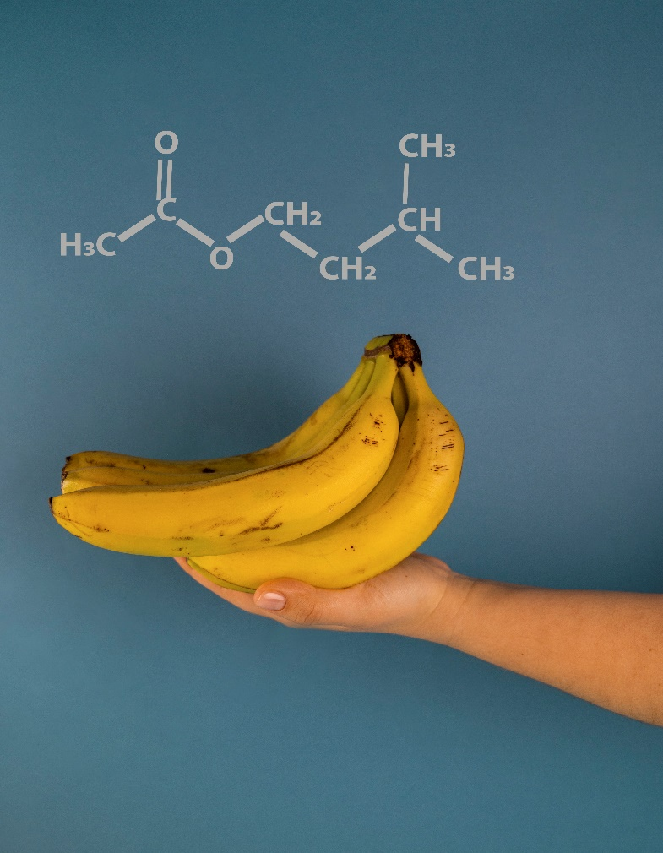

Making an ester
UNIT 2 PPA 2
Introduction
An ester is an organic compound formed from a condensation reaction between an alcohol and a carboxylic acid.
carboxylic acid
alcohol
ester
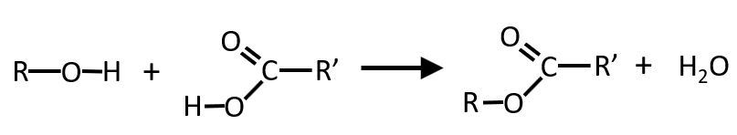

The reaction is generally slow at room temperature and the yield of ester is low. The rate can be by heating the reaction mixture and by using concentrated sulphuric acid as a catalyst. The presence of the concentrated sulphuric acid also increases the yield of ester.
The aim of this experiment is to prepare an ester and to identify some of the characteristic properties of esters.

You will need
test tube and rack | Test tube holder
paper towel | Rubber band
large beaker | small beaker
Bunsen burner and heating mat | Cotton wool
samples of alcohols (methanol, ethanol, propan-1-ol, butan-1-ol and pentan-1-ol) | Samples of acids (methanoic acid. ethanoic acid , propanoic acid, benzoic acid and salicylic acid)
Concentrated sulphuric acid | 1 mol l⁻¹ sodium hydrogencarbonate solution
Health & Safety
Concentrated sulphuric acid causes severe burns to the eyes and skin.
Methanol, ethanol and propan-1-ol are highly flammable and butan-1-ol and pentan-l-ol are flammable.
All the alcohols are harmful by inhalation, skin absorption and by swallowing and the eyes may damaged by alcohol splashes
Methanol is toxic.
Methanoic, ethanoic and propanoic acids are corrosive and the benzoic and salicylic acids are irritating to the eyes and skin.
Wear goggles and immediately wash off any chemical spillages on the skin.
Wear gloves when working with the concentrated sulphuric acid.
When smelling the ester product do it very cautiously using the technique described below.
Method
Decide which ester you are to make and follow the procedure outlined below.
- Before collecting the alcohol and carboxylic acid set up a water bath using the larger beaker and heat the water until it boils. Then turn off the Bunsen.
Alternatively. boil some water in a kettle and pour it into the large beaker.
- Add the alcohol to a test tube to a depth of about 1 cm. To this add about the same volume of carboxylic acid. If the acid is a solid then use a spatulaful.
- Add about 5 drops of concentrated sulphuric acid to the reaction mixture - in the interests of safety your teacher / lecturer may carry out this step.
- Soak the paper towel in cold water, fold it up and wrap it round the neck of the test tube and secure it with a rubber band.
This arrangement acts as a condenser when the reaction mixture is being heated.
- Place a loose plug of cotton wool in the mouth of the test tube. This will contain any chemicals which may spurt out of the reaction mixture when it is heated.
- Place the test tube in the hot water bath.
- While the reaction mixture is being heated add about 20 cm³ of sodium hydrogencarbonate solution to the small beaker.
- After about 10 minutes take the test tube from the water bath and remove the plug of cotton wool. Slowly pour the reaction mixture into the sodium hydrogencarbonate solution.
This neutralises the sulphuric acid and any remaining carboxylic acid and so removes the smell of the carboxylic acid, which can interfere with the aroma of the ester
- Gently swirl the contents of the beaker and look to see if there is any sign of the ester separating from the aqueous mixture,
- To smell the ester follow the technique outlined below,
  - First breathe in deeply to fill the lungs with uncontaminated air.
  - With your nose at least 30 cm from the mouth of the beaker gently waft the vapour towards your nose and take just a sniff.

Notes
The experiment should be carried out in a well-ventilated room.

Technicians
Each group will need
1 test tube and rack | 1 Test tube holder
paper towel | 1 Rubber band
1 large beaker 400 – 600 cm³ | 1 small beaker 100 cm³
1 Bunsen burner and heating mat | Cotton wool
1 cm³ of samples of alcohols (methanol, ethanol, propan-1-ol, butan-1-ol and pentan-1-ol) | 1 cm³ samples of acids (methanoic acid. ethanoic acid , propanoic acid, benzoic acid and salicylic acid) or a few g of solids
A few drops of concentrated sulphuric acid. A single bottle could be put out for use or supervision by the teacher | ~ 20 cm³ 1 mol l⁻¹ sodium hydrogencarbonate solution (84g per litre)
Health & Safety
See the risk assessment for details
Concentrated sulphuric acid causes severe burns to the eyes and skin.
Methanol, ethanol and propan-1-ol are highly flammable and butan-1-ol and pentan-l-ol are flammable.
All the alcohols are harmful by inhalation, skin absorption and by swallowing and the eyes may damaged by alcohol splashes
Methanol is toxic.
Methanoic, ethanoic and propanoic acids are corrosive and the benzoic and salicylic acids are irritating to the eyes and skin.
Wear goggles and immediately wash off any chemical spillages on the skin.
Wear gloves when working with the concentrated sulphuric acid.
When smelling the ester product do it very cautiously using the technique described below.
Method
Decide which ester you are to make and follow the procedure outlined below.
- Before collecting the alcohol and carboxylic acid set up a water bath using the larger beaker and heat the water until it boils. Then turn off the Bunsen.
Alternatively. boil some water in a kettle and pour it into the large beaker.
- Add the alcohol to a test tube to a depth of about 1 cm. To this add about the same volume of carboxylic acid. If the acid is a solid then use a spatulaful.
- Add about 5 drops of concentrated sulphuric acid to the reaction mixture - in the interests of safety your teacher / lecturer may carry out this step.
- Soak the paper towel in cold water, fold it up and wrap it round the neck of the test tube and secure it with a rubber band.
This arrangement acts as a condenser when the reaction mixture is being heated.
- Place a loose plug of cotton wool in the mouth of the test tube. This will contain any chemicals which may spurt out of the reaction mixture when it is heated.
- Place the test tube in the hot water bath.
- While the reaction mixture is being heated add about 20 cm³ of sodium hydrogencarbonate solution to the small beaker.
- After about 10 minutes take the test tube from the water bath and remove the plug of cotton wool. Slowly pour the reaction mixture into the sodium hydrogencarbonate solution.
This neutralises the sulphuric acid and any remaining carboxylic acid and so removes the smell of the carboxylic acid, which can interfere with the aroma of the ester
- Gently swirl the contents of the beaker and look to see if there is any sign of the ester separating from the aqueous mixture,
- To smell the ester follow the technique outlined below,
  - First breathe in deeply to fill the lungs with uncontaminated air.
  - With your nose at least 30 cm from the mouth of the beaker gently waft the vapour towards your nose and take just a sniff.

Notes
The experiment should be carried out in a well-ventilated room.

