Chemical Investigations
Identifying Carbonyl Compounds
Teacher/Technician Guide
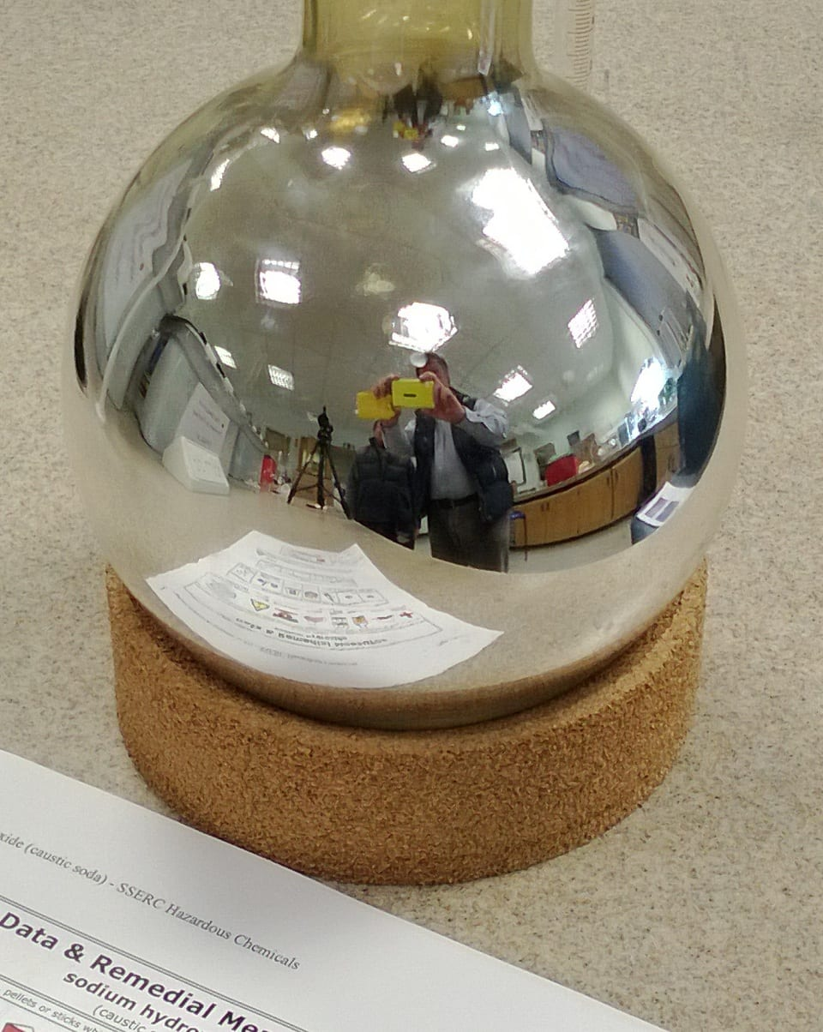

Identifying Carbonyl Compounds
UNIT 2 PPA 1
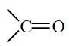
Introduction
Both aldehydes and ketones contain the carbonyl group,

In aldehydes a hydrogen atom is bonded to the carbonyl group but in ketones the carbonyl group is always flanked by carbon atoms:
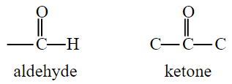
This structural difference accounts for the fact that aldehydes can undergo mild oxidation to form carboxylic acids but ketones resist oxidation. Oxidising agents can therefore be used to distinguish between aldehydes and ketones.
The aim of this experiment is to use the mild oxidising agents, acidified potassium dichromate solution, Benedict's solution and Tollens' reagent, to distinguish between two given carbonyl compounds one of which is an aldehyde and the other a ketone.

You will need
test tubes and rack | carbonyl compounds X and Y*
test tube holder | 0.1 mol l⁻¹ potassium dichromate
Bunsen burner and heating mat | 1 mol l⁻¹ sulphuric acid
tripod | Benedict's solution
large beaker | Tollens' reagent (a solution of silver nitrate in aqueous ammonia)

* X = propanal, Y = propanone
Health & Safety
Carbonyl compounds X and Yare highly flammable and their vapours irritate the eyes, skin and lungs. Compound X (propanal) is toxic by skin absorption and by swallowing. Compound Y (propanone) is harmful if swallowed.
0.1 mol l⁻¹ potassium dichromate is toxic if swallowed. It is carcinogenic and very toxic by inhalation. It is also a skin sensitiser and is very toxic to the aquatic environment.
1 mol l⁻¹ sulphuric acid irritates the eyes.
Benedict's solution contains copper salts and so is harmful if swallowed.
Tollens' reagent contains diluted sodium hydroxide which irritates the skin and eyes.
Wear eye protection and immediately wash off any chemical spillages on the skin.
When working with Tollens' reagent and compounds X and Y wear gloves.

Procedure
- Before collecting the carbonyl compounds X and Y set up a water bath and heat the water until it boils. Turn off the Bunsen.
Alternatively, boil some water in a kettle and pour it into the large beaker.
- Add sulphuric acid to each of two test tubes to a depth of about 2 cm. Then add potassium dichromate solution to both to give a total depth of about 3 cm in each.
- To one of these test tubes add about 5 drops of compound X and to the other add about 5 drops of compound Y.
- Place both test tubes in the water bath and observe and record any changes.
- Add Benedict's solution to each of two test tubes to a depth of about 3 cm.
- Repeat steps 3 and 4.
- Add Tollens' reagent to each of two very clean test tubes to a depth of about 3 cm.
- Repeat steps 3 and 4 and immediately after, wash the contents of the test tubes down the drain with large amounts of water.

Notes
This experiment should be carried out in a well-ventilated room.
Propanal has been recommended as the aldehyde rather than ethanal since the latter is more volatile and is a carcinogen.
Glucose solution could be used in place of propanal - it gives a better 'silver mirror' test.
It is important that the Tollens' reagent be prepared Just prior to its being used since it becomes explosive on evaporation. For the same reason residues must be washed down the drain immediately after use with copious amounts of water.
Fehling's solutions No. 1 (harmful) and No. 2 (corrosive) can be used as an alternative to Benedict's solution.
Sandell's reagent can also be used as a substitute for Benedict's solution. Its preparation is described on the SSERC Hazardous Chemicals database under Fehling's solutions No. 1 and No. 2.
Technicians Guide
Each group will need
6 test tubes and a rack | ~1 cm³ of propanal, labelled carbonyl compound X
1 large beaker 400 – 600 cm³ | ~1 cm³ of propanol, labelled carbonyl compound Y
1 test tube holder | ~ 2 cm³ 0.1 mol l⁻¹ potassium dichromate
1 Bunsen burner and heating mat | ~ 4 cm³ 1 mol l⁻¹ sulphuric acid
1 tripod | ~ 6 cm³ Benedict's solution
 | ~6cm³ Tollens' reagent (a solution of silver nitrate in aqueous ammonia)

0.1 mol l⁻¹ potassium dichromate – 29.4 g potassium dichromate per litre
1 mol l⁻¹ sulphuric acid – 55 cm³ concentrated sulphuric acid per litre
Benedicts reagent, qualitative. See SSERC website or SSERC Recipe Book for the recipe
Tollens' reagent – to 5 cm³ of 0.05 mol l⁻¹ silver nitrate solution add about 5 drops of 2 mol l=1 sodium hydroxide. Then add drops of 2 mol l⁻¹ ammonia solution until the precipitate formed just dissolves.

Health & Safety
See risk assessment for this activity
Do NOT make up the Tollens reagent in advance, or keep residues to try to recycle the silver. It forms dangerously explosive compounds on standing for more than about an hour. Make up immediately before use and wash to waste immediately after.
Carbonyl compounds X and Yare highly flammable and their vapours irritate the eyes, skin and lungs. Compound X (propanal) is toxic by skin absorption and by swallowing. Compound Y (propanone) is harmful if swallowed.
0.1 mol l⁻¹ potassium dichromate is toxic if swallowed. It is carcinogenic and very toxic by inhalation. It is also a skin sensitiser and is very toxic to the aquatic environment.
1 mol l⁻¹ sulphuric acid irritates the eyes.
Benedict's solution contains copper salts and so is harmful if swallowed.
Tollens' reagent contains diluted sodium hydroxide which irritates the skin and eyes.
Wear eye protection and immediately wash off any chemical spillages on the skin.
When working with Tollens' reagent and compounds X and Y wear gloves.
Method
- Before collecting the carbonyl compounds X and Y set up a water bath and heat the water until it boils. Turn off the Bunsen.
Alternatively, boil some water in a kettle and pour it into the large beaker.
- Add sulphuric acid to each of two test tubes to a depth of about 2 cm. Then add potassium dichromate solution to both to give a total depth of about 3 cm in each.
- To one of these test tubes add about 5 drops of compound X and to the other add about 5 drops of compound Y.
- Place both test tubes in the water bath and observe and record any changes.
- Add Benedict's solution to each of two test tubes to a depth of about 3 cm.
- Repeat steps 3 and 4.
- Add Tollens' reagent to each of two very clean test tubes to a depth of about 3 cm.
- Repeat steps 3 and 4 and immediately after, wash the contents of the test tubes down the drain with large amounts of water.

Notes
This experiment should be carried out in a well-ventilated room.
Propanal has been recommended as the aldehyde rather than ethanal since the latter is more volatile and is a carcinogen.
Glucose solution could be used in place of propanal - it gives a better 'silver mirror' test.
It is important that the Tollens' reagent be prepared Just prior to its being used since it becomes explosive on evaporation. For the same reason residues must be washed down the drain With copious amounts of water.
Fehling's solutions No. 1 (harmful) and No. 2 (corrosive) can be used as an alternative to Benedict's solution.
Sandell's reagent can also be used as a substitute for Benedict's solution. Its preparation is described in the Hazardous Chemicals Manual under Fehling's solutions No. 1 and No. 2.

