Chemical Investigations
Identifying Carbonyl Compounds
Pupil Guide
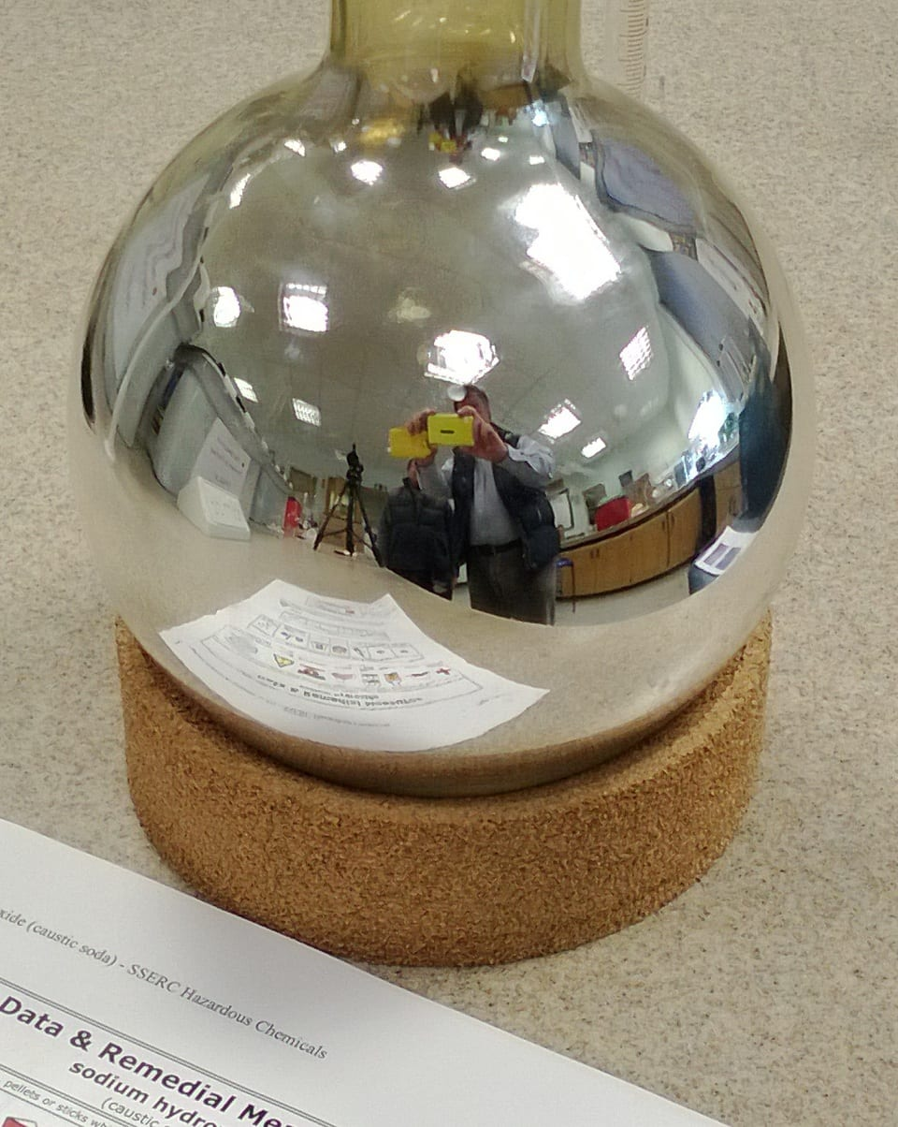

Identifying Carbonyl Compounds
UNIT 2 PPA 1
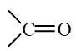
Introduction
Both aldehydes and ketones contain the carbonyl group,

In aldehydes a hydrogen atom is bonded to the carbonyl group but in ketones the carbonyl group is always flanked by carbon atoms:
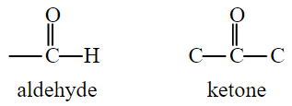
This structural difference accounts for the fact that aldehydes can undergo mild oxidation to form carboxylic acids but ketones resist oxidation. Oxidising agents can therefore be used to distinguish between aldehydes and ketones.
The aim of this experiment is to use the mild oxidising agents, acidified potassium dichromate solution, Benedict's solution and Tollens' reagent, to distinguish between two given carbonyl compounds one of which is an aldehyde and the other a ketone.

You will need
test tubes and rack | carbonyl compounds X and Y*
test tube holder | 0.1 mol l⁻¹ potassium dichromate
Bunsen burner and heating mat | 1 mol l⁻¹ sulphuric acid
tripod | Benedict's solution
large beaker | Tollens' reagent (a solution of silver nitrate in aqueous ammonia)

* X = propanal, Y = propanone
Health & Safety
Carbonyl compounds X and Yare highly flammable and their vapours irritate the eyes, skin and lungs. Compound X is toxic by skin absorption and by swallowing. Compound Y is harmful if swallowed.
0.1 mol l⁻¹ potassium dichromate is toxic if swallowed. It is carcinogenic and very toxic by inhalation. It is also a skin sensitiser and is very toxic to the aquatic environment.
1 mol l⁻¹ sulphuric acid irritates the eyes.
Benedict's solution contains copper salts and so is harmful if swallowed.
Tollens' reagent contains diluted sodium hydroxide which irritates the skin and eyes.
Wear eye protection and immediately wash off any chemical spillages on the skin.
When working with Tollens' reagent and compounds X and Y wear gloves.

Procedure
- Before collecting the carbonyl compounds X and Y set up a water bath and heat the water until it boils. Turn off the Bunsen.
Alternatively, boil some water in a kettle and pour it into the large beaker.
- Add sulphuric acid to each of two test tubes to a depth of about 2 cm. Then add potassium dichromate solution to both to give a total depth of about 3 cm in each.
- To one of these test tubes add about 5 drops of compound X and to the other add about 5 drops of compound Y.
- Place both test tubes in the water bath and observe and record any changes.
- Add Benedict's solution to each of two test tubes to a depth of about 3 cm.
- Repeat steps 3 and 4.
- Add Tollens' reagent to each of two very clean test tubes to a depth of about 3 cm.
- Repeat steps 3 and 4 and immediately after, wash the contents of the test tubes down the drain with large amounts of water.

Notes
This experiment should be carried out in a well-ventilated room.
It is important that the Tollens' reagent be prepared Just prior to its being used since it becomes explosive on standing. For the same reason residues must be washed down the drain immediately after use with copious amounts of water.

