Chemical Investigations
Hess’s Law
Pupil Guide
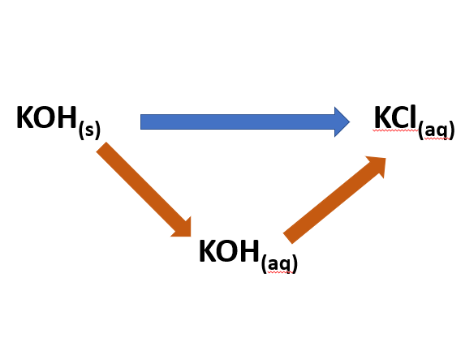

Hess’s Law
UNIT 3 PPA 1
Introduction
Solid potassium hydroxide can be converted into potassium chloride solution by two different routes:
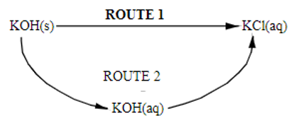
Route I is the direct route whereby potassium chloride solution is made by adding solid potassium hydroxide directly to hydrochloric acid. Let's suppose it has an enthalpy change of ΔH₁
KOH_{(s)} + HCl_{(aq)} KCl_{(aq)} H₂O_{(l)} ΔH₁
Route 2 is the indirect route and involves two steps. In the first of these solid potassium hydroxide is dissolved in water:
KOH_{(s)} + H₂O_{(l)} KOH_{(aq)} ΔH_{2a}
The resulting potassium hydroxide solution is then added to hydrochloric acid to form potassium chloride solution:
KOH_{(aq)} + HCl_{(aq)} KCl_{(aq)} H₂O_{(l)} ΔH_{2b}
According to Hess's Law the overall enthalpy change involved in converting solid potassium hydroxide into potassium chloride solution will be the same no matter whether the direct or indirect route is taken.
The aim of this experiment is to confirm Hess's Law.
You will need
thermometer | measuring cylinders
plastic beakers or polystyrene cups | balance
potassium hydroxide | 1 mol l⁻¹ hydrochloric acid

Health & Safety
Solid potassium hydroxide and the potassium hydroxide solution you make are corrosive.
1 mol l⁻¹ hydrochloric acid is of no significant hazard.
Wear goggles and wash your hands immediately if any solid potassium hydroxide comes into contact with them.
If any potassium hydroxide solution splashes on your skin: wash it off immediately.

Method
Route 1 (direct route)
- Using the measuring cylinder: measure out 25 cm³ of 1 mol l⁻¹ hydrochloric acid into a plastic beaker or polystyrene cup.
- Measure and record the temperature of the acid.
- Weigh out accurately about 1.2 g of potassium hydroxide into a plastic beaker or polystyrene cup and record the mass.
Make sure the mass of potassium hydroxide does not exceed 1.4 g.
- Add the acid to the potassium hydroxide. Slowly and continuously stir the reaction mixture with the thermometer until all the solid reacts.
- Measure and record the highest temperature reached by the reaction mixture.

Route 2 (indirect route)
Step A
The solution you prepare in this step is needed in step B - DON'T THROW IT AWAY!
- Using the measuring cylinder, measure out 25 cm³ of water into a plastic beaker or polystyrene cup.
- Measure and record the temperature of the water
- Weigh out accurately about 1.2 g of potassium hydroxide into a plastic beaker or polystyrene cup and record the mass.
Make sure the mass of potassium hydroxide does not exceed 1.4 g.
- Add the water to the potassium hydroxide. Slowly and continuously stir the reaction mixture with the thermometer until all the solid dissolves.
- Measure and record the highest temperature reached by the solution.
- Keep the solution you have just prepared but allow it to cool down for some time before proceeding to step B.
Step B
- Using the measuring cylinder, measure out 25 cm³ of 1 mol l⁻¹ hydrochloric acid into a plastic beaker or polystyrene cup.
- Measure and record the temperature of the acid.
- Measure and record the temperature of the potassium hydroxide solution you prepared in step A.
- Add the acid to the potassium hydroxide solution and stir the reaction mixture slowly and continuously with the thermometer.
- Measure and record the highest temperature reached by the reaction mixture.

Notes
It is important that the hydrochloric acid be in excess. Provided that the concentrations and volumes of acid used are as stated a mass of just less than 1.4 g (0.025 mol) potassium hydroxide will ensure this.

Calculations
Note: In calculating the heat energies absorbed by the reaction mixtures we treat the latter as if they were entirely made up of water. This means that we assume their specific heat capacities and densities to be the same as those for water i.e. 4.18 kJ kg⁻¹ °C⁻¹ and 1.00 g cm⁻³ (or 1.00 kg l⁻¹).
Route 1 - calculation of ΔH₁
- The heat energy gained by the reaction mixture (E_{h}) can be calculated using the formula:
E_{h} = c m ΔT
where c = the specific heat capacity
m = the mass (in kg)
ΔT = the rise in temperature (in °C)
- We assume that all the heat energy released in the reaction is absorbed only by the reaction mixture.
So the heat energy we calculated in stage (a) is equal to that released when, say, x g of potassium hydroxide reacts with the acid.
- We can work out the mass of one mole of potassium hydroxide and knowing how much heat energy is released when x g of potassium hydroxide reacts with the acid we can calculate the heat energy released when one mole of potassium hydroxide reacts.
This will be equal to the enthalpy change for route 1 i.e. ΔH₁.
Route 2 - calculation of ΔH_{2a} and ΔH_{2b}
- ΔH_{2a} the enthalpy change for the first step of route 2, can be calculated in a similar fashion to that described above.
- ΔH_{2b} the enthalpy change for the second step, can be calculated in the same way but remember
  - the mass of the reaction mixture is the combined masses of the potassium hydroxide solution and the hvdrochloric acid.
  - The initial temperature of the reaction mixture will be the average of the initial temperatures of the potassium hydroxide solution and the hydrochloric acid.
  - The mass of potassium hydroxide used will be identical to that used in calculating ΔH_{2a}

Example calculations
Route 1 - calculation of ΔH₁
Suppose 1.25 g of potassium hydroxide had been added to 25 cm³ of hydrochloric acid and the temperature of the reaction mixture had risen by 23.5 °C.
The heat energy gained by the reaction mixture (E_{h}) is calculated using the formula:
E_{h} = c m ΔT
where c = the specific heat capacity
m = the mass (in kg)
ΔT = the rise in temperature (in °C)

E_{h} = 4.18 x 0.025 x 23.5
= 2.456 kJ
We assume that the heat energy released in the reaction is gained only by the reaction mixture.
The heat energy released on reacting 1.25 g of potassium hydroxide with hydrochloric acid = 2.456 kJ.
potassium hydroxide: KOH
Mass of 1 mole = 39 + 16+1 = 56g
We can now calculate the heat energy released on reacting 1 mole of potassium hydroxide with hydrochloric acid.
1.25 2.456 kj
56g 2.456 x 56
1.25
= 110kJ
= -110kJmor:
(A negative sign is used because the reaction is exothermic)
Route 2 - calculation of ΔH_{2a}
Suppose 1.18 g of potassium hydroxide had been added to 25 cm³ of water and the temperature had risen by 10 °C.
Eh = 4.18 x 0.025 x 10
= 1.045 kJ
The heat energy released on reacting 1.18 g of potassium hydroxide with water = 1.045 kJ
We can now calculate the heat energ released on reacting 1 mole (56 g) of potassium hydroxide with water.
1.18g 1.045kJ
55g 1.045 x 56
1.18
= 49.6 kj
Hence ΔH_{2a} = -49.6 kJ mol⁻¹

Route 2 - calculation of ΔH_{2b}
Suppose the temperature ofthe reaction mixture had risen by 5.5 °C when 25 cm³ of hydrochloric acid had been added to the 25 cm³ of potassium hydroxide solution prepared in the first step of route 2.
The mass of the reaction mixture will be 0.050 kg (the combined masses of the two solutions)
E_{h} = 4.18 x 0.050 x 5.5
= 1.150 kJ
Knowing that the mass of potassium hydroxide present in the potassium hydroxide solution is 1.18g we can now calculate the heat energy released when 1 mole of potassium hydroxide (56 g) solution reacts with hydrochloric acid.
1.18g 1.150 kJ
56g 1.150 x 56
1.18
= 54.6kJ
Hence = ΔH_{2b} = - 54.6 kJ mol⁻¹

Enthalpy change for route 1 = ΔH₁ = -110 kJ mol⁻¹
Enthalpy change for route 2 = ΔH_{2a} + ΔH_{2b} = -49.6 -54.6 = -104 kJ mol-1
Since ΔH₁ is approximately equal to ΔH_{2a} + ΔH_{2b} Hess's Law has been confirmed.

