Chemical Investigations
Factors affecting enzyme activity
Teacher/Technician Guide
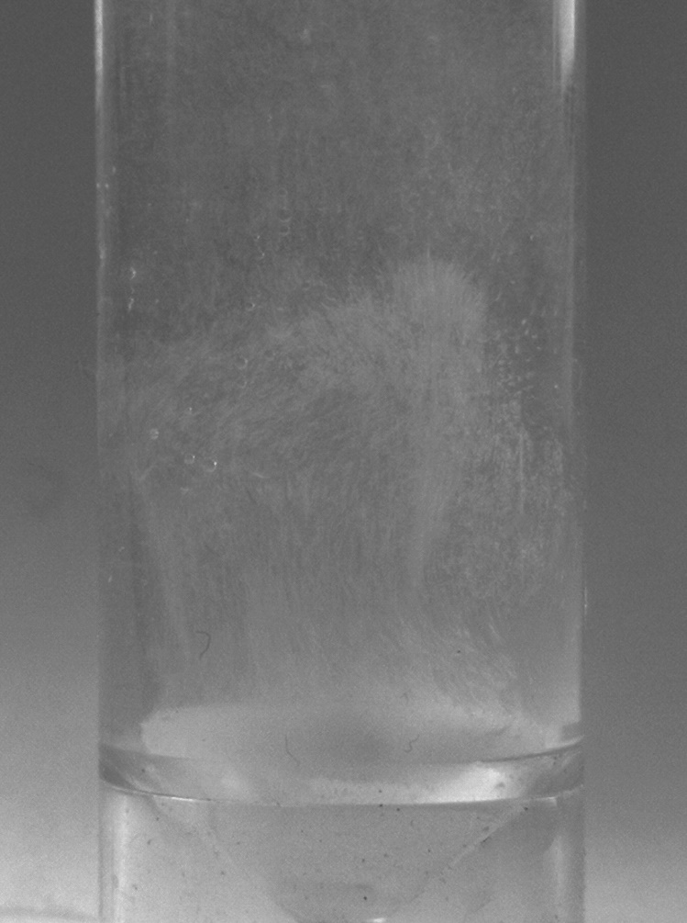

Factors Affecting Enzyme Activity
UNIT 2 PPA 3
Introduction
Enzymes are globular protein molecules which catalyse biochemical reactions. An enzyme is very specific usually catalysing only one reaction of one particular compound. The latter is known as the substrate and it binds on to an enzyme's active site where it undergoes reaction. The active site has a unique shape which is matched by that Of the substrate molecule. This allows an enzyme to accept only its substrate molecule and reject all others. Any change which alters the shape of the active site will affect an enzyme's activity.
The aim of this experiment is to investigate the effect or pH or temperature changes on enzyme activity.
We will study catalase. an enzyme widely distributed in living organisms. It catalyses the decomposition of hydrogen peroxide into water and oxygen:
2H₂O_{2(aq)} 2H₂O_{(l)} + 0₂(g)
Choose the factor you will investigate (either pH or temperature) and proceed to the appropriate section below.
pH
You will need
test tube with side arm | delivery tube
stopper | syringes
small beaker | clamp stand and clamp
Timer
potato discs (catalase source) | hydrogen peroxide (30 volumes)
buffer solutions (pH 4, 7 and 10) | 0.1 mol l⁻¹ sodium hydroxide (pH 13)
0.1 mol l⁻¹ hydrochloric acid (pH l)

Health & Safety
30 vol Hydrogen peroxide is corrosive to the eyes.
0.1 mol l⁻¹ sodium hydroxide is a skin and eye irritant
Most buffers are of no significant hazard at working concentration – check with your teacher /lecturer though before using them.
Wear goggles and wash off any chemical spillages on the skin.
When using the syringes always keep them pointing downwards.
Method
Procedure
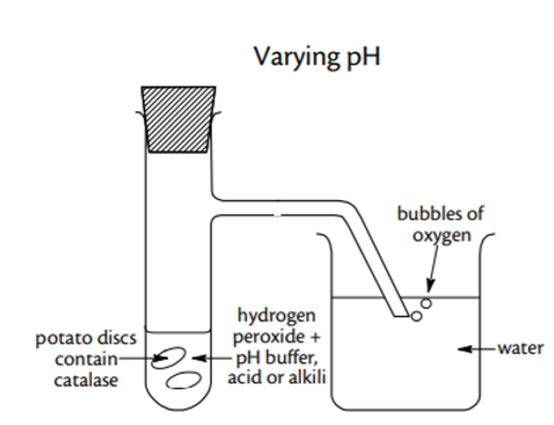
- Attach the delivery tube to the side arm of the test tube and clamp the test tube in a vertical position.
- Half fill the beaker with water.
- Arrange the apparatus so that the bent end of the delivery tube is beneath the surface of the water in the beaker
- Using a syringe, add 5cm³ of the pH 7 buffer solution into the test tube along with 3 potato discs.
- Leave the mixture to stand for three minutes and during this time measure I cm³ of hydrogen peroxide into a syringe.
- Add the hydrogen peroxide to the test tube and immediately start the timer and stopper the test tube. Then count and record the number of bubbles of oxygen given off during the next 3 minutes.
- Repeat the experiment with each of the two remaining buffer solutions and then with 0.1 rnol l⁻¹ hydrochloric acid (pH l) and finally with 0.1 mol l⁻¹ sodium hydroxide solution (pH 13).
In each experiment remember to:
- leave the buffer/potato disc mixture to stand for 3 minutes before adding the hydrogen peroxide
- count and record the number of bubbles of oxygen produced during the first 3 minutes of reaction.

Temperature
You will need
test tube with side arm | delivery tube
stopper | syringes
small beaker & large beaker | clamp stand and clamp
Timer | tripod
Bunsen burner and heating mat | thermometer
potato discs (catalase source) | hydrogen peroxide (30 volumes)
Deionised water
Health & Safety
30 vol Hydrogen peroxide is corrosive to the eyes.
Wear goggles and wash off any chemical spillages on the skin.
When using the syringes always keep them pointing downwards.

Method
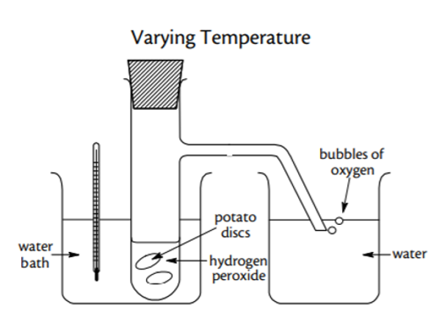
- Half fill both beakers with water from the cold tap and place the larger one on the tripod.
- Attach the delivery tube to the side arm of the test tube, place the test tube in the large beaker of water and clamp it in a vertical position.
- Arrange the apparatus so that the bent end of the delivery tube is beneath the surface of the water in the small beaker.
- Using a syringe, add 5 cm³ of deionised water into the test tube along with 3 potato discs.
- Place the thermometer in the test tube and leave the mixture to stand until its temperature remains steady. Measure and record this steady temperature.
- Measure 1 cm³ of hydrogen peroxide into a syringe.
- Add the hydrogen peroxide to the test tube and immediately start the timer and stopper the test tube. Then count and record the number of bubbles of oxygen given off during the next 3 minutes.
- Repeat the experiment another four times after heating the water in the large beaker first to 30 °C, then to 40 °C, then to 50 °C and finally to 60 °C. It is not necessary to heat the water to these precise temperatures - they are only approximate values.
In each experiment remember to:
- leave the water/potato disc mixture to stand until its temperature remains steady
- measure and record this steady temperature just before adding the hydrogen peroxide
- count and record the number of bubbles of oxygen produced during the first 3 minutes of reaction.

Notes
The potato discs can be prepared using a cork borer and slicing the potato cylinders.
Since catalase concentration in potatoes will vary it is advisable to trial this experiment and if necessary adjust the hydrogen peroxide concentration and/or the number of potato discs to give an appropriate rate of hydrogen peroxide decomposition.
Alternative sources of catalase could be used e.g. fresh liver or the commercially available catalase from bovine liver. With these alternatives the reaction rate will be faster and it may therefore be easier to measure the volume of oxygen rather than count the number of bubbles

Technician Guide

Each group will need

For both experiments
1 x test tube with side arm | 1 x delivery tube
1` x stopper | 2 x syringes (1 x 5 cm³ & 1 x 1 cm³)
1 x small beaker | 1 x clamp stand and clamp
1 x Timer
potato discs (catalase source) 15mm dia, 1mm thickness | 5 cm³ hydrogen peroxide (30 volumes)
For pH experiment only
5 cm³ each of buffer solutions (pH 4, 7 and 10) | 5 cm³ 0.1 mol l⁻¹ sodium hydroxide (pH 13)
5 cm³ 0.1 mol l⁻¹ hydrochloric acid (pH l)
For temperature experiment only
Bunsen burner and heating mat | 1 x 0-100°C thermometer
~ 25 cm³ Deionised water | tripod
1 x 400 - 600 cm³ beaker

. Method for pH
Method
Procedure
- Attach the delivery tube to the side arm of the test tube and clamp the test tube in a vertical position.
- Half fill the beaker with water.
- Arrange the apparatus so that the bent end of the delivery tube is beneath the surface of the water in the beaker
- Using a syringe, add 5cm³ of the pH 7 buffer solution into the test tube along with 3 potato discs.
- Leave the mixture to stand for three minutes and during this time measure I cm³ of hydrogen peroxide into a syringe.
- Add the hydrogen peroxide to the test tube and immediately start the timer and stopper the test tube. Then count and record the number of bubbles of oxygen given off during the next 3 minutes.
- Repeat the experiment with each of the two remaining buffer solutions and then with 0.1 rnol l⁻¹ hydrochloric acid (pH l) and finally with 0.1 mol l⁻¹ sodium hydroxide solution (pH 13).
In each experiment remember to:
- leave the buffer/potato disc mixture to stand for 3 minutes before adding the hydrogen peroxide
- count and record the number of bubbles of oxygen produced during the first 3 minutes of reaction.

Method for Temperature
- Half fill both beakers with water from the cold tap and place the larger one on the tripod.
- Attach the delivery tube to the side arm of the test tube, place the test tube in the large beaker of water and clamp it in a vertical position.
- Arrange the apparatus so that the bent end of the delivery tube is beneath the surface of the water in the small beaker.
- Using a syringe, add 5 cm³ of deionised water into the test tube along with 3 potato discs.
- Place the thermometer in the test tube and leave the mixture to stand until its temperature remains steady. Measure and record this steady temperature.
- Measure 1 cm³ of hydrogen peroxide into a syringe.
- Add the hydrogen peroxide to the test tube and immediately start the timer and stopper the test tube. Then count and record the number of bubbles of oxygen given off during the next 3 minutes.
- Repeat the experiment another four times after heating the water in the large beaker first to 30 °C, then to 40 °C, then to 50 °C and finally to 60 °C. It is not necessary to heat the water to these precise temperatures - they are only approximate values.
In each experiment remember to:
- leave the water/potato disc mixture to stand until its temperature remains steady
- measure and record this steady temperature just before adding the hydrogen peroxide
- count and record the number of bubbles of oxygen produced during the first 3 minutes of reaction.

Notes
The potato discs can be prepared using a cork borer and slicing the potato cylinders.
Since catalase concentration in potatoes will vary it is advisable to trial this experiment and if necessary adjust the hydrogen peroxide concentration and/or the number of potato discs to give an appropriate rate of hydrogen peroxide decomposition.
Alternative sources of catalase could be used e.g. fresh liver or the commercially available catalase from bovine liver. With these alternatives the reaction rate will be faster and it may therefore be easier to measure the volume of oxygen rather than count the number of bubbles

