Chemical Investigations
Enthalpy of combustion
Pupil Guide
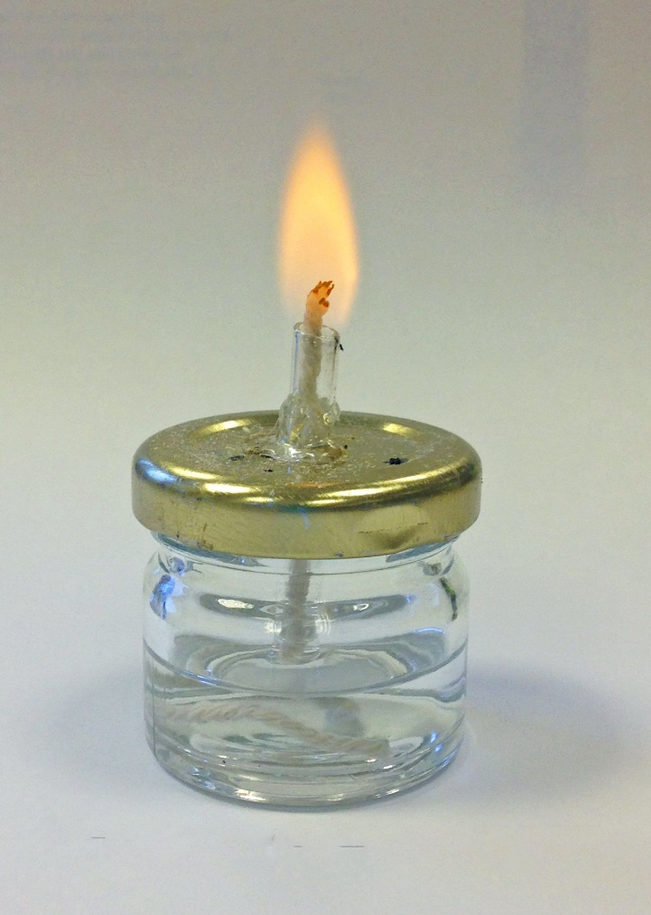

Enthalpy of Combustion
UNIT 1 PPA 3
Introduction
The enthalpy of combustion of a substance is the energy released when one mole of the substance is completely burned in oxygen.
The aim of this experiment is to determine the enthalpy of combustion of ethanol i.e. the enthalpy change for the reaction:
A measured mass of ethanol is burned in a spirit burner and the heat released is transferred to a copper can containing a known volume of water. From the resulting temperature rise, the enthalpy of combustion of ethanol can be calculated.
In this experiment we assume all the heat released in the combustion reaction is absorbed by the water in the copper can.

You will need
Spirit burner (containing ethanol) | Copper can
Clamp stand and clamp | Draught shield
Measuring cylinder | Balance
Thermometer

Safety
Ethanol is highly flammable and the main risk is from burns. Since only a small amount is burned the build up of any products of incomplete combustion is negligible.
Wear eye protection.
Ensure the spirit burner is always sitting in a stable position.
Should you have to re-fill the spirit burner, allow it to cool and then fill it away from sources of ignition

Method
- Weigh the spirit burner (already containing ethanol) with its cap on and record its mass. (The cap should be kept on to cut down the loss of ethanol through evaporation)
- Using the measuring measure out 100 cm³ of water and transfer to the copper can.
- Set up the apparatus as directed by your teacher / lecturer.
- Measure and record the temperature of the water.
- Remove the cap from the spirit burner and immediately light the burner.
- Slowly and continuously stir the water with the thermometer. the temperature has risen by about 10°C recap the spirit burnet and measure and record the maximum temperature of the water.
- Reweigh the spirit burner and record its mass.
Calculation
- The heat energy gained by the water (ED can be calculated using the formuIa:

E_{h} = c m ΔT
Where
c = the specific heat capacity of the water (the heat energy needed to raise the temperature of 1 kg of water by 1°Cand has the value 4.18 kJ kg⁻¹°C⁻¹
m= the mass (in kg) of water being heated. (The density of water is 1.0 g cm⁻³ or 1,000 kg l⁻¹
ΔT = the rise in temperature in °C

(b) The in the initial and final masses of the spirit burner gives us the mass of ethanol burned (say g) and so the heat energy we calculate in step (a) is equal to that released by burning x g of ethanol. We are assuming that all the heat energy released by the burning ethanol is absorbed only by the water.
(c) We can work out the mass of one mole of ethanol and knowing how much heat energy is released When x g of ethanol is burned we can calculate the heat energy released when one mole of ethanol is burned, This will be equal to the enthalpy of combustion of ethanol.

Calculation example
Suppose 0.25 g of ethanol had been burned and the temperature of the water had risen by 12.5°C.
The heat gained by the water (E_{h}) is calculated using the formula: E_{h} = c m ΔT
Where
c = the specific heat capacity of the water (the heat energy needed to raise the temperature of 1 kg of water by 1°Cand has the value 4.18 kJ kg⁻¹°C⁻¹
m= the mass (in kg) of water being heated. (The density of water is 1.0 g cm⁻³ or 1,000 kg l⁻¹
ΔT = the rise in temperature in °C

E_{h} = 4.18 x 0.10 x 12.5
= 5.225 kJ
We assume that the heat energy released by the burning ethanol is gained only by the water.
The heat energy released on burning 0.25g of ethanol = 5.225 kJ
Ethanol – CH₃CH₂OH
Mass of 1 mole = (2 x 12) + (6 x 1) + 16 = 46g
We can now calculate the heat energy released on burning 1 mole of ethanol.
0.25 5.225 kJ
46g 5.225 x 4600
0.25
= 961 kJ

So the enthalpy of combustion of ethanol is -961 kJ mol⁻¹
(a negative sign is used because combustion is an exothermic reaction)

