Chemical Investigations
Effect of concentration on rate of reaction
Teacher/Technician Guide
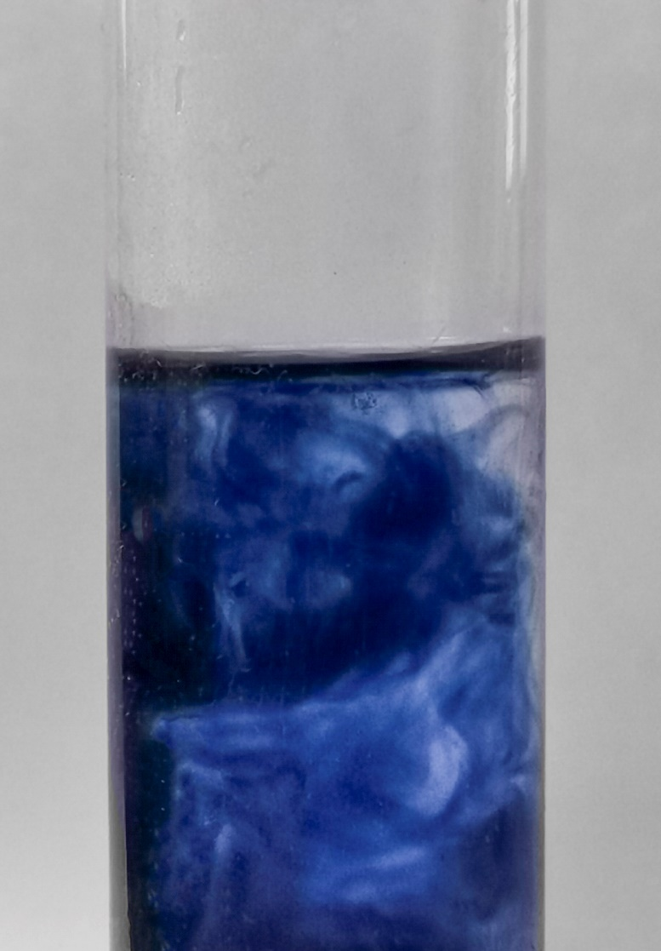

Effect of concentration on rate of reaction
UNIT 1 PPA 1
Introduction
This reaction investigates the effect on the rate of reaction between potassium iodide and hydrogen peroxide by changing the concentration of potassium iodide. This reaction is a type of ‘clock’ reaction.
In acidic conditions, hydrogen peroxide reacts with potassium iodide to form water and iodine
H₂O_{2(aq)} + 2H⁺_{(aq)} + 2I⁻_{(aq)} 2H₂O_{(l)} + I_{2(aq)}
To follow the course of the reaction, small quantities of starch and sodium thiosulphate can be added.
I_{2(aq)} + 2S₂O₃²⁻_{(aq)} 2I⁻_{(aq)} S₄O₆²⁻_{(aq)}
The starch is used to indicate the presence of iodine.
The thiosulphate ions react with the iodine and change it to iodide ions. Therefore, when the thiosulphate ions have been used up, iodine will be left over which then reacts with the starch turning the mixture from colourless to blue/black.
If you keep the amount of thiosulphate constant, it ensures that the time taken for the colour to change (appear) at each concentration of KI is the time taken to produce the same number of moles of iodine.
If t is the time taken for the blue/black colour to appear, then we can take 1/t as a measurement of the reaction rate.
Health & Safety
The solutions involved in this reaction are all dilute enough to be of no significant hazard and thus need no eye protection or other PPE.
(Though the same is not necessarily true for technicians preparing the solutions)

Each group will need
Hydrogen peroxide 3 vol (0.25 mol l⁻¹ / 0.83%) | Potassium iodide solution 0.5 mol l⁻¹
Sulphuric acid 0.05 mol l⁻¹ | Sodium thiosulphate solution 0.01 mol l⁻¹
Starch solution (~ 0.4%) | Distilled water
Small beakers / flasks | 25 cm³ measuring cylinder
Pipettes (3 cm³ pasteur pipettes are suitable but any others able to measure from 1 – 5 cm³ are fine | Timer
Procedure
- Using pipettes and/or measuring cylinders, add the following reagents to a set of flasks / beakers.
Expt No | Sulphuric acid cm³ | Starch cm³ | Potassium iodide cm³ | Water cm³ | Sodium thiosulphate cm³
1 | 25 | 1 | 1 | 4 | 1
2 | 25 | 1 | 2 | 3 | 1
3 | 25 | 1 | 3 | 2 | 1
4 | 25 | 1 | 4 | 1 | 1
5 | 25 | 1 | 5 | 0 | 1

Alternatively, you can prepare these one at a time and rinse the flask / beaker between experiments
- When you are ready to start you should add 1 cm³ of hydrogen peroxide solution to the first beaker and start timing Tum on the water tap and the suction from the pump will ensure that the ﬁlter paper adheres firmly to the perforated bed of the funnel.
- As soon as the blue/black colour appears, stop the timer and record the time (in seconds).
- Rinse the flask / beaker if you are only using one and fill it with the next set of reagents.
- Add 1 cm³ hydrogen peroxide, as before, and time how long it takes to for the colour to appear.
- Repeat again for the rest of the mixtures

Your results.
- Calculate the reciprocal of the times (in seconds) 1 / t
- Plot a graph of concentration of potassium iodide against the reciprocal of the time.

Notes
In order to avoid temperature changes confusing the issue, ensure that all the reagents are put out in the laboratory early enough for the temperature to equilibrate – especially is, as is common, the hydrogen peroxide has been kept in the fridge.

Extensions
You can use a similar experiment and keep the potassium iodide constant and see the effect of changing the temperature
You could repeat at different pH values
Technician Guide
UNIT 1 PPA 1

Each group will need
Volumes are rounded up to allow for a little extra.
10 cm³ Hydrogen peroxide 3 vol (0.25 mol l⁻¹ / 0.83%) | 20 cm³ Potassium iodide solution 0.5 mol l⁻¹
150 cm³ Sulphuric acid 0.05 mol l⁻¹ | 10 cm³ Sodium thiosulphate solution 0.01 mol l⁻¹
10 cm³ Starch solution (~ 0.4%) | 15 cm³ Distilled water
1 or 5 Small beakers / flasks (100 cm³) | 25 cm³ measuring cylinder
Pipettes (3 cm³ pasteur pipettes are suitable but any others able to measure from 1 – 5 cm³ are fine | Timer

Procedure
- Using pipettes and/or measuring cylinders, add the following reagents to a set of flasks / beakers.
Expt No | Sulphuric acid cm³ | Starch cm³ | Potassium iodide cm³ | Water cm³ | Sodium thiosulphate cm³
1 | 25 | 1 | 1 | 4 | 1
2 | 25 | 1 | 2 | 3 | 1
3 | 25 | 1 | 3 | 2 | 1
4 | 25 | 1 | 4 | 1 | 1
5 | 25 | 1 | 5 | 0 | 1

Alternatively, you can prepare these one at a time and rinse the flask / beaker between experiments
- When you are ready to start you should add 1 cm³ of hydrogen peroxide solution to the first beaker and start timing Tum on the water tap and the suction from the pump will ensure that the ﬁlter paper adheres firmly to the perforated bed of the funnel.
- As soon as the blue/black colour appears, stop the timer and record the time (in seconds).
- Rinse the flask / beaker if you are only using one and fill it with the next set of reagents.
- Add 1 cm³ hydrogen peroxide, as before, and time how long it takes to for the colour to appear.
- Repeat again for the rest of the mixtures

Your results.
- Calculate the reciprocal of the times (in seconds) 1 / t
- Plot a graph of concentration of potassium iodide against the reciprocal of the time.

Notes
In order to avoid temperature changes confusing the issue, ensure that all the reagents are put out in the laboratory early enough for the temperature to equilibrate – especially is, as is common, the hydrogen peroxide has been kept in the fridge

