Chemical Investigations
Effect of temperature on rate of reaction
Pupil Guide
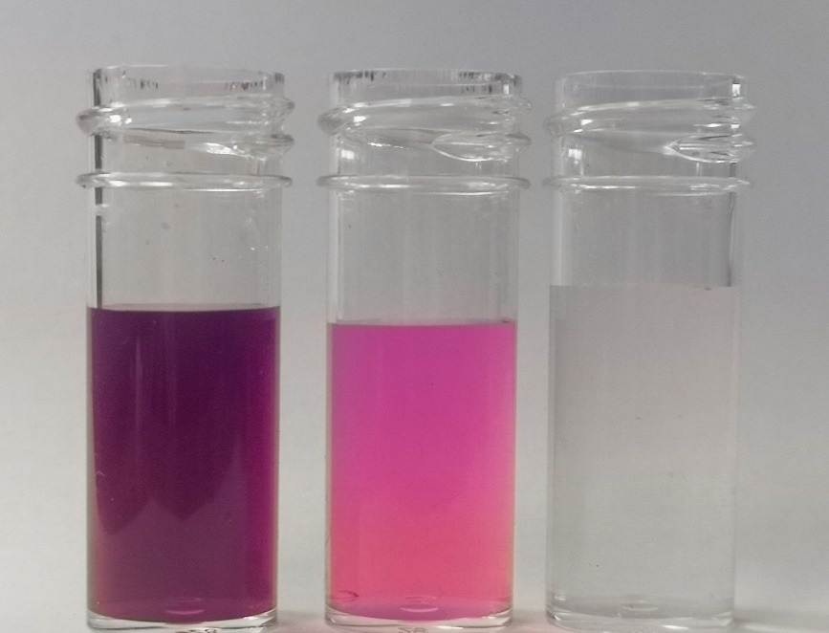

The Effect Of Temperature Changes On Reaction Rate
UNIT 1 PPA 2
Introduction
The aim of this experiment is to find the effect of varying temperature on the rate or reaction between ethanedioic (oxalic) acid and an acidified solution of potassium permanganate:
5 (COOH)_{2(aq)} + 6 H⁺ + 2 MnO4²⁻_{(aq)} 2 Mn²⁺_{(aq)} + 10 CO_{2(g)} + 8 H₂O_{(l)}
Initially the reaction mixture is purple in colour due to the presence of the permanganate ions but it will turn colourless as soon as they are used up. This colour change allows us to follow the course of the reaction.
A series of experiments will be carried out in which only the temperature of the reaction mixtures be kept constant. The concentrations and volumes of the reactants be kept constant.
Since the amount of permanganate ions initially present will be the same in each experiment, the point at which the purple colour disappears will always represent the same extent of reaction. So if t is the time it takes the colour change to occur then we can take l/t as a measure of the reaction rate.
You will need
A selection of syringes | 100 cm³ glass beakers
white tile | Bunsen burner, heating mat & tripod
Timer | Thermometer
0.2 mol l⁻¹ ethanedioic (oxalic) acid | 1 mol l⁻¹ sulphuric acid
0.02 mol l⁻¹ potassium permanganate | deionised water

Health & safety
1 mol l⁻¹ sulphuric acid is a skin and eye irritant - wear eye protection.
If any chemical splashes on your skin, wash it off immediately,
When using the syringes always keep them pointing downwards.

Method
- Using syringes, add
  - 5 cm³ of sulphuric acid
  - 2 cm³ of potassium permanganate and
  - 40 cm³ of water
to a 100 cm³ dry glass beaker.
- Heat the mixture to about 40°C
- Place the beaker on a white tile and measure 1 cm³ of oxalic acid solution into a syringe.
- Add the oxalic acid to the mixture in the beaker as quickly as possible and at the same time start the timer.
- Gently stir the reaction mixture with the thermometer.
- When the reaction mixture just turns colourless Stop the timer and record the time (in seconds).
Measure and record the temperature of the reaction mixture.
- Repeat the experiment another three times but heat the initial sulphuric acid / potassium permanganate water mixtures first to 50°C then to 60°C and finally to 70°C.
In each experiment, measure and record the time it takes for the reaction mixture to just turn colourless and measure and record its temperature when this happens.

Notes
At temperatures below 40°C the colour change in the reaction is gradual and difficult to pinpoint.

