

|  |
| --- |
| Chemical Demonstrations |
| Copper and Le Chatelier |

 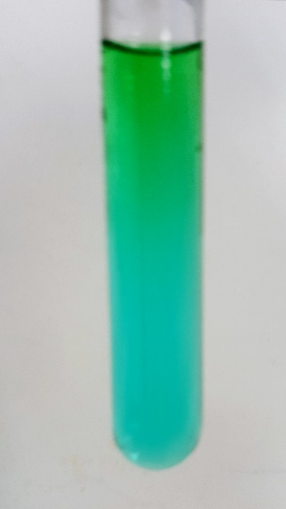This is a version of the well-known ‘equilibrium and Le Chatelier experiment that is used to great effect to show the effect of heat on the equilibrium position of cobalt that has either pink aqueous or blue chloride ligands.

This reaction can be applied to curriculum for excellence.

*Through experimentation, I can identify indicators of chemical reactions having occurred. ...*

**SCN 3-19a**

CfE Higher – Chemistry in Society

*Equilibria*

Cobalt, however, is significantly carcinogenic so here is a safer version using copper rather than cobalt.

**Background**

The effect of temperature on the position of an equilibrium can easily be seen by observing the colour changes of the octahedral hexaaquacopper(II) cation and the tetrahedral tetrachlorocopper(II) anion as the sample is moved from a low temperature to a high temperature.

The equilibrium equation can be expressed as follows:

Cu (H2O)­62+ (aq) + 4Cl-(aq) CuCl42-(aq) + 6H2O(l) ΔH+ve

Blue Green

The change is not as clear as using cobalt but it certainly observable.

## What you will need

|  |  |
| --- | --- |
| 0.5 M Copper(II) chloride solution | Distilled water |
| Sodium chloride (solid or saturated solution) |  |
| 100cm3 measuring cylinder | 250cm3 beaker |
| 100 cm3 beaker of hot water | 100 cm3 beaker of iced water |
|  |  |
| Hair dryer | Small square of polystyrene with hole cut in it (diameter of the test tube) |

## Preparation of the solution

1. Prepare a 0.5 M solution of the copper chloride in the large beaker by dissolving 8.5g in 100 cm3of distilled water.
2. Place 20 cm3 of the solution in each of three test tubes.
3. Add a spatula of sodium chloride or a few cm3 of solution to one tube until the solution turns bright green.
4. 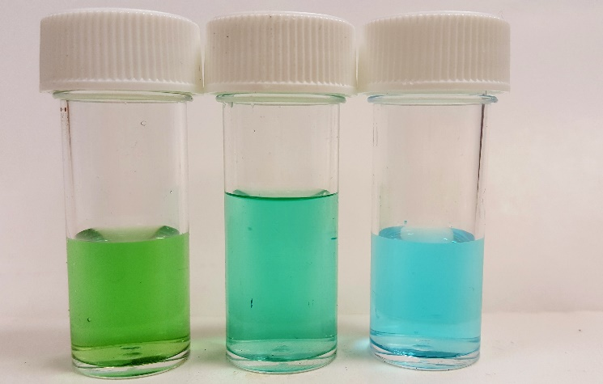Taking this tube and one of your originals as your end points, add a small amount of sodium chloride or solution to the third test tube until it’s colour is a green/blue – half-way between the two others.

## The demonstration

1. Take 2 beakers, one containing boiling (or very hot) water and the other with iced water.
2. Divide your ‘balanced’ solution between two test tubes and place one in each beaker.
3. Leave for a minute or two and then inspect the colours.
4. Now swap them over and see what happens.

OR

1. Place the polystyrene collar about a third of the way down your test tube.
2. Place the test tube in the beaker of iced water to a depth of about a third its length. At the same time use the hair dryer to heat the top third of the solution above the polystyrene.
3. (The polystyrene is to stop the middle third of the test tube heating up).
4. Observe the colour changes!

If desired, test tubes of the solution can be prepared for students to carry out the experiment for themselves.

At Higher level, if they are given the equilibrium equation and the colours of the ions in solution, their observations of the colours at low and higher temperatures can lead them to predict if the ΔH for the forward reaction is positive or negative.

# Safety

**It is the responsibility of teachers doing this demonstration to carry out an appropriate risk assessment.**