Chemical Investigations
Oxidation of ethanol
Teacher/Technician Guide
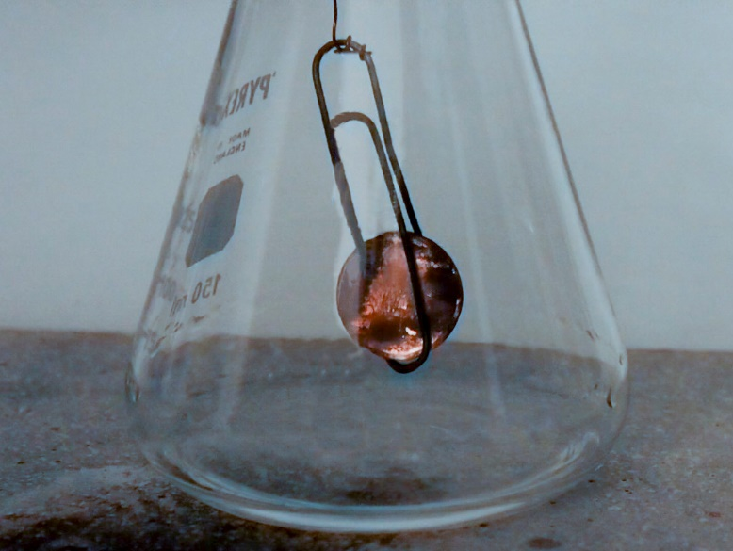
This reaction can be applied to curriculum for excellence.
Through experimentation, I can identify indicators of chemical reactions having occurred. ...
SCN 3-19a
National 4 - Chemical Changes and Structure
Energy changes of chemical reactions
CfE Higher – Chemical Changes and Structure
Catalysts
CfE Higher – Nature’s Chemistry
Oxidation of Food

Introduction
Alcohols can be oxidised relatively easily by a variety of agents.
Primary alcohols, such as ethanol, are oxidised in two stages:
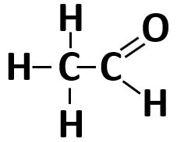
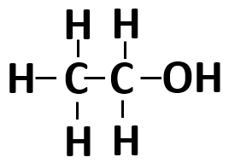
Firstly the alcohol is oxidised to an aldehyde

And then the aldehyde is oxidised further to a carboxylic acid
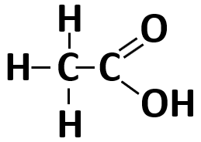

Each group will need
A small flask or beaker | Ethanol (IDA is fine)
A copper coin* | Wire
A glass rod or a metal spatula | Access to a Bunsen burner

* You can use a piece of copper foil or some copper wire but a coin is more fun.

Preparation
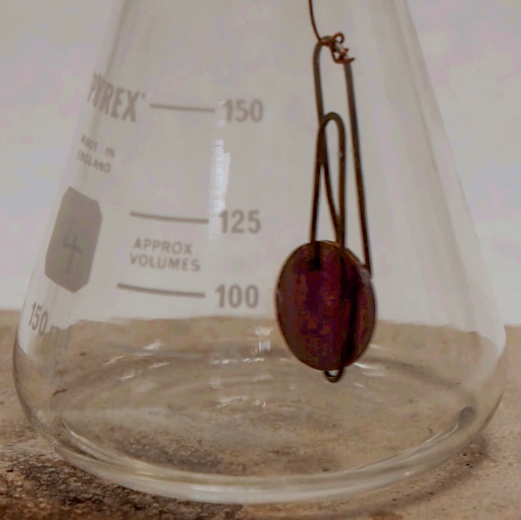
- Fix the coin to the wire. You can either tie/wrap it or use a metal paper-clip as some sort of ‘cradle’ that you then tie the wire to. (Or use any other method)
- Dangle the coin on the wire into the flask so that it is just above the bottom (0.5 – 1 cm) and note/mark the length.
- Tie the other end of the wire round the glass rod or spatula and check that it is still at the right height.
- Pour a small amount of ethanol into the bottom of the flask

To Do
- Use tongs to hold the coin in the blue flame of a Bunsen burner until it is very hot – glowing slightly. (You will probably need to hold the spatula/glass rod in your other hand to keep it out of the way).
- Remove it from the flame and as quickly as possible insert it into the flask so that it is dangling just above the surface held by the wire.
- Observe what happens

Results
Initially the coin is black as a result of the coating of copper II oxide as the surface was burned in the flame.
After a few seconds you should notice that there are patches of brightness playing over the surface of the coin, sometimes covering all of it – this is more noticeable if the lights are dimmed. These will continue effectively indefinitely. If you lift the coin up it goes darker and the brightness returns if you lower it again.
If you cautiously smell the vapours from the top of the flask you will smell a definite aroma of ethanal.

Explanation
In contact with the copper oxide, hydrogen is removed from the ethanol to produce ethanal.
CH₃CH₂OH CH₃CHO + H₂
The hydrogen reduces copper II oxide to copper I oxide and produces water.
2CuO + H₂ Cu₂O + H₂O
In there is air present then oxygen will react with the hot copper I oxide, re-oxidising it to copper II oxide and the process can start again.
2Cu₂O + O₂ 4CuO

Extensions
It is possible to carry out similar oxidations with other substances. Propanol and propanone for instance.
Do NOT use methanol though. For a start it is much more flammable and will catch fire but methanol vapours are also toxic and the oxidation produces methanal (formaldehyde) which is also toxic

Safety
It is the responsibility of teachers doing this demonstration to carry out an appropriate risk assessment.
The autoignition temperature of ethanol or IDA is high so ignition of the ethanol is unlikely but it is best to be prepared – unless spilled, the fire can be put out simply by placing a heatproof mat over the top.

Technician’s Guide

Each group will need
A small flask or beaker | Ethanol (IDA is fine) (10 cm³ or so)
A copper coin* | Wire
A glass rod or a metal spatula | Access to a Bunsen burner

* You can use a piece of copper foil or some copper wire but a coin is more fun. Although a piece of foil is more easily fixed as a hole can be made in it more easily and the wire simply pushed through this and tied.
It may be easier to prepare the wire/coin arrangement in advance rather than get pupils to fix it.

Preparation
- Fix the coin to the wire. You can either tie/wrap it or use a metal paper-clip as some sort of ‘cradle’ that you then tie the wire to. (Or use any other method)
- Dangle the coin on the wire into the flask so that it is just above the bottom (0.5 – 1 cm) and note/mark the length.
- Tie the other end of the wire round the glass rod or spatula and check that it is still at the right height.
- Pour a small amount of ethanol into the bottom of the flask

To Do
- Use tongs to hold the coin in the blue flame of a Bunsen burner until it is very hot – glowing slightly. (You will probably need to hold the spatula/glass rod in your other hand to keep it out of the way).
- Remove it from the flame and as quickly as possible insert it into the flask so that it is dangling just above the surface held by the wire.
- Observe what happens

