Chemical Investigations
Analysing Cations
Teacher / Technician Guide
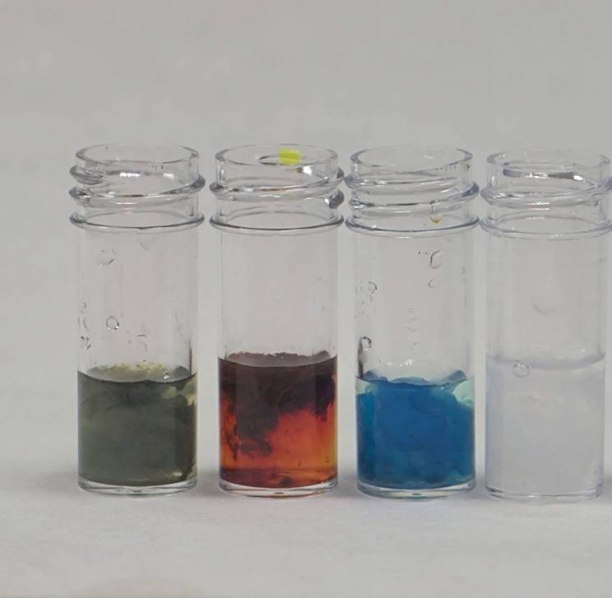
  - Introduction
Identifying substances is a very important aspect of chemistry.
To test for many cations, it is common to use flame tests, which are covered in a different document. Here we look at a variety of simple tests that will allow for the identification of a variety of cations in solution: aluminium, ammonium, calcium, copper, iron II, iron III, lead and zinc.
  - Each group will need
Your samples | Test tubes & rack
Sodium hydroxide (0.4 mol l⁻¹) | Ammonia (1 mol l⁻¹ )
Potassium hexacyanoferrate III (0.2 mol l⁻¹) | Potassium thiocyanate (0.2 mol l⁻¹)
Potassium iodide (0.2 mol l⁻¹) | Alizarin S (0.1%)

The concentrations are not critical here as the tests are qualitative.
  - Safety
0.4 mol l⁻¹ sodium hydroxide is an irritant. Wear eye protection.

  - To do
The first set of tests involves adding sodium hydroxide and ammonia to two different samples of your unknown.
Part 1 – adding sodium hydroxide
- Add a few cm³ of your unknown solution to a test tube.
- Add a few drops of sodium hydroxide – Is a precipitate formed?
- Now add more sodium hydroxide – until the test tube is about ¾ full. Stir and see if the precipitate dissolves.

Part 2 - Results and further actions
- No precipitate – in this case it is probably one of the following – ammonium, potassium sodium, lithium or barium.
Hold a piece of moist red litmus over the top of the mixture with sodium hydroxide. If it goes blue, ammonia is being released so it was an ammonium ion
If there is no change, you need a flame test to distinguish the ions.
- Blue precipitate – probably copper
To confirm – to another sample, add excess ammonia. If a blue precipitate forms and then dissolves to a deep blue solution, it is copper
- Green precipitate – probably iron II but possibly Chromium
To confirm, to another sample add a few drops of potassium hexacyanoferrate III (ferricyanide) a deep blue colour shows it is iron II
- Brown precipitate – red/brown is iron III but a white precipitate that goes brown could be manganese II
To confirm, to another sample add a few drops of potassium thiocyanate a deep red colour shows it is iron III
- White precipitate that does not dissolve in excess hydroxide – calcium or magnesium
These can be distinguished by a flame test.
- White precipitate that does dissolve in excess hydroxide – aluminium, zinc or lead
Add ammonia in excess. If the white precipitate formed dissolves in excess, it is zinc.
If not, Add a few drops of potassium iodide solution. A brilliant yellow colour means it is lead
No colour means it is aluminium
To confirm aluminium:
- To 5 cm³ of the (neutral or acid) test solution, add 1 cm³ of alizarin and then ammonia until the solution is alkaline – as shown by it going purple.
- Boil for a few moments and allow to cool.
- Add dilute ethanoic acid. A red colour or precipitate remaining is evidence of aluminium.

  - Extensions / Additions
Testing for Cobalt 2+ ions
Add ammonia solution
Small quantities give a precipitate of a basic salt of complex structure (blue) or Cobalt hydroxide Co(OH)₂ (rose-red).
In excess this dissolves to form the orange/yellow complex hexaamminecobalt(II) ion:
Co²⁺ + 6NH₃ [Co(NH₃)₆]²⁺
This darkens in air to a deep red solution. (You can speed up the process by adding hydrogen peroxide)
Testing for Nickel 2+ ions.
Not generally used in schools but may be encountered at Higher / Advanced Higher.
Add dimethylglyoxime solution. Then add a bit of ammonia to make solution basic. Nickel will give a red precipitate.

Testing for Chromium ions
Avoid chromates and dichromates.
Chromium III ions give a green precipitate with sodium hydroxide. It dissolves in excess to give a green solution.
Confirmatory test
Add aqueous ammonium sulphide and Chromium III ions form a black precipitate of chromium sulphide (Cr₂S₃) precipitate. It quickly hydrolyses to chromium III hydroxide Cr(OH)₃ which is a green precipitate.
Testing for Manganese II ions
With NaOH solution the Mn²⁺ ion, an off white / beige precipitate of manganese hydroxide Mn(OH)₂ forms. It is insoluble in excess
On standing, it darkens to give manganese dioxide which is a black precipitate.

Some additional tests
Confirmatory test for lead
You can use dithizone – though potassium iodide is easier.
Test for Ammonium/potassium ions
Sodium hexanitritocobaltate(III) (sodium cobaltinitrite) is used to test for the presence of ammonium and potassium ions. Though the emission of ammonia gas or a lilac flame test might be an easier option.
Testing for cobalt II, copper II and Nickel II
You can use Thiooxamide (rubeanic acid) for this – but easier methods are described above.

Technician’s Guide
  - Each group will need
Your samples | Test tubes & rack
Sodium hydroxide (0.4 mol l⁻¹) | Ammonia (1 mol l⁻¹ )
Potassium hexacyanoferrate III (0.2 mol l⁻¹) | Potassium thiocyanate (0.2 mol l⁻¹)
Potassium iodide (0.2 mol l⁻¹) | Alizarin S (0.1%)

  - Preparing solutions
The alkalis and the potassium salts are familiar enough to need no details.
There are, though, some less common reagents that may be used.
Alizarin solution
The working solution is approximately 0.1% (m/v) solution
Alizarin itself is not soluble in water. You have two alternatives:
- Use you need the water-soluble salt. It will be listed as ‘Alizarin S’ or ‘Alizarin Red S’ (CAS Nor 130-22-3)
Dissolve 0.1 g of Alizarin S/Alizarin Red S in 100 cm³ of distilled/deionised water.
- Alizarin (CAS No 72-48-0) itself, though, is soluble in propanone
Dissolve 0.1 g of Alizarin (1,2-dihydroxyanthraquinone) in 100 cm³ of propanone.
Alternatively, you can prepare a 1% ‘stock’ solution of either (1 g per 100 cm³) and dilute as required.

Dimethyl Glyoxime
Wear eye protection. Work away from any sources of ignition..
To prepare a 1% (m/v) solution, dissolve 1 g of dimethylglyoxime in 100 cm³ of ethanol/IDA.
Transfer the prepared solution to a suitable labelled bottle.

Dithizone (diphenylthiocarbazone)
Wear eye protection and gloves. Work in a fume cupboard. Keep away from any sources of ignition.
Add roughly 0.01 g of dithizone to 100 cm³ of propanone (acetone). Stir to dissolve.
The concentration of the reagent is not critical as it forms a very strongly coloured solution.
Transfer the prepared solution to a suitable labelled bottle.
Sodium hexanitritocobaltate(III) (sodium cobaltinitrite)
Wear eye protection. Avoid skin contact.
Add 4 g of the solid to 100 cm³ of distilled water. Stir to dissolve as much as possible.
Filter the solution into a suitable labelled bottle.
NB it has a maximum shelf-life of only around 3 weeks.
Thiooxamide (rubeanic acid)
Wear eye protection. Keep away from any sources of ignition
To prepare a 0.5% (m/v) solution, add 0.5 g of thiooxamide to 100 cm³ of ethanol/IDA. Stir to dissolve.
Transfer the prepared solution to a suitable labelled bottle.

