Chemical Investigations
Analysing Cations
Pupil Guide
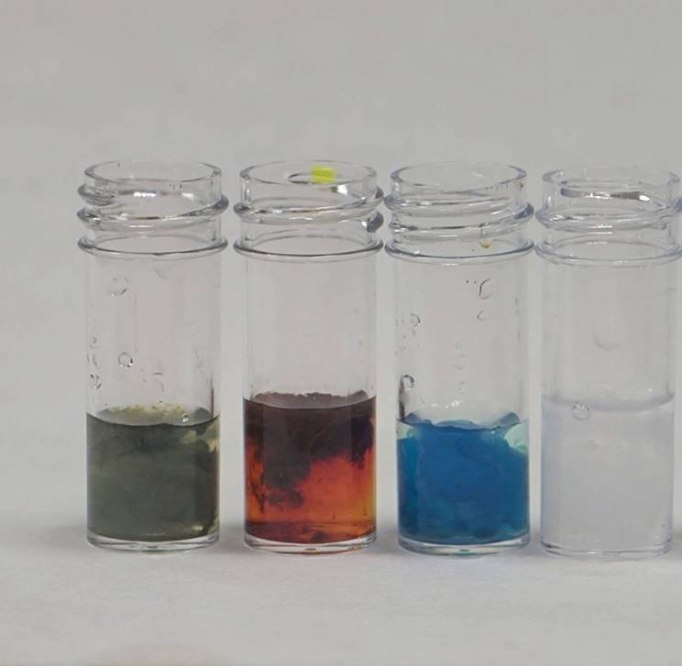

  - Introduction
Identifying substances is a very important aspect of chemistry.
To test for many cations, it is common to use flame tests, which are covered in a different document. Here we look at a variety of simple tests that will allow for the identification of a variety of cations in solution: aluminium, ammonium, calcium, copper, iron II, iron III, lead and zinc.
  - You will need
Your samples | Test tubes & rack
Sodium hydroxide (0.4 mol l⁻¹) | Ammonia (1 mol l⁻¹ )
Potassium hexacyanoferrate III (0.2 mol l⁻¹) | Potassium thiocyanate (0.2 mol l⁻¹)
Potassium iodide (0.2 mol l⁻¹) | Alizarin S (0.1%)

The concentrations are not critical here as the tests are qualitative.
  - Safety
0.4 mol l⁻¹ sodium hydroxide is an irritant. Wear eye protection.

  - To do
The first set of tests involves adding sodium hydroxide and ammonia to two different samples of your unknown.
Part 1 – adding sodium hydroxide
- Add a few cm³ of your unknown solution to a test tube.
- Add a few drops of sodium hydroxide – Is a precipitate formed?
- Now add more sodium hydroxide – until the test tube is about ¾ full. Stir and see if the precipitate dissolves.

Part 2 - Results and further actions
- No precipitate – in this case it is probably one of the following – ammonium, potassium sodium, lithium or barium.
Hold a piece of moist red litmus over the top of the mixture with sodium hydroxide. If it goes blue, ammonia is being released so it was an ammonium ion
If there is no change, you need a flame test to distinguish the ions.
- Blue precipitate – probably copper
To confirm – to another sample, add excess ammonia. If a blue precipitate forms and then dissolves to a deep blue solution, it is copper
- Green precipitate – probably iron II but possibly Chromium
To confirm, to another sample add a few drops of potassium hexacyanoferrate III (ferricyanide) a deep blue colour shows it is iron II
- Brown precipitate – red/brown is iron III but a white precipitate that goes brown could be manganese II
To confirm, to another sample add a few drops of potassium thiocyanate a deep red colour shows it is iron III
- White precipitate that does not dissolve in excess hydroxide – calcium or magnesium
These can be distinguished by a flame test.
- White precipitate that does dissolve in excess hydroxide – aluminium, zinc or lead
Add ammonia in excess. If the white precipitate formed dissolves in excess, it is zinc.
If not, Add a few drops of potassium iodide solution. A brilliant yellow colour means it is lead
No colour means it is aluminium
To confirm aluminium:
- To 5 cm³ of the (neutral or acid) test solution, add 1 cm³ of alizarin and then ammonia until the solution is alkaline – as shown by it going purple.
- Boil for a few moments and allow to cool.
- Add dilute ethanoic acid. A red colour or precipitate remaining is evidence of aluminium.

