Chemical Demonstrations

Ammonia Fireflies
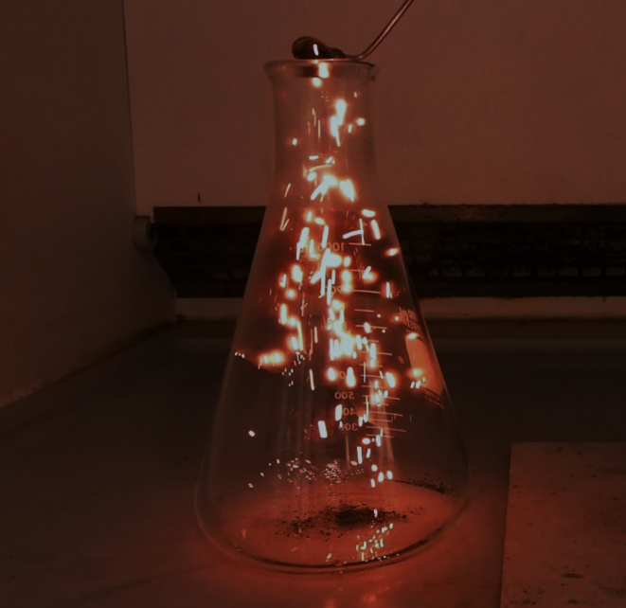
This reaction can be applied to curriculum for excellence.
Through experimentation, I can identify indicators of chemical reactions having occurred ...
SCN 3-19a
N5 - Chemistry in Society
Fertilisers
Higher – Chemical Changes and Structure
Catalysts
Introduction
In this demonstration experiment, ammonia is oxidised by chromium III oxide. This needs to be produced by the ammonium dichromate volcano (in itself an exciting demonstration) as it will only work with the light and ‘fluffy’ particles produced this way. Cr₂O₃ off the shelf won’t work. Once prepared, though, the chromium III oxide can be stored successfully.
Hot chromium III oxide is tipped into a flask of ammonia vapour and it produces a shower of sparks as the ammonia reacts with the oxygen
You will need
Ammonium dichromate Vl | Heatproof mat
Large flask | .880 Ammonia (5 cm³ or so)
Deflagrating spoon | Bunsen burner
Chromium III oxide

To do
Preparation
- Place a small pile of ammonium dichromate VI on a heatproof mat in a fume cupboard.
It is wise to switch of the fume cupboard as the chromium III oxide particles are very light and might get blown all over the place.
- Apply a flame to the edge of the pile until it catches fire
- The orange solid begins to give off sparks and decomposes into a flaky green solid. This has a considerably larger volume than the original compound.
- Once the rection has finished, wait a couple of minutes and brush the chromium III oxide into a jar – avoiding any unreacted ammonium dichromate which will be at the bottom of the pile.

The Demonstration
- Take a large flask – the larger the better.
- In a fume cupboard, add a few cm³ of concentrated (.880) ammonia and swirl it around to fill the flask with vapour.
It is a good idea to carry out the whole of the demonstration in the fume cupboard but it is not essential. If not, add the ammonia in the fume cupboard and put a bung in the top before taking it out.
- Take a deflegrating spoon of the chromium III oxide prepared as above (it does not have to be prepared freshly) and heat strongly for 30 seconds or so.
- Remove the bung (if it is in) and tip the oxide into the flask. (Replace the bung if you are working outside the fume cupboard).
You will see a shower of sparks, some of which will float, still glowing, for quite a while.
You can continue adding more batches of chromium II oxide to repeat the experiment.

Health and Safety
Ammonium dichromate VI, (NH₄)₂Cr₂O₇, is: an Oxidiser, an acute toxin, (cat 3 by ingestion and cat 2 by inhalation), corrosive, a carcinogen, a mutagen, a reproductive toxin, a skin sensitiser, a specific target organ toxin and very hazardous to the aquatic environment with long-lasting effects.
(Wear eye protection and avoid skin contact with ammonium(VI) dichromate. Consider wearing gloves.
Do not mix other chemicals with ammonium dichromate(VI).
Concentrated ammonia is corrosive – wear goggles (BS EN166 3) and gloves. Ammonia fumes are toxic and corrosive work in a fume cupboard or a well ventilated lab with appropriate procedural controls to limit exposure.

The Chemistry
The equation for the decomposition reaction of ammonium dichromate is:
(NH₄)₂Cr₂O₇(s) → Cr₂O₃(s) + N₂(g) + 4H₂O(g)
The addition of hot chromium III oxide to the flask of ammonia vapour catalyses the oxidation of ammonia
4NH₃ + 5O₂ → 4NO + 6H₂O
In fact there are various reactions going on. There is also nitrogen gas produced and also further oxidation of some of the nitric oxide to nitrogen dioxide.
As well as demonstrating catalysis, the reaction can be used to illustrate oxidation of ammonia in the Ostwald process as the reaction is similar even if the catalyst is different.
Disposal
Unless there is a significant amount of unreacted ammonium dichromate, the reagents can be diluted with plenty of water and washed down the sink in a fume cupboard.
If there is more than a trace of unreacted dichromate, it should be carefully brushed up (avoiding raising dust) and kept for disposal by a licensed contractor.

