Science investigation
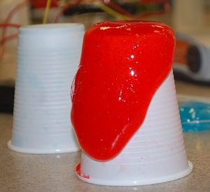

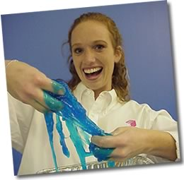
What’s going on here?

Polymer Slime – Pupil’s Guide
You can turn PVA into slime by mixing it with
another chemical called borax.
The slime is quite thick and flows slowly.
We say that the slime is viscous.

Your task is to investigate how varying the volume of borax added, affects how fast the slime flows. i.e. how it affects the viscosity of the slime.

Why do the chemicals make a polymer slime?
The word “polymer” shows the molecules are very long chains (they can consist of thousands of small molecules linked together end to end).

The starting material to make the slime is the chemical called PVA (poly vinyl alcohol). It is a liquid. Just like in an ordinary liquid, the molecules can slip over each other so PVA can be poured.

When you add borax, it is able to link the long chains together. This turns the PVA liquid into a slimy solid.

What you must do now:
Carry out the experiment by following the instructions on the Experiment card.

You will need

Bench mat | 25 cm³ syringe
5 cm³ syringe | Stirring rod
50 cm³ glass beaker | PVA solution (4%)
Food colouring (various) | Borax solution (4%)

Safety
While the solutions themselves are not hazardous, there is a risk (very small but possible) of exposure to solid borax (or a saturated solution) which is a Category 2 reproductive toxin.
Pupils wash their hands after handling the slime and should not take home with them.
A few people with sensitive skin my be irritated by the slime – if this is likely, they should wear gloves.

Basic Slime Recipe
- Measure out 25cm³ of the PVA solution and pour it into a plastic cup.
Add a few drops of food colouring to the PVA and stir to mix.
You MUST add the colouring BEFORE the borax.
- Measure out 5cm³ of the borax solution in the second measuring cylinder.
- Now slowly add the borax to the PVA, stirring all the time.
A gel will form.
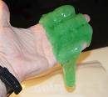
- Remove the gel from the cup and work it in your hands for 2-3 minutes to complete the cross-linking and to eliminate air from the slime.
Squeeze and roll the slime to get rid of any air bubbles.

Polymer Slime

What to do | What happens to the writing? | What happens to the slime?
Write your name on a piece of paper with a water based pen.
Press the slime on top of it
Write your name on a piece of paper with a non-water based pen.
Press the slime on top of it
Name:……………………………………………………………………………
What to do | What happens?
Pull the slime SLOWLY

Pull the slime SHARPLY AND QUICKLY

Roll the slime into a ball and drop it on
a bench

Place a small bit of slime onto the bench and hit it with your hand

The Polymer slime-o-meter

What to do

You will need to make up four (4) separate slimes. Wear gloves at all times and then dispose of them at the end of the experiment. Once you have all four slimes made you will then do an experiment to compare them.

- For the first slime, measure out 80 cm³ of the PVA and put it in one of the beakers. Add two drops of green food colouring to the PVA and stir to mix them. Now measure out
4 cm³ of the Borax and add it to the PVA as well. Mix them well with a stirring rod.

- For the second slime, measure out 80 cm³ of the PVA and put it in one of the beakers. Add two drops of green food colouring to the PVA and stir to mix them. Now measure out 8 cm³ of the Borax and add it to the PVA. Mix them well with a stirring rod.

- Make the third slime in the same way as the second, but add 12 cm³ of the Borax this time.

- Make the fourth slime in the same way as the second, but add 16 cm³ of the Borax this time.

- Take each of the slimes and work them with your hands for approximately 1 minute to eliminate air and complete the cross-linking.

Experiment:
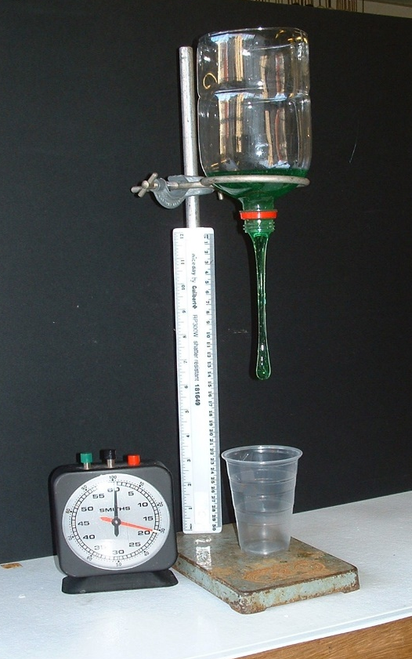
Add one of the slimes to the bottle. Unscrew the stopper and at the same time start the stop-clock. Stop the clock when the slime has touched the bottom of the beaker. Note the time. Repeat with different slimes. Multiple readings for each experiment can be done and averages calculated.
When you have finished with the slime, place it in one of the poly bags provided.

Record your findings below.
Type of slime | Time 1 Time 2 Time 3  (s) (s) (s) | Average time to fall to the beaker
Slime with 4 cm³ of Borax added
Slime with 8 cm³ of Borax added
Slime with 12 cm³ of Borax added
Slime with 16 cm³ of Borax added
Remember: Average time = Time 1 + Time 2 + Time 3
3
Space for working

Now plot a graph of your results:
Note: The graph may not be a straight line.
T
i
m
e

(s)
Volume o
f borax added (cm³)

Conclusion:
What happens to the viscosity of the polymer as you add more borax?

Will this trend continue? Explain.

What you must do now:
Predict from the graph the time the slime would take to touch the bottom of the beaker if you had used 10 cm³ of borax.
Write this down here: ...................s
What you must do next:

Test your prediction by carrying out the experiment and recording your results below:
Type of slime | Time 1  (s) | Time 2  (s) | Time 3  (s) | Average  time (s)
Slime with 10 cm³ of Borax added

Difference between predicted time = ………………………………………
and actual time taken
What things may have affected how accurate you were able to do the experiment?

If you do the experiment again, how could you improve it?

Polymer dough

What to do

You will need to make up four (4) separate doughs. Wear gloves at all times and then dispose of them at the end of the experiment. Once you have all four doughs made you will then do an experiment to compare them.

- For the first dough, measure out 25 cm³ of the PVA and put it in one of the beakers.
Now measure out 5 cm³ of the Borax and add it to the PVA.
Mix them well with a stirring rod.
- For the second dough, measure out 25 cm³ of the PVA and put it in one of the beakers. Now add 4 level spoonfuls of talcum powder to the PVA and mix them well with a stirring rod. Measure out 5 cm³ of the Borax and add it to the PVA and talc mixture.
It is very important that you add the talc before you add the borax.
- Make the third dough in the same way as the second, but add 8 level spoonfuls of talc this time.
- Make the fourth dough in the same way as the second, but add 12 level spoonfuls of talc this time.
- Take each of the doughs and roll them into a ball for approximately 1 minute to dry them and to eliminate air.

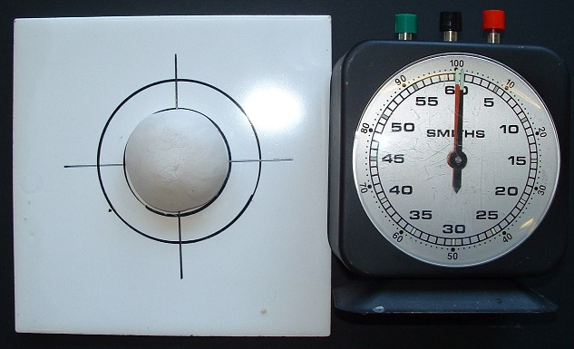
Experiment:
- Place each ball of dough in turn in the centre of the circles on the tile.
- Wait until it spreads out to reach the inner circle and then start the stop clock.
- Stop the clock when the slime reaches the outer circle.
- Repeat with different doughs.
Multiple readings for each experiment can be done and averages calculated.
Record your answers in the table below.
When you have finished with the slime, place it in one of the poly bags provided.

Type of dough | Times to  spread out | Average time to spread out
no talc
dough with 4 level spoonfuls of talc
dough with 8 level spoonfuls of talc
dough with 12 level spoonfuls of talc

Plot a graph of your results.

T
i
m
e

(s)

0
Spoons of talc added

What happens to the viscosity of the polymer as you add more talc?

Will this trend continue? Explain.

Note: The slime will eventually dry out, so store it in an airtight container such as a zip plastic bag if you wish to keep it. To dispose of unwanted slime, just let it dry out and put the solid in the bin.

