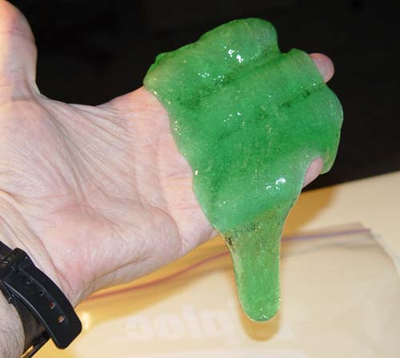 **Background:**

Slime!

Investigating a PVA polymer

The PVA polymer is formed when borax is added to the PVA. This cross-linked between the long PVA chains so a gel or slime is formed from the viscous liquid.

Investigating a PVA polymer - borax

# Pupil Apparatus needed

|  |  |
| --- | --- |
| Measuring cylinders (100 cm3 and 25 cm3 and 10 cm3) | Clear plastic drinking cups (not polystyrene) |
| Sufficient PVA solution | Sufficient borax solution |
| Some food colouring (optional) | Wash bottles for the borax |
| Stirring rods | Empty 2.5 l lemonade bottles with bottoms cut off |
| Rulers | Retort rings |
| Retort stands |  |

# What you will need

|  |  |
| --- | --- |
| Indirect vent goggles | Gloves |
| Hot plate and magnet stirrer | Stirring rod |
| Beakers | Storage jars for the PVA and Borax solutions |
| PVA powder ( high molecular weight type, 70,000-100,00). | Borax powder |
| Measuring cylinders (100 cm3 and 25 cm3) |  |

# What you do

1. Prepare a 4% w/v solution of the PVA

e.g. Weight out 40g of the PVA powder. Heat 1 litre of water to 50oC on a hot plate fitted with a magnetic stirrer. Gradually sprinkle the polymer powder on the surface.

Gradually increase heat to 70oC (do NOT boil) and continue stirring until all the powder dissolves. The solution will be colourless and clear.

Remove from the heat, cover and allow to cool overnight.

1. Prepare a 4% w/v solution. You will need to calculate the volume required.

The borax and PVA are usually mixed in the ratio of 1 volume borax : 5 volumes PVA

Investigating a PVA polymer - talc

# Pupil Apparatus needed

* Measuring cylinders (100 cm3 and 25 cm3)
* Clear plastic drinking cups (not polystyrene)
* Sufficient PVA solution
* Sufficient borax solution
* Some food colouring (optional)
* Stirring rods
* Talc
* Small teaspoons or kitchen measuring spoons
* Empty 2.5 l lemonade bottles with bottoms cut off
* Tiles with a cross and concentric circles of approximately
* 5cm and 7½ cm diameter drawn on it like so
* Stop clocks or other suitable timers
* Clamp stands with rings
* Rulers

What you will need

* Indirect vent goggles
* Gloves
* Hot plate and magnet stirrer
* Stirring rod
* Beakers
* Storage jars for the PVA and Borax solutions
* PVA powder ( high molecular weight type, 70,000-100,00).
* Borax powder
* Measuring cylinders (100 cm3 and 25 cm3)

**What you do**

1. Prepare a 4% w/v solution of the PVA

e.g. Weight out 40g of the PVA powder. Heat 1 litre of water to 50oC on a hot plate fitted with a magnetic stirrer. Gradually sprinkle the polymer powder on the surface.

Gradually increase heat to 70oC (do NOT boil) and continue stirring until all the powder dissolves. The solution will be colourless and clear.

Remove from the heat, cover and allow to cool overnight.

1. Prepare a 4% w/v solution. You will need to calculate the volume required.

The borax and PVA are usually mixed in the ratio of 1 volume borax : 5 volumes PVA