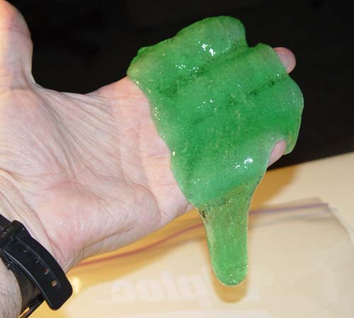 **Background:**

Slime!

Investigating a PVA polymer

The PVA polymer is formed when borax is added to the PVA. This cross-linked between the long PVA chains so a gel or slime is formed from the viscous liquid.

The starting material to make the slime is PVA (poly vinyl alcohol). It is a liquid. Just like in an ordinary liquid, the molecules can slip over each other so PVA can be poured.

When you add borax, it is able to link the long chains together. This turns the PVA liquid into a slimy solid.

**Setting the scene:**

**Prepare samples of the polymer as a class demonstration as follows:**

**What you will need**

* 2 measuring cylinders
* Two clear plastic drinking cups (not polystryene)
* A bottle of PVA solution
* A bottle of borax solution
* Some food colouring (optional)
* Stirring rod

**What you do**

Before the demonstration

1. Prepare a 4% w/v solution of the PVA (use high molecular weight type, 70,000-100,000).

e.g. Weigh out 40g of the PVA powder. Heat 1 litre of water to 50oC on a hot plate fitted with a magnetic stirrer. Gradually sprinkle the polymer powder on the surface.

Gradually increase heat to 70oC (do NOT boil) and continue stirring until all the powder dissolves. The solution will be colourless and clear.

Remove from the heat, cover and allow to cool overnight.

1. Prepare a 4% w/v solution. You will need to calculate the volume required.

The borax and PVA are usually mixed in the ratio of 1 volume borax : 5 volumes PVA

**The demonstration.**

1. Measure out 25cm3 of the PVA solution and pour it into a plastic cup.

1. Add a few drops of food colouring to the PVA and stir to mix.

You MUST add the colouring BEFORE the borax.

1. Measure out 5cm3 of the borax solution in a second measuring cylinder.
2. Now slowly add the borax to the PVA, stirring all the time.

A gel will form.

1. Remove the gel from the cup and work it in your hands for 2-3 minutes to complete the cross-linking and to eliminate air from the slime.

**Optional**: Pupils can complete Pupil Activity Sheet

1. Pull the slime slowly and the slime stretches.
2. Pull the slime sharply and quickly and the slime breaks.
3. Roll the slime into a ball and drop it on the bench and it bounces.
4. Roll the slime into a ball on the bench and hit it with your hand.

The slime thickens.

1. Write a word in water-based felt tip pen. Press the slime onto it and then lift off. The writing is taken up by the gel.

The slime lends itself to two investigations on viscosity. An indication of the viscosity can be had by timing how long the slime takes to pour or to spread out. The longer the time, the more viscous the slime.

**Possible variables:** Pupils can investigate the effect on viscosity of

* 1. changing the volume of borax added (and hence the number of cross-links)
  2. adding varying amounts of talc to the polymer.

**Setting the scene:**

Explain that the PVA is called a viscous liquid. Explain what viscous means.

Explain that when the borax is added to the PVA it forms new bonds with the PVA across its long polymer chains so a gel is formed from the thick (viscous) liquid.

This cross-linking between the long PVA chains makes the polymer even more viscous.

Pose the question: How can we change the ‘runniness’ (viscosity) of the slime?

Now with class in groups, issue Investigation Cards and set them on the task.

**General Hints**:

A class discussion will be required to bring out methods of how to measure the viscosity. Discussion on how to set up the experiments will also be needed. This can be done after the groups have had a chance to formulate their strategies, possibly after viewing the apparatus to hand. Volumes to use will have to be discussed.

1. **changing the volume of borax added**

**Pupil Apparatus needed:**

* 100 cm3 measuring cylinders labelled ‘PVA’ and ‘Borax’
* Clear plastic drinking cups (not polystyrene)
* Rulers
* A bottle of PVA solution
* A bottle of borax solution
* Some food colouring (optional)
* Stirring rod
* Some 2.5 litre plastic lemonade bottles cut in half
* Stop-clocks or suitable timers

**Safety**

While the solutions themselves are not hazardous, there is a risk (very small but possible) of exposure to solid borax (or a saturated solution) which is a Category 2 reproductive toxin.

Pupils wash their hands after handling the slime and should not take home with them.

A few people with sensitive skin my be irritated by the slime – if this is likely, they should wear gloves.

It is the responsibility of teachers doing this demonstration to carry out an appropriate risk assessment.

A minimum of four dependent variable readings should be recorded for each investigation to enable data to be plotted. Prepare different slimes by mixing portions of the PVA solution with different volumes of the borax solution. e.g. 80 cm3 or 100 cm3 of the PVA with say 2 cm3, 4 cm3, 8 cm3, 10 cm3, 12 cm3,

15 cm3, 20 cm3 etc of the borax. Work the slimes as before the eliminate air, then set up the apparatus like this:

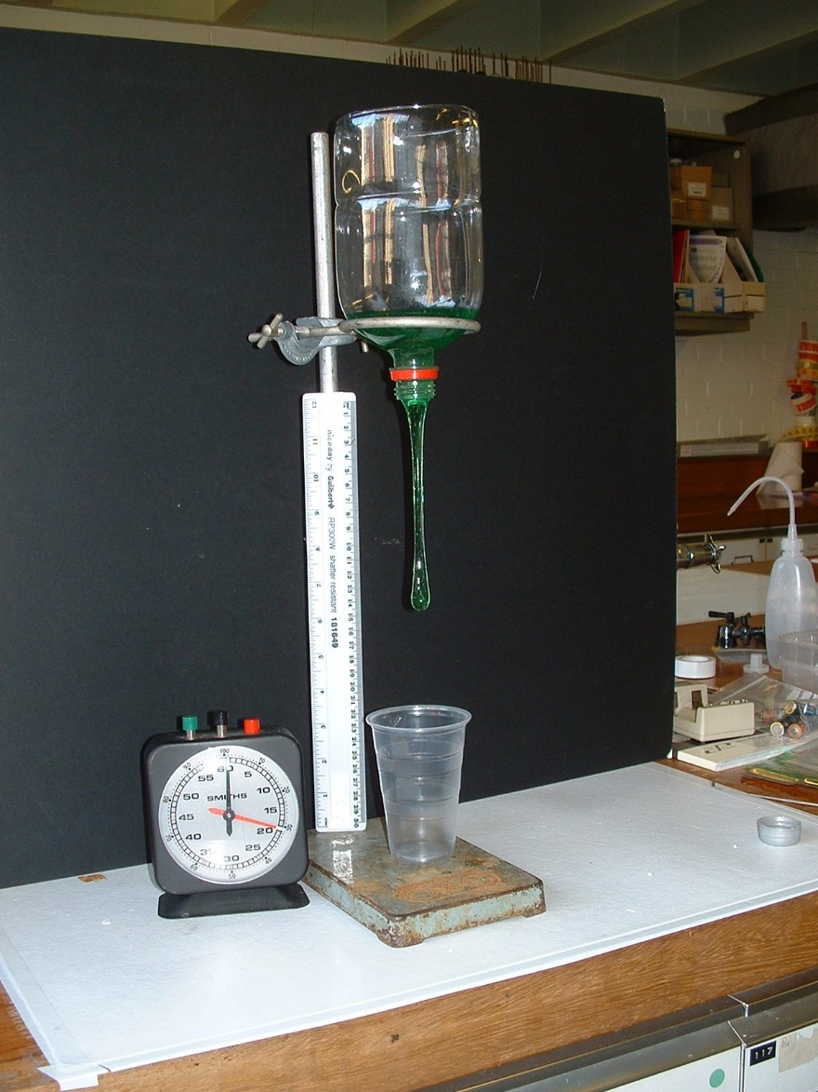

Add one of the slimes to the bottle. Unscrew the stopper and at the same time start the stop-clock. Stop the clock when the slime has touched the bottom of the beaker. Note the time. Repeat with different slimes. Multiple readings for each experiment can be done and averages calculated. If a selection of similarly sized bottles is available, the experiments can be run simultaneously.

1. **adding varying amounts of talc to the polymer.**

**Pupil Apparatus needed:**

* 100 cm3 measuring cylinders
* clear plastic drinking cups (not polystryene)
* A bottle of PVA solution
* A bottle of borax solution
* Some food colouring (optional)
* Stirring rods
* Talc
* Spoons (teaspoons or small measuring spoons)
* A tile with concentric circles of approximately 5cm and 7½ cm diameter drawn on it
* Stop clocks or suitable timers

**Safety**

While the solutions themselves are not hazardous, there is a risk (very small but possible) of exposure to solid borax (or a saturated solution) which is a Category 2 reproductive toxin.

Pupils wash their hands after handling the slime and should not take home with them.

A few people with sensitive skin my be irritated by the slime – if this is likely, they should wear gloves.

It is the responsibility of teachers doing this demonstration to carry out an appropriate risk assessment.

A minimum of four dependent variable readings should be recorded for each investigation to enable data to be plotted.

Each slime is made by mixing 25 cm3 of the PVA with the required number of level spoonfuls of talc. Stir this well to mix the talc into the PVA and only then add 5 cm3 of the borax solution.

**It is very important that you add the talc before you add the borax.**

A teaspoon can be used and the talc levelled using a ruler. This ensures the same amount of talc is used each time.

A small measuring spoon (of the type sold in cook shops) could be used instead. Since these small spoons are graduated in mls this would enable units to be used in tables and graphs instead of ‘number of spoons added’

The number of spoons (or mls) added could be 0, 2, 4, 6, 8. If much more than this is added, the viscosity increases to the extent where the slime does not flow. This of course, is to be expected.

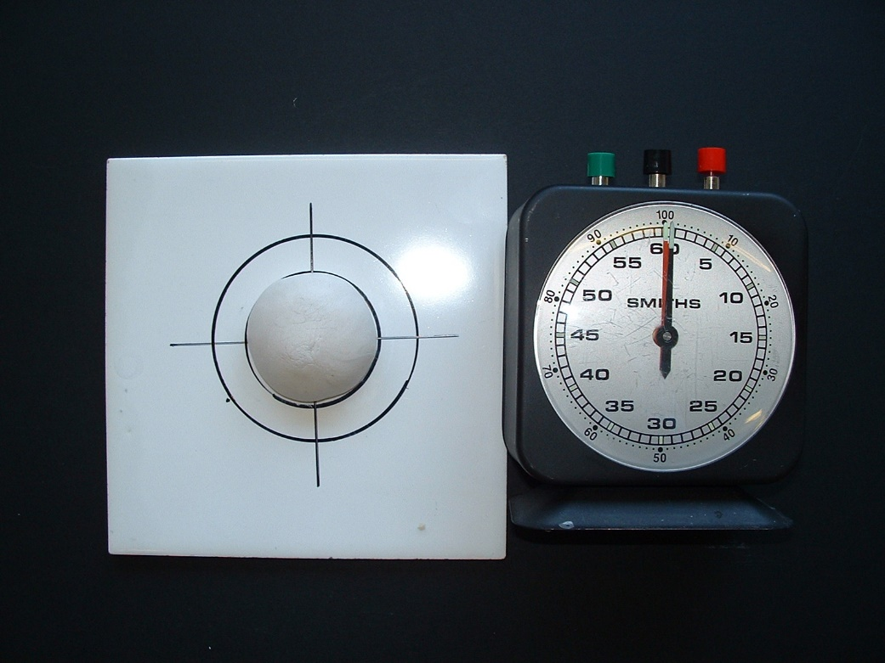

Once the slimes have been made, take each of them and roll them into a ball for approximately 1 minute to dry the slime and to eliminate air.

Place each ball of slime in turn in the centre of the cross on the tile. Wait until it spreads out

to reach the inner circle and then

start the stop-clock. If the slime

has not been centred correctly, time from when the slime reaches the circle at one of the arms of the cross. Stop the clock when the slime reaches the outer circle (if need be at the corresponding arm of the cross). Record your answers.

Multiple readings can be taken for each experiment and average times calculated.

**Polymer Slime Answers**

|  |  |
| --- | --- |
| **What to do** | **What happens?** |
| Pull the slime SLOWLY | It stretches |
| Pull the slime SHARPLY  AND QUICKLY | It breaks |
| Roll the slime into a ball and  drop it on a bench | ***It bounces*** |
| Place a small bit of slime onto the bench and hit it with your hand | It does not bounce. It thickens |

|  |  |  |
| --- | --- | --- |
| **What to do** | **What happens to the writing?** | **What happens to the slime?** |
| Write your name on  a piece of paper with  a water based pen.  Press the slime on top of it | **It dissolves** | **The slime takes up the writing** |
| Write your name on a piece of paper with a non-water based pen.  Press the slime on top of it | **It does not dissolve.** | It stays the same |

**Slime-o-meter specimen answers:**

The following results were obtained from the experiment using 80 cm3 of PVA solution each time, although the times will vary depending on the temperature on the day of the experiment:

|  |  |
| --- | --- |
| Volume of borax added (cm3) | Average time (s) |
| 4 | 10 |
| 5 | 24 |
| 8 | 67 |
| 10 | 86 |
| 12 | 101 |
| 15 | 108 |
| 20 | 119 |

A plot of time (Y-axis) against volume of borax used (X-axis) will give a line graph. This will eventually level off since a point will be reached when sufficient borax has been added to produce all the cross-links. The addition of more borax will then have no effect on the viscosity of the slime.



What happens to the viscosity of the polymer as you add more borax?

**it increases.**

Will this trend continue? Explain.

**No. The graph starts to level off because as more borax is added there are less and less cross-links left to be formed. Eventually all the cross-links will be formed. Extra borax will then have no further effect on the viscosity and the graph will become horizontal.**

Note: The slime will eventually dry out, so store it in an airtight container such as a zip plastic bag if you wish to keep it. To dispose of unwanted slime, just let it dry out and put the solid in the bin.

**Polymer Dough Specimen Results:**

The following results were obtained using 25 cm3 of PVA solution and 5 cm3 of the borax each time each time, although the times will vary depending on the temperature on the day of the experiment:

|  |  |
| --- | --- |
| Number of spoons of talc | Average time (s) |
| 0 | 132 |
| 2 | 166 |
| 4 | 196 |
| 6 | 229 |
| 8 | 260 |

Plot time (Y axis) against number of spoons of talc added to obtain a line graph.

A point will be reached when so much talc has been added that the polymer will not flow. i.e. the time to flow from the first circle to the second will be infinite. The line will be vertical.

What happens to the viscosity of the polymer as you add more talc?

**It increases.**

Will this trend continue? Explain.

No. A point will be reached when sufficient talc has been added so that the dough will no longer flow. The time to travel between the two circles will then become infinite and the line graph will become vertical.