

|  |
| --- |
| Chemical Experiments |
| Copper complexes |

**Background**

CfE Advanced Higher

Inorganic & Physical Chemistry

Ligands

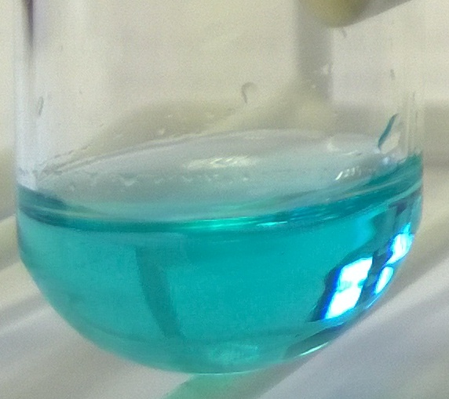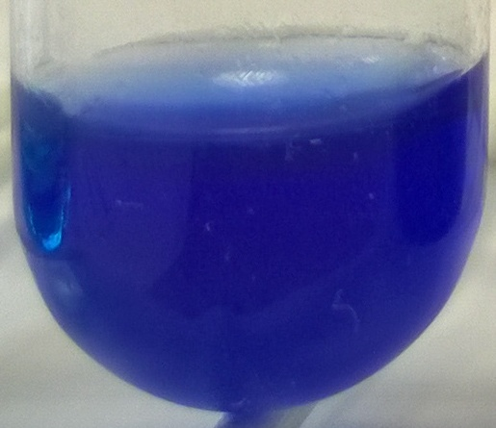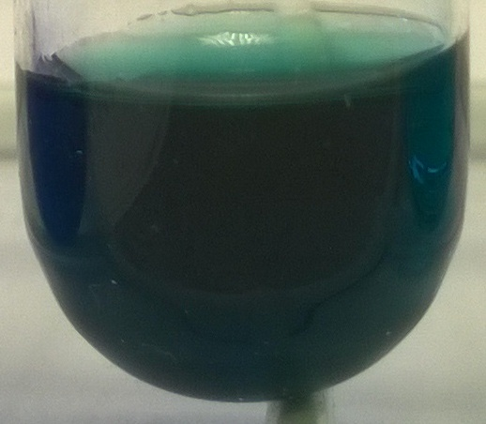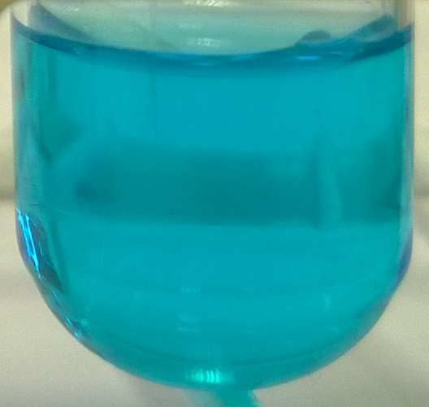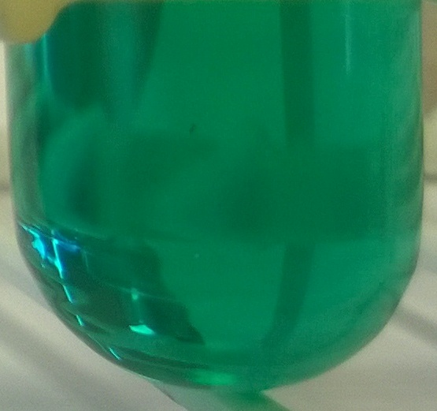

Copper ions can form stable complexes with a range of ligands; indeed, the blue colour normally seen in copper salts is due to the copper ions complexing with water.

The coordination number is most commonly 6 but can be 4 for some ligands.

A stability constant can be defined for displacement of water ligands from hydrated copper II ions by other ligands. Eg for chloride ions

[Cu(H2O)6]2+ (aq) + 4 Cl- (aq) [CuCl4] 2- (aq) + 6H2O

The values of these stability constants vary over a wide range so is more common to use log K values instead. The larger the value of Log K, the further to the right the equilibrium lies and the stronger the new complex is in relation to water and thus the more stable it is.

The table below shows log K values for some common ligands.

|  |  |  |  |
| --- | --- | --- | --- |
| **Ligand name** |  | **Colour** | **Log K** |
| water | Monodentate | Pale blue | - |
| chloride | Monodentate | Green | 5.6 |
| ammonia | Monodentate | Deep blue | 13.1 |
| 2-hydroxybenzoate (salicylate) | Bidentate | Greenish blue | 16.9 |
| 1,2-dihydroxybenzene (catechol) | Bidentate | Light green | 25.0 |
| EDTA | Hexadentate | Light blue | 18.8 |

In this experiment, you will observe the colours of copper complexes and see how one ligand can displace another

**You will need**

|  |  |
| --- | --- |
| Test tube and rack | Pasteur pipettes (x5) |
| Copper sulphate solution (0.5 Mol l-1) | Ammonia solution (2 Mol l-1) |
| Sodium 2-hydroxybenzoate (salicylate)(0.05 Mol l-1) | Sodium EDTA (0.25 Mol l-1)* |
| 1,2-dihydroxybenzene (catechol) (0.05 Mol l-1)** |  |

* This is effectively a saturated solution. (You can only get it more concentrated by making the medium alkaline)

** made up in dilute alkali (in this case 0.01M NaOH)

If you use different concentrations, it will still work but the quantities will be different.

# What you do

1. Place 4 drops of 0.5 Mol l-1 copper sulphate solution in your test tube.
2. Add 25 drops or so of 0.5 Mol l-1 ammonia, until the solution is deep blue.
3. Then add about 20 drops of 0.05 Mol l-1 Sodium 2-hydroxybenzoate until the solution is a greenish blue.
4. Now add about 15 drops of 0.25 Mol l-1 Na EDTA until the solution is a light blue again.
5. Finally, add about 25 drops of 0.05 Mol l-1 1,2-dihydroxybenzene until the solution is green.

If you wish, you can set up a series of tubes, with each one having one more reagent in: Tube 1 CuSO4, Tube 2 CuSO4 and ammonia etc. That way you get all of the intermediate stages.

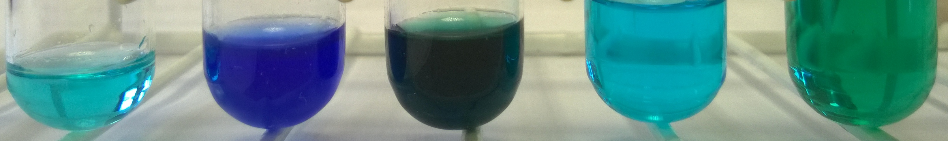

**Safety**

**Carry out in a well-ventilated area**



Wear eye protection. Consider wearing gloves

**It is the responsibility of teachers doing this demonstration to carry out an appropriate risk assessment.**

**Discussion**

You are adding the ligands in increasing order of log K and so each new ligand is more stable than the last.

You can also include as the first ligand a 1Mol l-1 solution of potassium (or sodium) nitrate III. This produces a green complex that is more stable than the blue water one but less so than the ammonia. I have not included it in the general practical though as the log K value seems not to be available.