Chemical Investigations
Determination of water in barium chloride
Teacher/Technician Guide
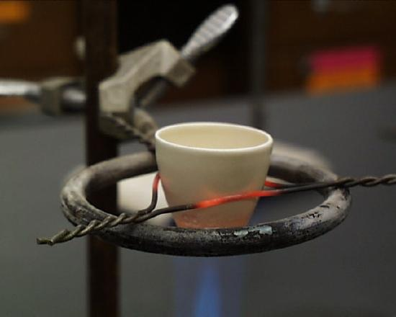
Photo from Chem.Libretexts.org – Public Domain

Determination of water in barium chloride
UNIT 2 PPA 2
Introduction
Gravimetric analysis can be used to determine the number of moles of water molecules of crystallisation per mole of hydrated barium chloride i.e. the value of n in BaCl₂.nH₂O. This can be achieved by comparing the mass of a sample of the hydrated salt with the mass of the anhydrous salt obtained on heating to constant mass.

Health & Safety
Wear eye protection and if any chemical splashes on your skin wash it off immediately.
Barium chloride is toxic if swallowed and harmful if inhaled. Avoid raising dust. Hydrated barium chloride is crystalline and so unlikely to be problematic but the anhydrous salt that is produced is powdery.

Requirements
hydrated barium chloride
silica or porcelain crucible and lid | tripod
pipe-clay triangle | Bunsen burner and heating mat
desiccator | tongs
balance (accurate to 0.001 g)

Procedure
- Carry out the following procedure in duplicate.
- Place the empty crucible and lid on the pipe-clay triangle and heat them for about 10 minutes using a blue Bunsen ﬂame. Heating should be gentle at first.
- Allow the crucible and lid to cool brieﬂy before transferring them, using clean tongs, to the desiccator.
- After cooling to room temperature, weigh the empty crucible and lid.
- Add 2 - 3 g of hydrated barium chloride to the crucible. Replace the lid and reweigh.
- Place the crucible back on the pipe-clay triangle with the lid partially covering the contents. Heat gently for about 2 minutes and then strongly for 10- l5 minutes.
- Allow the crucible to cool brieﬂy before transferring it to the desiccator.
- Reweigh the covered crucible and contents once they have cooled to room temperature.
- Heat the crucible and contents to constant mass i.e. reheat for about 4 minutes, cool in the desiccator and reweigh until two successive readings are within 0.002 g of each other.
- Calculate the value of n in BaCl₂.nH₂O.

Technician Guide
Requirements per student (or group)
Reagents
AnalaR hydrated barium chloride (BaCl₂.2H₂O.) (~ 6g)

Apparatus
silica or porcelain crucibles and lids (2) | tripods (2)
pipe-clay triangles (2) | Bunsen burners (2)
heating mats (2) | desiccator (1)
tongs (1) | access to balance (accurate to 0.001 g)

Notes
As an alternative to hydrated barium chloride, hydrated magnesium sulphate (MgSO₄.7H₂O) could be used. (As could hydrated copper sulphate (CuSO₄.5H₂O))

