Chemical Investigations
Preparation of potassium trioxalatoferrate
Pupil Guide
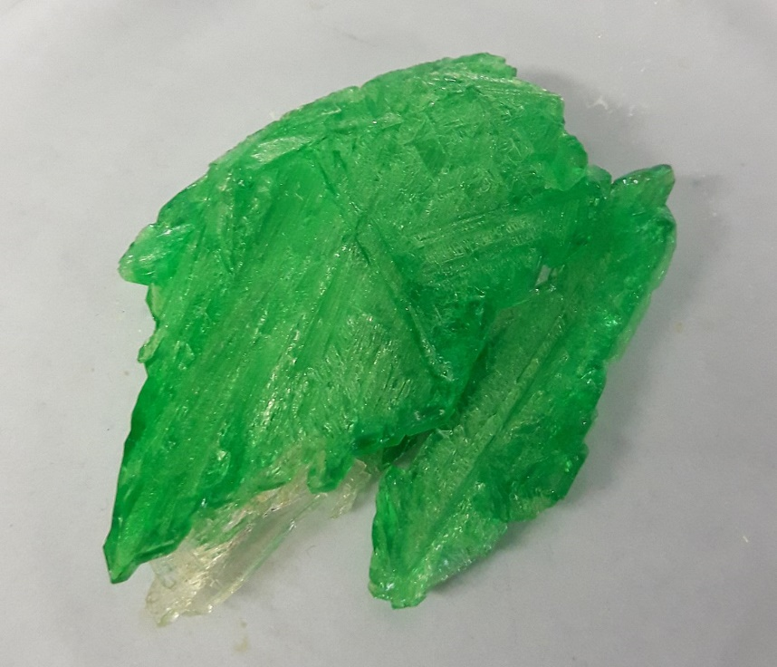
Photo: Korky Buchek via Wikimedia Commons under a Creative Commons 4.0 license.

Preparation of potassium trioxalatoferrate

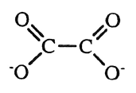
Introduction
Potassium trioxalatoferrate(III) contains the complex ion, [Fe(C₂O₄)₃]³⁻ in which three oxalate ions bind to an iron(III) ion in an octahedral arrangement.
The oxalate ions behave as ligands. Potassium trioxalatoferrate(III) can be prepared from ammonium iron(II) sulphate. A solution of the latter is first treated with oxalic acid to form a precipitate of iron(II) oxalate and ammonium hydrogensulphate solution. The iron(Il) oxalate is isolated from the mixture and on reaction with hydrogen peroxide and potassium oxalate, potassium trioxalatoferrate(III) and a precipitate of iron(III) hydroxide are produced. On further treatment with oxalic acid, the iron(III) hydroxide reacts to form more potassium trioxalatoferrate(III):
On cooling, crystals of hydrated potassium trioxalatoferrate(III), K₃[Fe Fe(C₂O₄)₃].3H₂O separate from the reaction mixture.

Health & safety
Wear eye protection and if any chemical splashes on your skin wash it off immediately.
Hydrated ammonium iron(lI) sulphate may irritate the eyes, skin or respiratory system. Avoid raising dust. Wear eye protection and consider gloves if significant spillage is likely.
The oxalic acid solution is of no significant hazard.
Potassium oxalate solution and the product, potassium trioxalatoferrate(IIl) are harmful by ingestion and are irritating to the eyes and skin. Wear eye protection and consider gloves if significant spillage is likely.
20 volume hydrogen peroxide is irritating to the eyes and skin. Wear eye protection and consider gloves if significant spillage is likely.
Ethanol is volatile, highly ﬂammable, irritating to the eyes and intoxicating if inhaled or ingested. Keep away from sources of ignition, work in a well-ventilated laboratory and wear eye protection.
2 mol l⁻¹ sulphuric acid is corrosive. Wear goggles (BE EN166 3) and consider gloves if spillage is likely.

You will need
hydrated ammonium iron(II) sulphate | oxalic acid solution
potassium oxalate solution | dilute sulphuric acid
20 volume hydrogen peroxide | deionised water
ethanol | 100 cm³ glass beakers
balance (accurate to 0.01 g) | hot plate
glass stirring rod | 25 cm³ measuring cylinder
thermometer | dropper
glass ﬁlter funnel | filter papers
100 cm³ crystallising basin | watch glass

Procedure
- Weigh a 100 cm³ glass beaker and to it, add approximately 5 g of hydrated ammonium iron(ll)sulphate, (NH₄)₂Fe(SO₄)₂.6H₂O. Reweigh the beaker and its contents.
- Add approximately l5 cm³ of deionised water and 1cm’ of dilute sulphuric acid to the ammonium iron(II) sulphate. Warm the mixture to dissolve the solid.
- Once the ammonium iron(II) sulphate has dissolved, add 25 cm³ of oxalic acid solution.
- Place the beaker on a hot plate and slowly heat the mixture with stirring until it boils.
- Remove the beaker from the heat and allow the precipitate of iron(lI) oxalate to settle to the bottom of the beaker.
- Decant off the liquid and add about 50 cm³ of hot deionised water to the precipitate. Stir the mixture and after the precipitate has settled once more, decant off the liquid.
- Add 10 cm³ of potassium oxalate solution to the washed precipitate and heat the mixture to about 40°C.
- To this mixture, add slowly with continuous stirring, 20 cm³ of 20 volume hydrogen peroxide solution. Keep the temperature close to 40°C during the addition of the hydrogen peroxide.
- Heat the mixture nearly to boiling and add oxalic acid solution, dropwise with stirring, until the brown precipitate of iron(III) hydroxide dissolves. Take care not to add too much oxalic acid.
- During the addition of the oxalic acid, keep the reaction mixture near to boiling.
- Filter the hot solution through a ﬂuted filter paper into a crystallising basin.
- Add 25 cm³ of ethanol to the ﬁltrate and if any crystals form, redissolve them by gentle heating.
- Cover the solution with a ﬁlter paper and set it aside in a dark cupboard for crystallisation to take place.
- Filter off the crystals and wash them with a 1:1 mixture of ethanol and water.
- Weigh a clock glass and transfer the crystals to it. Cover the crystals with a ﬁlter paper and leave them to dry at room temperature in a dark cupboard.
- Once dry, reweigh the crystals and clock glass.
- Calculate the percentage yield of hydrated potassium trioxalatoferrate(III), K₃[Fe(C₂O₄)₃].3H₂O

Note
Potassium trioxalatoferrate(III) is photosensitive and the surface of the crystals soon become coated with yellow iron(II) oxalate unless they are stored in the dark.

