Chemical Investigations
Thermodynamic prediction
Pupil Guide
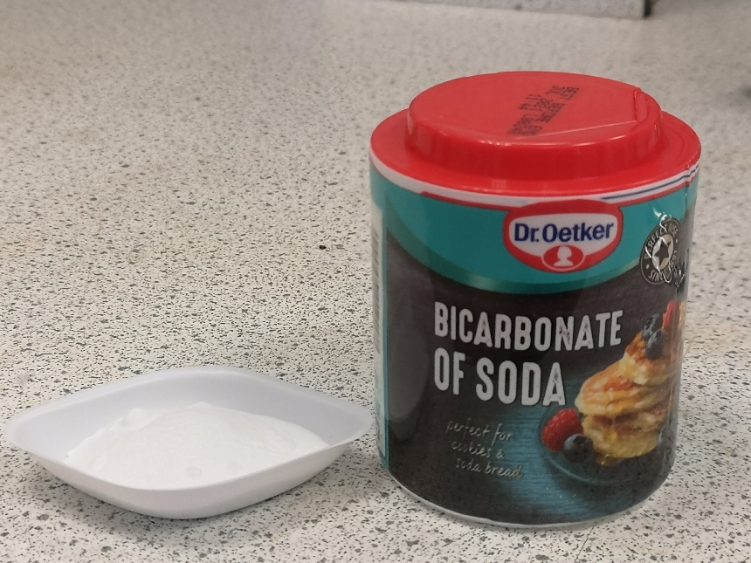

Thermodynamic Prediction

Introduction
Sodium hydrogencarbonate decomposes on heating to produce sodium carbonate, steam and carbon dioxide. From the relevant thermodynamic data it is possible to calculate the theoretical decomposition temperature and verify this experimentally.

Health & Safety
Wear eye protection and if any chemical Splashes on your skin wash it off immediately.
Sodium hydrogencarbonate is of no significant hazard
Liquid parafﬁn in general is of no significant hazard but if heated too strongly, it can give off fumes that are irritating to the eyes or if inhaled. Take care in heating it and make sure that the oil bath is in a stable position.
The sodium carbonate product is irritating to the eyes. Avoid raising a dust.

You will need
sodium hydrogencarbonate | liquid parafﬁn
narrow test tube with side arm | stopper with thermometer (0 - 200 °C) fitted
100 cm³ gas syringe | 400 cm³ glass beaker
balance (accurate to 0.01 g) | hot plate
glass stirring rod | clamp stands and clamps

Procedure
Part A
- Use the data in the following table to calculate the standard enthalpy and entropy changes for the decomposition of sodium hydrogencarbonate and hence the decomposition temperature of sodium hydrogencarbonate.
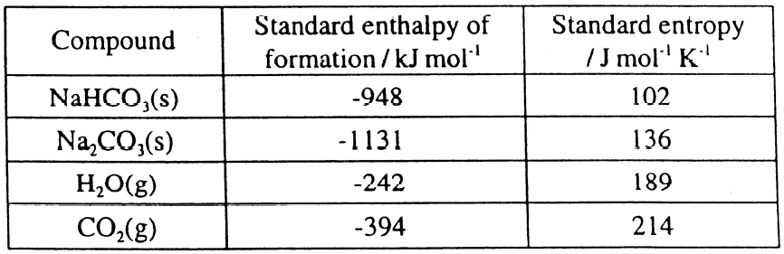
- Calculate the mass of sodium hydrogencarbonate required to produce approximately 90 cm³ of carbon dioxide on decomposition. Assume the molar volume of carbon dioxide to be 24 litres mol⁻¹.
Part B
- Weigh the narrow test tube and to it, add the calculated mass of sodium hydrogencarbonate. Reweigh the test tube and its contents.
- Place the stopper with ﬁtted thermometer in the neck of the test tube. Carefully adjust the thermometer so that its bulb is immersed in the sodium hydrogencarbonate. Make sure the stopper is ﬁtted tightly.
- Add liquid paraffin to the beaker until it is about two-thirds full and place the beaker on the hot plate.
- Place the test tube in the liquid parafﬁn and connect the gas syringe. Make sure the connection is air-tight.
- Heat the oil bath very slowly and carefully, taking volume and temperature readings at each 5 °C rise in temperature up to 100 °C and at each 2 °C rise, thereafter. During this time stir the liquid paraffin in the beaker.
- Plot a graph of your results and from it, estimate the decomposition temperature of sodium hydrogencarbonate.

