Chemical Investigations
Propanone-iodine reaction
Teacher/Technician Guide
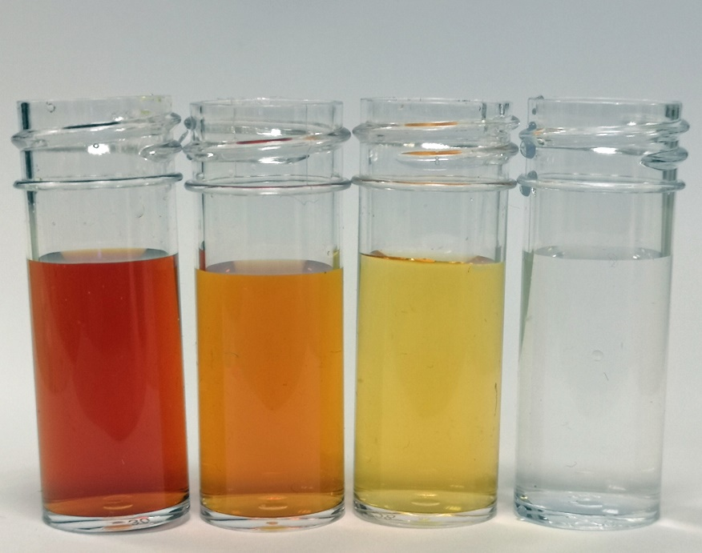

Reaction of propanone with iodine
UNIT 2 PPA 5
Introduction
The reaction between propanone and iodine:
is first order with respect to propanone and first order with respect to the hydrogen ions which catalyse the reaction. The order with respect to iodine can be determined by taking a reaction mixture in which the initial concentrations of propanone and hydrogen ions are very much larger than that of iodine. With such conditions, only the concentration of the iodine will vary significantly during the reaction and this will allow us to see what effect it has on the reaction rate.
The course of the above reaction can be followed by monitoring the concentration of iodine This involves removing samples from the reaction mixture from time to time and analysing them for iodine.

Health & Safety
Wear eye protection and if any chemical splashes on your skin wash it off immediately.
0.010 mol l⁻¹ iodine solution is of no significant hazard.
Propanone itself is volatile and highly ﬂammable and the vapour irritates the eyes, skin and lungs. However, in aqueous solution as 1.0 mol l⁻¹ propanone there is no significant hazard.
1.0 mol l⁻¹ sulphuric acid is irritating to the eyes and skin. Wear eye protection and consider gloves if spillage is likely.
0.0050 mol l⁻¹ sodium thiosulphate is of no significant hazard
lodopropanone is formed in solution: it is a powerful lachrymator and is corrosive. Inhalation causes difficulty in breathing. However, it is only formed in tiny amounts and so there is no significant risk.

Requirements
0.010 mol l⁻¹ iodine solution | 1.0 mol l⁻¹ propanone solution
1.0 mol l⁻¹ sulphuric acid | 0.5 mol l⁻¹ sodium hydrogencarbonate
0.0050 mol l⁻¹ sodium thiosulphate | 1 % fresh starch solution
conical ﬂasks (100 cm³ and 250 cm³) | stoppers (to fit 250 cm³ conical ﬂasks)
10 cm³ pipette | 25 cm³ pipette
50 cm³ pipette | 50 cm³ burette
10 cm³ measuring cylinder | pipette ﬁller
ﬁlter funnel | white tile
wash bottle | dropper
timer

Procedure
- Rinse the 50 cm³ pipette with 0.010 mol l⁻¹ iodine solution and pipette 50 cm³ of this solution into a 250 cm³ conical ﬂask and stopper it.
- Rinse the 25 cm³ pipette with 1.0 mol l⁻¹ sulphuric acid and pipette 25 cm³ of this solution into a second 250 cm³ conical ﬂask.
- Wash the 25 cm³ pipette and then rinse it with 1.0 mol l⁻¹ propanone solution. Pipette 25 cm³ of the propanone solution into the conical ﬂask containing the acid and stopper the ﬂask.
- Using the measuring cylinder, add 10 cm³ of sodium hydrogencarbonate solution to each of seven 100 cm³ conical ﬂasks.
- Rinse the burette, including the tip, with 0.0050 mol l⁻¹ sodium thiosulphate and ﬁll it with the same solution.
- Add the sulphuric acid/propanone mixture to the iodine solution and immediately start the timer. Stopper the ﬂask and swirl the contents to ensure thorough mixing.
- After about 2 minutes, pipette 10 cm³ of the reaction mixture into one of the conical ﬂasks containing the sodium hydrogencarbonate solution and note the exact time when the pipette is half empty. Swirl the contents of the ﬂask.
- Titrate this solution against 0.0050 mol l⁻¹ sodium thiosulphate and when it is straw coloured, add a few drops of starch solution. Continue the titration to the end-point taking care not to overshoot the end-point.
- Repeat steps seven and eight after about 6, 10, 14, 18, 22 and 26 minutes. In each case, remember to note the exact time when the pipette is half empty.
- Calculate the concentration of iodine in the reaction mixture each time a sample was removed from it. Your teacher/lecturer will provide you with the accurate concentration of the sodium thiosulphate solution.
- Draw a graph of iodine concentration against time and from it, deduce the order of the reaction with respect to iodine.
- Calculate the rate of the reaction.
- Work out the initial concentrations of propanone and hydrogen ions in the reaction mixture remembering that sulphuric acid is diprotic, i.e. contains two moles of hydrogen ions per mole of acid. Use these initial concentrations along with the rate of reaction to calculate the rate constant for the reaction. Remember that the reaction is ﬁrst order with respect to both propanone and hydrogen ions.

Notes
Hydrated sodium thiosulphate is not a primary standard but for the purposes of this experiment it may be regarded as such and the 0.0050 mol l⁻¹ sodium thiosulphate solution can be prepared directly from it.
Alternatively, the sodium thiosulphate solution could be prepared from a more concentrated standard solution or from a commercial volumetric standard.
While it is appreciated that a ‘titre volume/time‘ plot would be sufﬁcient to determine the order with respect to iodine, students have been asked to plot iodine concentration against time since they are likely to be more familiar with the use of ‘concentration/time‘ graphs in determining orders.

Technician Guide
Requirements per student (or group)
Reagents
0.010 mol l⁻¹ iodine (50 cm³) (2.54 g iodine and 40 g potassium iodide per litre) | 1.0 mol l⁻¹ propanone (25 cm³) (73.3 cm³ propanone per litre)
1.0 mol l⁻¹ sulphuric acid (25 cm³) (55 cm³ concentrated sulphuric acid per litre) | 0.5 mol l⁻¹ sodium hydrogencarbonate (70 cm³) (42 g sodium hydrogencarbonate per litre)
0.0050 mol l⁻¹ sodium thiosulphate (~75 cm³) (1.24 g AnalaR sodium thiosulphate-5-hydrate per litre) | l % fresh starch solution (~7 cm³) (mix l g soluble starch to a thin paste with water, then add to 100 cm³ boiling water)

Apparatus
250 cm³ conical ﬂasks (2) | 10 cm³ pipette (1)
25 cm³ pipette (1) | 50 cm³ pipette (1)
50 cm³burette (1) | 10 cm³ measuring cylinder (1)
stoppers to ﬁt above (2) | pipette filler (1)
100 cm³ conical ﬂasks (7) | ﬁlter funnel (1)
white tile (1) | wash bottle (1)
dropper (1) | timer (1)

Notes
Hydrated sodium thiosulphate is not a primary standard but for the purposes of this experiment it may be regarded as such and the 0.0050 mol l⁻¹ sodium thiosulphate solution can be prepared directly from it.
Alternatively, the sodium thiosulphate solution could be prepared from a more concentrated standard solution or from a commercial volumetric standard.

