Chemical Investigations
Preparation of cyclohexene
Pupil Guide

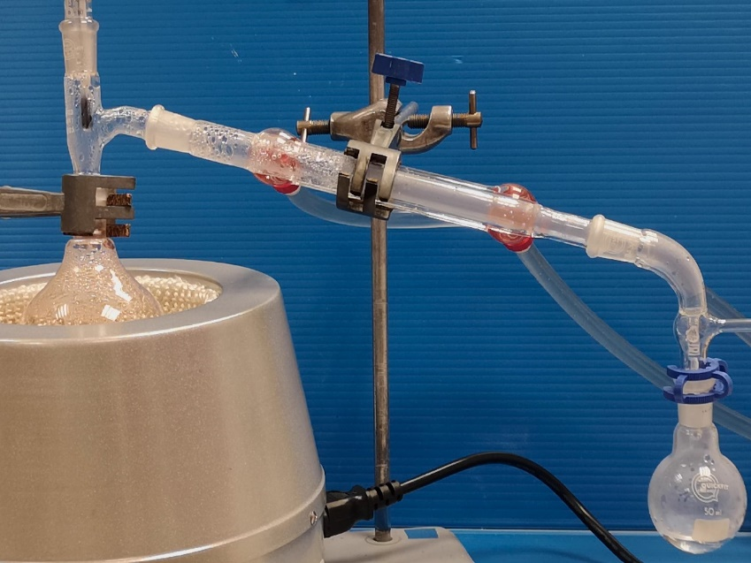

Preparation of Cyclohexene

Introduction
Cyclohexene can be prepared by dehydrating cyclohexanol using concentrated phosphoric acid.
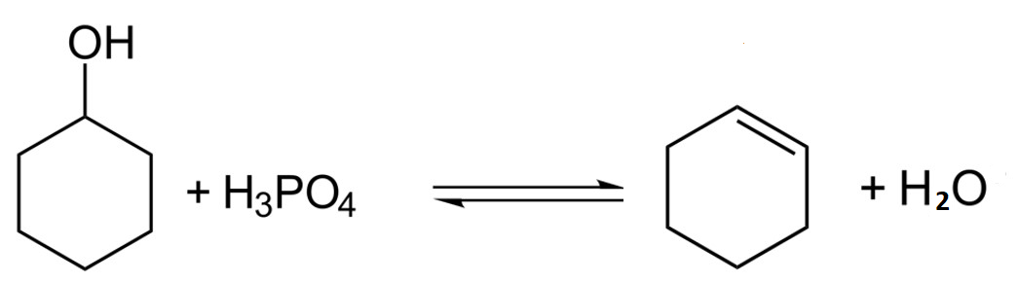

The product can be separated from the reaction mixture by distillation and after purification, it can be weighed and the percentage yield calculated.

Health & Safety
Wear eye protection and if any chemical splashes on your skin wash it off immediately.
Cyclohexanol and its vapour is harmful if swallowed or inhaled and a skin/respiratory irritant. Wear eye protection and gloves.
85 % phosphoric acid is corrosive; it bums and irritates the skin and eyes. It is a systemic irritant if inhaled and if swallowed, causes serious internal injury. Wear goggles (BS EN166 3) and gloves.
Anhydrous calcium chloride irritates the eyes, lungs and skin. Wear gloves.
Cyclohexene is extremely flammable, harmful if swallowed and toxic in contact with skin. Wear gloves. At the end of the experiment, dispose of the cyclohexene since it may form unstable peroxides if it is stored.
Bromine solution causes bums and is toxic. Wear gloves. If any splashes on the skin. wash it off with sodium thiosulphate solution.

You will needs
85 % phosphoric acid | cyclohexanol
saturated sodium chloride solution | anhydrous calcium chloride
50 cm³ round-bottomed ﬂasks | cork ring
condenser | still head
receiver adapter anti-bumping granules | thermometer adapter bromine solution
thermometer | balance (accurate to 0.01 g)
heating mantle | 250 cm³ separating funnel
clamp stands and clamps | 10 cm³measuring cylinder
50 cm³ conical ﬂask | test tube and rack
dropper

Procedure
- Weigh a 50 cm³ round-bottomed ﬂask supported on a cork ring. To the ﬂask, add about 20 g of cyclohexanol and reweigh the ﬂask and its contents.
- To the cyclohexanol, add dropwise with swirling approximately 8 cm³ 85 % phosphoric acid.
- Add a few anti-bumping granules to the reaction mixture and set up the apparatus for distillation. Gently heat the mixture for about 15 minutes - do not allow it to boil. Raise the temperature and distil the mixture very slowly, collecting the liquid which comes over between 70 and 90°C.
- Wash the distillation apparatus and leave it to dry.
- Pour the distillate into a separating funnel and add about an equal volume of saturated sodium chloride solution. Stopper the funnel and shake the contents vigorously. (Sodium chloride solution is used rather than water because it is more dense and will separate from the cyclohexene more rapidly)
- Clamp the separating funnel and allow the two layers to separate.
- Remove the stopper from the funnel and run off the lower aqueous layer into a beaker and dispose of it down the sink.
- Run the top layer (the crude alkene) into a small conical ﬂask and add a few pieces of anhydrous calcium chloride. Stopper the ﬂask and shake the mixture for a few minutes until the liquid is clear.
- Weigh a dry 50 cm³ round-bottomed ﬂask in which to collect the pure cyclohexene.
- Decant the alkene into another dry 50 cm³ round-bottomed ﬂask and add a few anti-bumping granules. Distil the alkene very slowly collecting the liquid which comes over between 81 and 85°C in the preweighed ﬂask.
To cut down loss of the volatile cyclohexene during distillation, the receiving ﬂask could be placed in an ice bath.
- Weigh the ﬂask and product.
- Carry out a test to show that the product is unsaturated.
- Calculate the percentage yield of cyclohexene

