Chemical Investigations
Preparation of aspirin
Pupil Guide
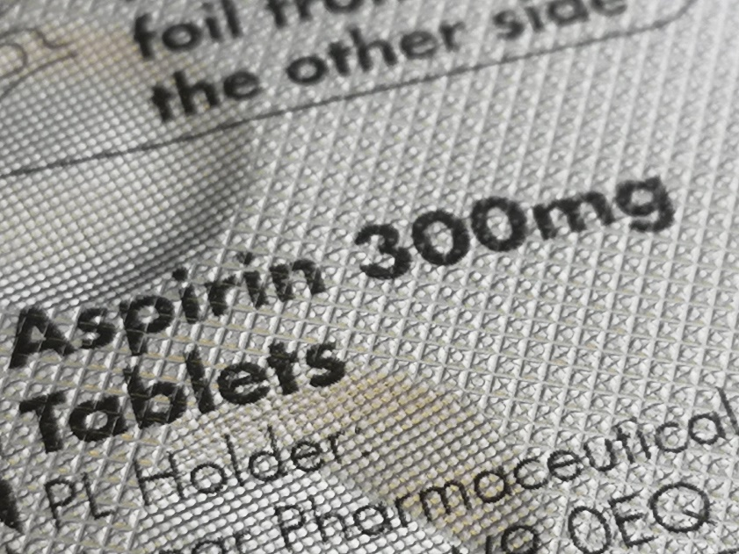

Preparation of Aspirin

Introduction
Aspirin is an analgesic (pain-killing), anti-inﬂammatory and anti-pyretic (fever-reducing) drug. It is an ester and can be prepared by the condensation reaction between 2-hydroxybenzoic acid (or salicylic acid) and ethanoic anhydride:
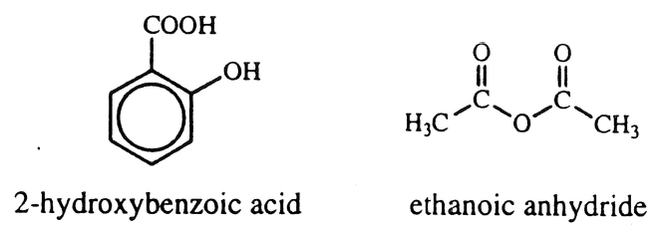
After purification by recrystallisation, the product can be weighed and the percentage yield determined. The purity of the ﬁnal sample can be checked by determining its melting point.

Health & Safety
Wear eye protection and if any chemical splashes on your skin wash it off immediately.
2-hydroxybenzoic acid is harmful if swallowed, causes serious eye damage and is a reproductive toxin. Wear goggles (BS EN166 3) and consider gloves.
Ethanoic anhydride is flammable, corrosive to skin and eyes and harmful if swallowed or inhaled and is severely lachrymatory. The liquid irritates and burns the eyes and skin severely while the vapour irritates the respiratory system and may cause bronchial and lung injury. Wear goggles (BS EN166 3) and gloves and handle in a fume cupboard.
85 % phosphoric acid is corrosive; it burns and irritates the skin and eyes. It is a systemic irritant if inhaled and if swallowed, causes serious internal injury. Wear goggles (BS EN166 3) and gloves.
Ethanol is volatile, highly flammable, irritating to the eyes and intoxicating if inhaled or ingested.

You will need
2-hydroxybenzoic acid | ethanoic anhydride
85% phosphoric acid | ethanol
deionised water
50 cm³ conical ﬂask | 100 cm³ conical ﬂasks
measuring cylinders (10 cm³, 50 cm³) | 250 cm³ glass beakers
thermometers anti-bumping granules | dropper
balance (accurate to 0.01 g) ice | hot plate
glass stirring rod | Buchner funnel and ﬂask
water pump | ﬁlter papers
clock glass | oven
melting point apparatus | capillary tube

Procedure
- Weigh a 50 cm³ conical ﬂask and to it, add about 5 g of 2-hydroxybenzoic acid. Reweigh the ﬂask and its contents.
- In a fume cupboard, add l0 cm³ of ethanoic anhydride from a measuring cylinder, to the 2-hydroxybenzoic acid. During the addition, swirl the contents of the ﬂask to ensure thorough mixing.
- Add 5 drops of phosphoric acid to the mixture, again with swirling.
- Place the ﬂask on a hot plate (in the fume cupboard) and heat the mixture to about 85°C. Hold it at this temperature for about l0 minutes and constantly stir the mixture.
- Cool the mixture in an ice/water bath and then pour it into approximately 150 cm³ of cold water contained in a 250 cm³ beaker.
- Filter off the precipitate at the water pump and wash it thoroughly with several portions of cold water.
- Transfer the crude product to about 15 cm³ of ethanol in a 100 cm³ conical ﬂask. Add a couple of anti-bumping granules and heat the mixture gently on a hot plate until the solid dissolves.
- Pour this solution into a 100 cm³ conical ﬂask containing about 40 cm³ of water. If an oil forms, re-heat the mixture on the hot plate to dissolve it. If the oil still persists, add a few drops of ethanol and re-heat the mixture.
- Set aside the mixture and allow it to cool to room temperature.
If crystals of aspirin fail to appear on recrystallisation, then ‘seeding‘ the solution or scratching with a glass rod will rapidly induce crystallisation.
- Filter off the crystals of aspirin at the water pump and wash them with a small volume of cold water. Allow air to be drawn through the crystals for a few minutes in order to partially dry them.
- Weigh a clock glass and transfer the crystals to it. Dry the crystals in an oven at about 100°C and then reweigh the clock glass and crystals.
(alternatively, they can be dried in the open air or in a desiccator with silica gel or anhydrous calcium chloride as desiccant.)
- Determine the melting point of the aspirin.
- Calculate the percentage yield of aspirin.

