Chemical Investigations
Partition of iodine
Teacher/technician Guide
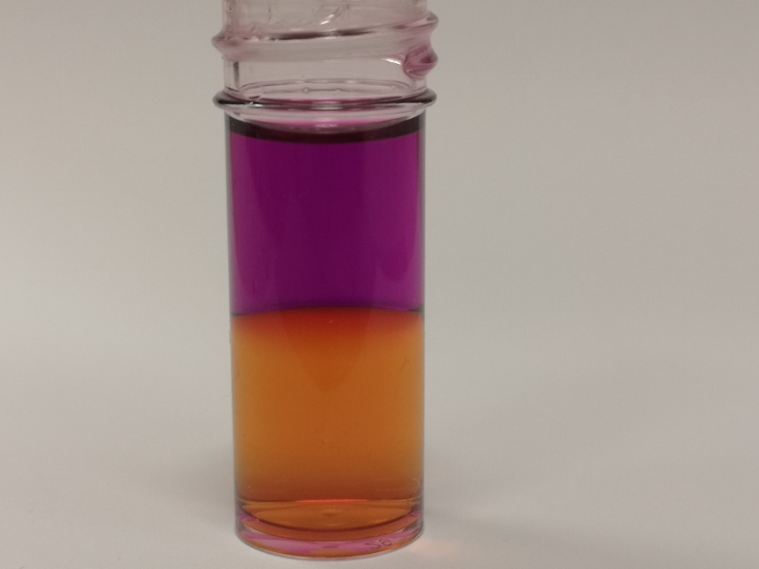

Partition of Iodine
UNIT 2 PPA 3
Introduction
When iodine is added to a pair of immiscible liquids, such as aqueous potassium iodide and cyclohexane, it distributes or partitions itself between the two liquids and the following equilibrium is established:
The partition of the iodine between the two liquids can be described quantitatively in terms of a partition coefficient.

Health & Safety
We eye protection and if any chemical splashes on your skin wash it off immediately.
0.050 mol l⁻¹ iodine solution is of no significant hazard.
The sodium thiosulphate solutions are of no significant hazard.
Cyclohexane is highly ﬂammable and irritating to the skin. eyes and respiratory system. The vapour can be narcotic in high concentrations. Wear eye protection and gloves.

Requirements
0.050 mol l⁻¹ iodine solution | 0.050 mol l⁻¹ sodium thiosulphate
0.025 mol l⁻¹ sodium thiosulphate | 1 % fresh starch solution
cyclohexane | deionised water
250 cm³ separating funnel | 50 cm³ pipettes
10 cm³ pipettes | 50 cm³ burette
100 cm³ conical ﬂasks | 10 cm³ measuring cylinder
100 cm³ beakers | ﬁlter funnel
pipette ﬁller | white tile
wash bottle | clamp stand and clamp
dropper

Procedure
- Rinse a 50 cm³ pipette with 0.050 mol l⁻¹ iodine solution and pipette 50 cm³ of this solution into the separating funnel.
- Rinse a 50 cm³ pipette with cyclohexane and pipette 50 cm³ of it into the same separating funnel.
- Stopper the separating funnel and shake the contents vigorously for about two minutes. Clamp the separating funnel and allow the layers to separate.
- Rinse the burette, including the tip, with 0.050 mol l⁻¹ sodium thiosulphate and fill it with the same solution.
- Remove the stopper from the separating funnel and run off the lower aqueous layer into a dry beaker. Leave the upper cyclohexane layer in the separating funnel and re-stopper the funnel.
- Rinse a 10 cm³ pipette with a little of the lower aqueous layer and pipette 10 cm³ of this solution into a conical ﬂask.
- Titrate this solution against 0.050 mol l⁻¹ sodium thiosulphate. Just before the end-point when the solution is 'straw' coloured, add a few drops of starch solution and continue the titration to the end-point.
- Repeat the titrations until two concordant results are obtained.
- Wash out the burette and then rinse it and fill it with 0.025 mol l⁻¹ sodium thiosulphate.
- Remove the stopper from the separating funnel and run the cyclohexane layer into a dry beaker.
- Rinse a 10 cm³ pipette with a little of the cyclohexane layer and pipette 10 cm³ of this solution into a conical ﬂask together with approximately 10 cm³ of deionised water.
- Titrate this mixture against 0.025 mol l⁻¹ sodium thiosulphate using the starch indicator solution as before. It is imperative to stop the titration at intervals, especially near the end-point, and agitate the contents of the conical ﬂask quite vigorously.
- Repeat the titrations until two concordant results are obtained.
- Calculate the concentrations of iodine in the aqueous and cyclohexane layers using the accurate concentrations of the two sodium thiosulphate solutions provided by your teacher/lecturer.
- Calculate the partition coefficient for the system.
- Calculate the percentage error and hence the absolute error in the partition coefficient. Your teacher/lecturer will provide you with the errors in the concentrations of the two thiosulphate solutions used.

Notes
Hydrated sodium thiosulphate is not a primary standard but for the purposes of this experiment it may be regarded as such and the 0.050 mol l⁻¹ sodium thiosulphate solution can be prepared directly from it. The 0.025 mol l⁻¹ solution can then be prepared by appropriate dilution of the 0.050 mol l⁻¹ solution.
Alternatively, the sodium thiosulphate solutions could be prepared from a commercial volumetric standard.
When titrating the iodine in the cyclohexane layer, it is important to emphasise to the students the need to stop the titration at intervals and vigorously agitate the contents of the ﬂask. This allows the iodine to be extracted from the organic layer into the aqueous layer in order that it can react with the thiosulphate. This is particularly important near the end-point if the titration is not to be overshot.

Technician Guide
Requirements per student (or group)
Reagents
0.050 mol l⁻¹ iodine (50 cm³) (12.69 g iodine and 40 g potassium iodide per litre) | 0.050 mol l⁻¹ sodium thiosulphate (~50 cm³) (12.41 g AnalaR sodium thiosulphate 5-hydrate per litre)
0.025 mol l⁻¹ sodium thiosulphate (~50 cm³) (500 cm³ 0.050 mol I" sodium thiosulphate per litre) | 1 % fresh starch solution (~6 cm³) (mix 1 g soluble starch to a thin paste with water, then add to 100 cm³ boiling water)
cyclohexane (50 cm³) | deionised water

Apparatus
250 cm³ separating funnel (1) | pipette ﬁller (1)
S0 cm³pipettes (2) | ﬁlter funnel (1)
10 cm³pipettes (2) | white tile (1)
50 cm³ burette (1) | wash bottle (1)
100 cm³conical ﬂasks (2) | dropper (1)
10 cm³ measuring cylinder (1) | clamp stand and clamp (1)
100 cm³ beakers (2)

Notes
Hydrated sodium thiosulphate is not a primary standard but for the purposes of this experiment it may be regarded as such and the 0.050 mol l⁻¹ sodium thiosulphate solution can be prepared directly from it. The 0.025 mol l⁻¹ solution can then be prepared by appropriate dilution of the 0.050 mol l⁻¹ solution.
Alternatively, the sodium thiosulphate solutions could be prepared from a commercial volumetric standard.

