Chemical Investigations
Nickel titration
Teacher/Technician Guide
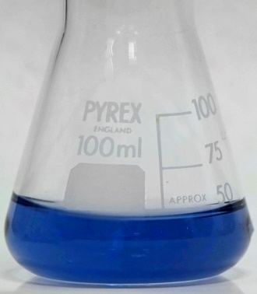
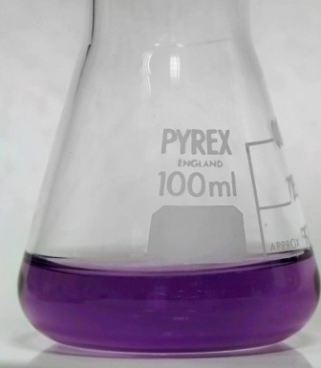
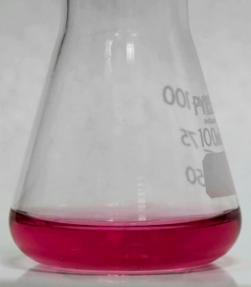

Nickel Titration
UNIT 2 PPA 1
Introduction
Since ethylenediaminetetraacetic acid - commonly abbreviated to EDTA - forms stable complexes with most metal ions, it is widely used to determine metals in what are known as complexometric titrations. EDTA is a tetracarboxylic acid and can be represented as H₄Y. In alkaline conditions,
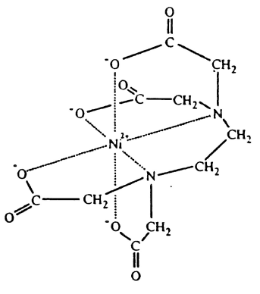
EDTA exists as Y⁴⁺ ions:
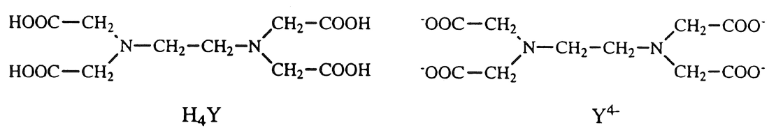

The Y⁴⁺ ions form l:l complexes with metal ions. For example, Ni²⁺ ions bind with them to form the complex, NiY²⁻ , which has the octahedral structure shown opposite.

The end-point of an EDTA complexometric titration can be detected by means of a metal ion indicator - an organic dye which changes colour when it binds with metal ions. For it to be suitable in an EDTA titration, the indicator must bind less strongly with metal ions than does EDTA.

Health & Safety
Wear eye protection and if any chemical splashes on your skin wash it off immediately.
Hydrated nickel(II) sulphate is carcinogenic if inhaled and harmful by ingestion and inhalation. It irritates the eyes and skin. Continued skin contact can cause dermatitis. Avoid raising a dust or aerosol. Wear gloves.
EDTA is a skin/eye irritant but the solution is of no significant hazard..
0.88 aqueous ammonia is toxic if inhaled in high concentrations or if swallowed. The solution and vapour irritate the eyes. The solution burns the skin and swallowing causes internal damage. Wear goggles and gloves and handle it in a fume cupboard.
1 mol l⁻¹ ammonium chloride is irritating to skin and eyes.
Murexide is a skin/eye/respiratory irritant and may be a mutagen. The quantities are very small but avoid raising dust.
Nickel(EDTA) complex - limited information is available on its toxicity. its high stability and water solubility will almost certainly give rise to low toxicity.

Requirements
100 cm³ standard flask | 250 cm³ conical ﬂasks
20 cm³ pipette | 50 cm³ burette
weighing bottle | balance (accurate to 0.01 g)
25 cm³ measuring cylinder | pipette ﬁller
ﬁlter funnel | white tile
wash bottle | glass stirring rod
dropper
hydrated nickel(II) sulphate (NiSO₄.6H₂O) | 0.10 mol l⁻¹ EDTA solution
1 mol l⁻¹ ammonium chloride | 0.88 aqueous ammonia
murexide indicator | deionised water

Procedure
Part
- Calculate the theoretical percentage by mass of nickel in NiSO₄.6H₂O.
Part B
- Carry out the following procedure in duplicate.
- Transfer approximately 2.6 g of hydrated nickel(II) sulphate to a weighing bottle and weigh the bottle and contents.
- Add about 25 cm³ of deionised water to a 100 cm’ beaker and transfer the bulk of the nickel salt to the water.
- Reweigh the bottle with any remaining salt.
- Stir the solution in the beaker until the solid has dissolved.
- Transfer the solution to a 100 cm³ standard ﬂask.
- Rinse the beaker with a little deionised water and add the rinsings to the ﬂask. Repeat this procedure until you are within about a centimetre of the graduation mark on the ﬂask.
- Using a dropper, make up the solution to the graduation mark with deionised water.
- Stopper the ﬂask and invert it several times to ensure the contents are thoroughly mixed.
- Rinse the burette, including the tip, with 0.10 mol l⁻¹ EDTA and fill it with the same solution.
- Rinse the 20 cm³ pipette with a little of the nickel salt solution and pipette 20 cm³ of it into a conical ﬂask. Dilute the solution to about 100cm³ with deionised water.
- Add murexide indicator (approximately 0.05 g) to the diluted nickel salt solution together with approximately 10 cm³ of ammonium chloride solution.
- Titrate the mixture with the EDTA solution and after the addition of about 15 cm³ of EDTA make the solution alkaline by adding approximately 10 cm] of 0.88 aqueous ammonia.
- Continue the titration to the end-point which is shown by the first appearance of a blue-violet colour. Detection of the end-point can be very difficult, so use this as a trial run. Keep the titrated solution to help you detect the end-points in subsequent titrations.
- Repeat the titrations until two concordant results are obtained.
- Calculate the percentage by mass of nickel in your sample of hydrated nickel(II) sulphate using the accurate concentration of the EDTA solution provided by your teacher/lecturer.
- For one of your determinations, calculate the percentage error and hence the absolute error in the percentage of nickel in NiSO₄.6H₂O. Your teacher/lecturer will provide you with the error in the concentration of the EDTA solution.

Note
It is worthwhile reminding the students to keep the solution from their trial titration to help them detect the end-points in subsequent titrations.

Technician Guide
Requirements per student (or group)
Reagents
AnalaR nickel(II) sulphate 6-hydrate (~5.2 g) | 0.10 mol l⁻¹ (-120 cm³) (37.22 g AnalaR ethylenediaminetetraacetic acid disodium salt 2-hydrate per litre)
1 mol l⁻¹ ammonium chloride (~60 cm³) (53.5 g ammonium chloride per litre) | murexide indicator (~0.3 g) (grind murexide with AnalaR sodium chloride in the mass ratio 1:100)
0.88 aqueous ammonia (~60 cm³) | deionised water
Apparatus
100 cm³ standard ﬂasks (2) | 25 cm³ measuring cylinder (1)
250 cm³ conical ﬂasks (2) | pipette filler (1)
20 cm³ pipette (1) | ﬁlter funnel (1)
50 cm³ burette (1) | white tile (1)
weighing bottle (1) | wash bottle (1)
access to balance (accurate to 0.01 g) | glass stirring rod (1)
dropper (1)

Notes
The AnalaR disodium salt of EDTA can be regarded as a primary standard and so can be used directly to prepare the standard solution.
Alternatively, the EDTA solution could be prepared from a commercial volumetric standard.

