Chemical Investigations
Manganese in Steel
Pupil Guide
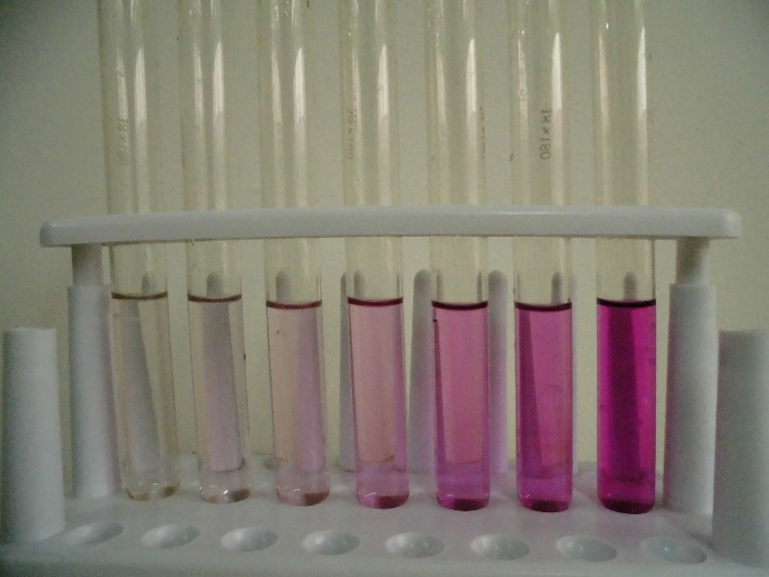
Photo by Leiem via Wikimedia Commons under a Creative Commons 4.0 license

Manganese in Steel

Introduction
Colorimetry is an analytical technique used to determine the concentrations of coloured substances in solution. It relies on the fact that a coloured substance absorbs light of a colour complementary to its own and furthermore, the amount of light it absorbs (absorbance) is proportional to its concentration.
Colorimetry is particularly suited to the determination of manganese in steel because the manganese can be converted into permanganate ions which are coloured. The conversion is achieved in two stages. Using nitric acid, the manganese is first oxidised to manganese(II) ions which are then oxidised to permanganate ions by the more powerful oxidising agent, potassium periodate.

Health & Safety
Wear eye protection and if any chemical splashes on your skin wash it off immediately.
The acidiﬁed 0.0010 mol l⁻¹ potassium permanganate is a skin/eye irritant (due to the acid). Consider gloves.
Both 2 mol l⁻¹ nitric acid and its vapour are corrosive and toxic causing severe burns to the eyes, digestive and respiratory systems and in contact with the skin. But at this concentration a well-ventilated room is sufficient to control the risk from the fumes. Wear goggles (BS EN1663) and consider gloves if splashes are likely.
85 % phosphoric acid is corrosive; it burns and irritates the eyes and skin. A systemic irritant if inhaled and if swallowed, causes serious internal injury. Wear gloves and goggles (BS EN1663).
Acidiﬁed potassium periodate solution has no hazards other than of the 2 mol l⁻¹ nitric acid it is made up in. Corrosive to the eyes, skin and respiratory system. Wear goggles (BS EN1663) and consider gloves if splashes are likely.
Potassium persulphate irritates the eyes, skin and respiratory system (causing dermatitis and possible allergic reactions for regular users). Avoid raising dust. Wear gloves.
Propanone is volatile and highly ﬂammable and is harmful if swallowed. The vapour irritates the eyes, skin and lungs and is narcotic in high concentrations. Work in a well-ventilated lab or use a fume cupboard. Consider gloves if splashes are likely.

You will need
0.0010 mol l⁻¹ acidiﬁed potassium permanganate | steel paper clips
2 mol l⁻¹ nitric acid | 85 % phosphoric acid
acidified potassium periodate solution | potassium persulphate
propanone | deionised water
anti-bumping granules
standard ﬂasks (50 cm³ and 100 cm³) | 50 cm³ burette
colorimeter | 540 nm filter
optically matched cuvettes | balance (accurate to 0.001 g)
glass beakers (50 cm³ and 250 cm³) | Bunsen burner, heating mat and tripod
measuring cylinders (50 cm³ and 10 cm³) | dropper
watch glass | filter funnel
tweezers | wash bottle
wire cutters

Procedure
Part A - Calibration graph
Rinse the burette, including the tip, with 0.0010 mol l⁻¹ acidiﬁed potassium permanganate and ﬁll it with the same solution.
Run 2 cm³ of the permanganate solution into a 50 cm³ standard ﬂask and make up to the graduation mark with deionised water. Use a dropper for the final centimetre.
Stopper the ﬂask and invert it several times to ensure the contents are completely mixed.
Rinse a cuvette with some of this solution and fill it.
Using the colorimeter (ﬁtted with a 540 nm ﬁlter) measure the absorbance of the solution in the cuvette.
Repeat steps two to five with 4, 6, 8, 10, 12 and 14 cm³ of the permanganate stock solution in the burette.
Plot a calibration graph of ‘absorbance‘ against ‘concentration of potassium permanganate’.
Your teacher/lecturer will provide you with the accurate concentration of the potassium permanganate stock solution.

Part B - Conversion of manganese to permanganate
Carry out the following procedure in duplicate.
Degrease a steel paper clip by swirling it with a little propanone in a small beaker. Using tweezers, remove the paper clip and leave it to dry for about a minute or so on a paper towel.
Cut up the paper clip into small pieces.
Weigh accurately about 0.2g of the paper clip pieces and transfer them to a 250 cm³ glass beaker.
Add approximately 40 cm³ of 2 mol l⁻¹ nitric acid to the beaker and cover it with a watch glass.
Heat the mixture cautiously, in a fume cupboard, until the reaction begins. Continue heating gently to maintain the reaction, but remove the source of heat if it becomes too vigorous.
Once the steel has dissolved, allow the solution to cool a little. Add a couple of anti-bumping granules and then boil the solution until no more brown fumes are given off.
After the solution has cooled considerably - no more than ‘hand hot’ - add about 5 cm³ of 85 % phosphoric acid, approximately 0.2g of potassium persulphate and a couple of fresh anti-bumping granules. Boil the mixture for about 5 minutes.
To this solution, add approximately 15 cm³ of acidified potassium periodate solution plus a couple of fresh anti-bumping granules and then gently boil the mixture. The solution should start to tum pink. Continue gentle boiling until the intensity of the pink colour remains constant. This should take about 5 minutes.
Allow the pink solution to cool to room temperature and then transfer it to a 100 cm³ standard ﬂask leaving the anti-bumping granules in the beaker.
Rinse the beaker with a little deionised water and add the rinsings (but not the anti-bumping granules) to the ﬂask. Repeat this procedure until you are within about a centimetre of the graduation mark on the ﬂask.
Using a dropper, make up the solution to the graduation mark with deionised water.
Stopper the ﬂask and invert it several times to ensure the contents are completely mixed.
Using a colorimeter fitted with a 540 nm filter, measure the absorbance of the solution.
Use your calibration graph to convert the absorbance to a permanganate concentration and then calculate the percentage by mass of manganese in the steel paper clip.

