Chemical Investigations
Hydrolysis of ethyl benzoate
Pupil Guide
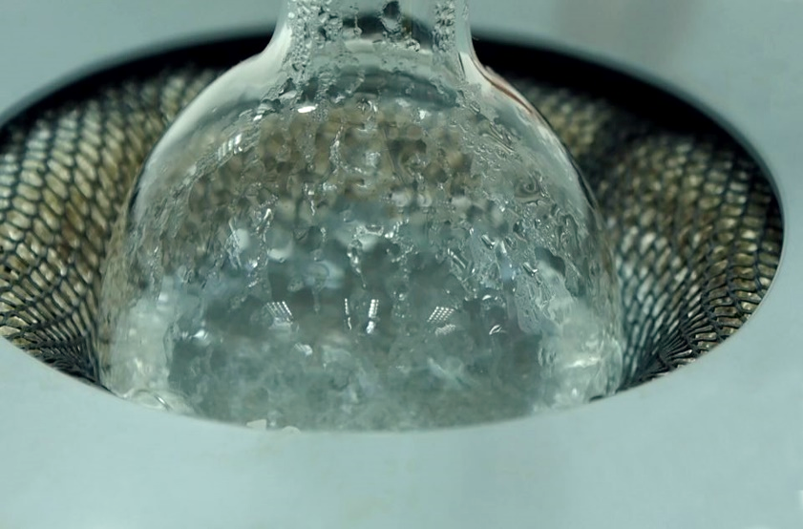

Hydrolysis of ethyl benzoate

Introduction
Benzoic acid can be prepared by the alkaline hydrolysis of the ester, ethyl benzoate:
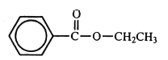
If sodium hydroxide is used, then the residual solution will contain sodium benzoate. Insoluble benzoic acid can be displaced from this solution by acidification. It can then be filtered off and purified by recrystallisation from water. The percentage yield of benzoic acid can be calculated and its melting point determined.
Health and Safety
Wear eye protection and if any chemical splashes on your skin wash it off immediately.
Ethyl benzoate is of no significant hazard.
2 mol l⁻¹ sodium hydroxide is corrosive to the eyes and skin. Gloves and goggles should be worn.
5 mol l⁻¹ hydrochloric acid is irritating to the eyes, lungs and skin and if swallowed. Wear gloves.
The product, benzoic acid is a skin, eye and respiratory irritant.
Ethanol is volatile, highly ﬂammable, irritating to the eyes and intoxicating if inhaled or ingested. But only a small amount of ethanol is produced in the reaction.

You will need
ethyl benzoate | 2 mol l⁻¹ sodium hydroxide
5 mol l⁻¹ hydrochloric acid | deionised water
l00 cm³ round-bottomed ﬂask | cork ring
condenser | heating mantle
anti-bumping granules | dropper
Buchner funnel and ﬂask blue litmus paper or pH paper | 100 cm³ measuring cylinder
glass ﬁlter funnel | melting point apparatus
capillary tube | thermometer
water pump | balance (accurate to 0.01 g)
oven | hot plate
ﬁlter papers | 250 cm³ glass beakers
clock glass | glass stirring rod

Procedure
- Weigh the 100 cm³ round-bottomed ﬂask supported on a cork ring. To the ﬂask, add about 5 g of ethyl benzoate and reweigh the ﬂask and its contents.
- To the ethyl benzoate, add approximately 50 cm³ of 2 mol l⁻¹ sodium hydroxide and a few anti-bumping granules.
- Set up the apparatus for heating under reﬂux. Using a heating mantle, reﬂux the reaction mixture until all oily drops of the ester have disappeared. This may take 45 - 60 minutes.
- Allow the apparatus to cool and then transfer the reaction mixture to a 250 cm³beaker.
- Slowly and with stirring, add 5 mol l⁻¹ hydrochloric acid to the reaction mixture to precipitate out the benzoic acid. Continue adding the acid until no more precipitation takes place and the mixture tums acidic - test with blue litmus paper or pH paper. (About 30 cm³ of acid will be required)
- Allow the mixture to cool to room temperature and filter off the precipitate at the water pump and wash the crude benzoic acid with a small volume of water.
- Transfer the crude benzoic acid to a 250 cm³ beaker and recrystallise it from about 100 cm³ of water.
- Filter off the crystals of benzoic acid at the water pump and wash them with a small volume of water. Allow air to be drawn through the crystals for a few minutes in order to partially dry them.
- Weigh a clock glass and transfer the crystals to it. Dry the crystals in an oven at about 70°C and then reweigh the clock glass and crystals. (alternatively, you can dry it in the open air or in a desiccator with silica gel or anhydrous calcium chloride as desiccant.)
- Determine the melting point of the benzoic acid.
- Calculate the percentage yield of benzoic acid.

